Hong Kong Institute of Information Technology (HKIIT)
HD in Software Engineering

Prototype II and Final Report

Date: 2026/6/26

Group No. | G1

Student | Contribution to the project (%)  (Total 100%) | Signature
Miao Tung | 33.33333
Chan Ho Yin | 33.33333
Sung Kit | 33.33333

We declare that this is a group project and that no part of this submission has been copied from any other student’s work or from any other source except where due acknowledgement is made explicitly in the text, nor has any part been written for us by another person.

Abstract
The purpose of this study is to analyze the current delivery service operations of Premium Living Furniture Co. Ltd. and to propose a computer‑based solution that enhances efficiency, accuracy, and customer satisfaction. Premium Living Furniture, established in 2012 and headquartered in Hong Kong, is a leading manufacturer of high‑quality furniture and household goods. With four factories across Mainland China, Vietnam, Thailand, and the Philippines, the company produces both original and custom‑made furniture to meet diverse customer needs. Its mission is to transform living spaces into stylish and functional environments through craftsmanship, innovation, and design excellence.

To achieve long‑term growth and adapt to a changing marketplace, Premium Living Furniture Co. Ltd. is undergoing a strategic transformation. The company is shifting from a purely Business‑to‑Consumer (B2C) model to a hybrid Business‑to‑Business (B2B) and B2C model. This transition elevates its role from a traditional manufacturer to a brand owner that actively engages with both corporate clients and individual consumers. To support this transformation, the company recognizes the need to streamline and modernize its computer systems, integrating departmental workflows into a centralized, scalable, and flexible platform.

Operational analysis has revealed several challenges that hinder efficiency and customer satisfaction. Material requests are currently submitted via non‑trackable emails, often lacking urgency levels or delivery dates, leading to procurement delays and production disruptions. Customer complaints are handled exclusively through phone calls, without a centralized system for logging or escalation, resulting in inconsistent follow‑ups and prolonged resolution times. Sales representatives are unable to update delivery schedules or product quantities directly, relying instead on manual communication with logistics staff, which reduces responsiveness and accuracy.

The proposed solution is the development of a centralized, role‑based, and trackable management system. This system will integrate inventory control, logistics coordination, and customer service processes, ensuring timely communication, accurate record‑keeping, and improved responsiveness. By addressing these issues, Premium Living Furniture Co. Ltd. aims to streamline delivery services, strengthen customer satisfaction, and support its dual B2B/B2C business model. A well‑designed system will not only resolve immediate operational inefficiencies but also provide a scalable foundation for future growth, enabling the company to maintain competitiveness and reinforce its brand value in the global marketplace.

Table of Content

1. Introduction 6

2. Problem Findings 7

2.1 Inventory and Material Request Process Issues 7

2.1.1 Unstructured Communication Channels 7

2.1.2 Manual Verification and Confirmation Process 8

2.1.3 Negative Impact on Production Scheduling 8

2.2 Customer Service and Complaint Management Issues 9

2.2.1 Reliance on Phone-Based Communication Only 9

2.2.2 Manual Recording of Customer Interactions 9

2.2.3 Lack of Process-Oriented Complaint Handling 9

2.2.4 Impact on Customer Satisfaction 9

2.2.5 Ineffective Utilization of Customer Feedback 10

2.3 Lack of Flexibility in Sales and Operational Data 10

2.3.1 Inability to Directly Modify Order Data 10

2.3.2 Reliance on Cross-Departmental Email Communication 10

2.3.3 Increased Risk of Order Errors 11

2.4 System Integration and Information Silos 11

2.4.1 Disparate Departmental Systems 11

2.4.2 Core Documents Managed in Disparate Formats 11

2.4.3 Duplicate Data Entry 12

2.4.4 Prominent Data Inconsistency Issues 12

2.4.5 Lack of Real-Time Visibility into Operational Status 12

2.5 Logistics and Shipment Management Issues 13

2.5.1 Delivery Scheduling Relies on Manual Coordination 13

2.5.2 Delivery Notes and Reply Slips in Paper Form 13

2.5.3 Delays in Shipment Status Updates 13

2.6 Documentation and Approval Process Issues 14

2.6.1 Paper-Based Approval Processes 14

2.6.2 Difficulties in Document Archiving and Retrieval 14

3. Functional Requirements 15

3.1 Order Management 15

3.1.1 Quotation 15

3.1.2 Order Creation 15

3.1.3 Order modification 15

3.1.4 Order history 16

3.2 Production Management 16

3.3 Raw materials and inventory 16

3.3.1 Raw material requirements 16

3.3.2 Inventory Monitoring 16

3.4 Logistics Management 17

3.5 Finance Management 17

3.5.1 Invoice 17

3.5.2 Working capital management 17

3.6 Report an issue the order 18

3.7 Return Management 18

3.8 Market Research 18

4. Non-Functional Requirements 19

4.1 Security 19

4.1.1 login mechanism 19

4.1.2 Data Protection 19

4.2 Usability 19

4.3 Backup 19

4.4 Maintenance 19

4.5 Performance 20

4.5.1 Speed time 20

4.5.2 Capacity 20

4.5.3 Reliability 20

4.6 Scalability 20

4.7 Compatibility 20

4.8 Cultural and Political Requirements 20

5. System Architecture 22

5.1 Hardware 22

5.2 Software 27

5.3 Network Configuration 30

6. How can an organization benefit from this central computerized management system? 36

6.1 Enhanced inventory control 36

6.2 Better customer service 36

6.3 A new communication channel 37

7. Constrains and limitation 38

8. Use Case Actor Description 40

9. Use Case 42

10.Initial use case description 43

11. Class Diagram 61

Check inventory 69

12. Sequence Diagram 73

12.1 Login 73

12.2 Create Quotation 74

12.3 Create Order 75

12.4 Modify order 76

12.5 Track logistics status 77

12.6 Complete survey 77

12.7 Create Survey 78

12.8 Return purchase 79

12.9 Complete Production 80

12.10 Submit Raw Materials Request 81

12.11 Create Purchase Order 82

12.12 Upload Reply Slip 83

12.13 Create delivery notes 84

12.14 Create invoice 85

12.15 Update order status 86

13. Entity Relation Diagram 87

14. Detailed Database Design 88

15. User Interface and Report Design 93

16. Test cases 123

User Guide 129

17. Project Schedule 156

18. Conclusion 157

19. Project Log 158

20. Reference 160
1. Introduction
Premium Living Furniture Co. Ltd., founded in 2012 and headquartered in Hong Kong, has established itself as a premier manufacturer of high‑quality furniture and household goods. The company’s mission is to transform living spaces into stylish and functional environments by offering products that combine craftsmanship, innovation, and design excellence. Its product portfolio ranges from elegant sofas and dining sets to essential household items, all meticulously crafted to meet diverse customer needs.
Over the past decade, Premium Living has expanded its operations beyond Hong Kong, managing four factories located in Mainland China, Vietnam, Thailand, and the Philippines. This regional presence enables the company to diversify production capabilities, optimize costs, and respond flexibly to market demands. With a workforce that includes 1,500 home planning specialists across 200 stores worldwide, Premium Living has built a reputation for personalized customer service and design consultation.
1.2 Strategic Transformation
The company is currently undergoing a significant strategic transformation. Traditionally operating under a Business‑to‑Consumer (B2C) model, Premium Living is now adopting a hybrid approach that integrates both Business‑to‑Business (B2B) and B2C operations. This shift reflects broader industry trends, where manufacturers seek to strengthen brand identity, expand market reach, and secure long‑term partnerships with corporate clients.
By positioning itself as both a manufacturer and a brand owner, Premium Living aims to elevate its role in the marketplace. The transition requires not only marketing innovation but also operational restructuring, particularly in the integration of information systems. A streamlined, centralized computer system is essential to support this dual business model, ensuring that both individual customers and corporate clients receive efficient, reliable, and responsive service.

1.3 Operational Procedures
Premium Living’s operations are divided into two major categories: original furniture production and custom‑made furniture production.
In original production, the Furniture Design Department develops concepts based on market research, finalizes specifications, and passes them to the Production Department for manufacturing.
In custom‑made production, home planning specialists collaborate directly with customers to design furniture tailored to their preferences and spatial requirements. Once approved, these designs are transferred to production and inventory control for execution.
The production process itself follows a structured workflow of eight steps—tapping, cutting, F‑jointing, drilling, sanding, painting, varnishing, and drying. Each product is assigned a unique serial number for tracking, warranty, and inventory purposes. After production, goods are stored in warehouses, coordinated by the Logistics Department, and delivered to customers with accompanying documentation such as delivery notes and reply slips.
1.4 Challenges and Issues
Despite its success, Premium Living faces several operational challenges that hinder efficiency and customer satisfaction:
Inventory Control: Material requests are submitted via non‑trackable emails, often lacking urgency levels or delivery dates. This leads to procurement delays and production disruptions.
Customer Service: Complaints are handled exclusively through phone calls, with no centralized system for logging or tracking issues. This results in inconsistent follow‑ups and prolonged resolution times.
Sales Flexibility: Sales representatives cannot directly update delivery dates or product quantities in the system. Instead, they must rely on manual communication with logistics staff, causing inefficiencies and errors.
These issues highlight the need for a centralized, role‑based, and trackable system that integrates communication across departments, enhances responsiveness, and ensures accountability.
1.5 Conclusion
Premium Living Furniture Co. Ltd. stands at a pivotal moment in its development, seeking to integrate technology into its operations to support strategic growth. The challenges in inventory control, customer service, and sales flexibility underscore the need for a centralized system that enhances efficiency and responsiveness. For students, this case study offers an invaluable opportunity to design and implement solutions that address real business problems, demonstrating the transformative power of information technology in modern enterprises.

2. Problem Findings

2.1 Inventory and Material Request Process Issues

2.1.1 Unstructured Communication Channels
The current material request process between the Production Department and the Inventory Control Department relies heavily on unstructured communication methods such as non-trackable emails and phone calls. According to the current company situation, when production clerks require materials, they submit requests directly to the Inventory Control Department via email or phone. These email requests typically list only the required materials, quantities, and priority level, but lack a unified format and standardized content. More critically, these request emails are non-trackable and do not specify the required delivery date, making it difficult for inventory clerks to prioritize requests and plan procurement accordingly.
Solution: Implement a standardized electronic material requisition form in the company's existing internal systems. This form includes required fields such as material name, quantity, and required delivery date, and automatically generates a unique tracking number, thus replacing disorganized emails and enabling more rational prioritization.

2.1.2 Manual Verification and Confirmation Process
Upon receiving a request, raw material inventory clerks must manually check current stock records to confirm whether the required materials are available. If materials are sufficient, the clerk sends a simple email confirmation in reply. If stock levels fall below the designated threshold, the clerk must separately notify the appropriate personnel to initiate a replenishment order. The entire process relies entirely on manual operations and email communication, with no system-level automation or information sharing. Stock record updates, material reservations, and purchase order generation are not directly linked to production requests.
Solution: Add an automatic inventory check function to the electronic requisition form. When an employee submits a material requisition, the system immediately compares the quantity with the current inventory. If the inventory is sufficient, the system automatically sends a confirmation message and reserves the materials. If the inventory is insufficient, the system automatically sends an alert to the purchasing department—thus avoiding manual verification and email delays.

2.1.3 Negative Impact on Production Scheduling
Due to the lack of standardization and traceability in the material request process, procurement delays frequently occur. When inventory clerks fail to process requests in a timely manner or need additional time to verify information, the Production Department cannot obtain the required materials, resulting in disrupted production schedules. Production line downtime not only wastes human resources but also affects overall production progress and order delivery timelines. Additionally, the risk of stock shortages increases, as emergency procurement is often difficult to complete within a short timeframe.
Solution: The material requisition system categorizes material purchases, prioritizing urgent requests. The system automatically sorts requests based on delivery dates. If a request remains unprocessed for more than two hours, the system will send a notification to management to prevent production delays.

2.2 Customer Service and Complaint Management Issues

2.2.1 Reliance on Phone-Based Communication Only
Currently, customer complaints and inquiries are handled exclusively through phone calls. Home planning specialists act as the first point of contact for customers, answering questions about product details, order status, delivery updates, and return policies. However, there is no centralized system to log, track, or escalate these customer issues. All customer interactions are conducted solely by phone, leaving no written or traceable records.
Solution: Implement a simple online complaint form on the company website. Customers simply need to enter their order number, name, email address, and problem details to submit a complaint. The system automatically generates a traceable work order with a unique ID, assigns it to the appropriate specialist, and records all updates.

2.2.2 Manual Recording of Customer Interactions
According to the current company situation, the Sales Department uses handwritten log sheets to record customer interactions. When customers call inquiries or complaints, specialists manually record relevant information on paper forms for follow-up and personalized service purposes. This manual recording method has numerous limitations: the content recorded depends on each specialist's handwriting habits and level of detail; paper records are difficult to search, analyses, or share across departments; logbooks are prone to loss or damage; and multiple specialists cannot view a customer's complete interaction history in real time.
Solution: Replace handwritten log sheets with a shared digital log. Specialists type customer interactions into fields—name, order number, issue, date—ensuring consistent, legible records. All entries are searchable, accessible to multiple specialists in real time, and securely stored to prevent loss or damage.

2.2.3 Lack of Process-Oriented Complaint Handling
When customers report damaged, delayed, or incorrect products, specialists record the complaint and product serial number for investigation. Solutions may include repairs, replacements, refunds, or escalation to relevant departments. However, the entire process has no clear workflow guidance. The assignment, processing, escalation, and closure of complaints all depend on individual specialists' judgment and sense of responsibility. There are no uniform standards for follow-up timing and methods, leading to unpredictable outcomes.
Solution: Create a simple complaint tracking template in Google Sheets, including date, customer, order number, issue type, responsible person, status, and follow-up date. A specialist records the complaint and sets the follow-up date. Managers review it weekly to ensure timely resolution.

2.2.4 Impact on Customer Satisfaction
Manual and phone-based complaint handling approach leads to inconsistent follow-ups, prolonged resolution times, and a lack of accountability. Customers may need to call multiple times to inquire about progress, often having to repeat their issue description each time because different specialists cannot access previous communication records. This inefficient service experience directly negatively impacts customer satisfaction and brand reputation.
Solution: After each complaint call, specialists send a brief text confirming receipt and providing a case number. Customers receive automatic updates when status changes, eliminating repeat calls and ensuring they stay informed without chasing progress.

2.2.5 Ineffective Utilization of Customer Feedback
Customer feedback collected through phone calls and handwritten logs is not systematically captured or analyzed. The company struggles to identify complaint trends, frequently occurring issue types, and areas for service improvement. These valuable customer voices remain only in the memories of individual specialists and cannot be transformed into insights for product optimization, service enhancement, or process improvement.
Solution: Create a simple complaint tracking spreadsheet and categorize complaints, such as damaged goods, delayed delivery. Specialists select a category for each complaint. Monthly, sort and analyze complaints by category to identify key issues, enabling targeted improvements without the need for complex analytics tools.

2.3 Lack of Flexibility in Sales and Operational Data

2.3.1 Inability to Directly Modify Order Data
Sales representatives currently face significant limitations when attempting to modify operational data. When customers request changes to delivery dates or product quantities, sales staff cannot make these adjustments directly in the system. The existing system lacks flexible, role-based access controls, allowing sales personnel to view order information only, without authorization to modify key fields.
Solution: Grant sales representatives' permission to edit delivery dates and quantities in the system, while locking key data such as prices. All changes will be logged, including the editing time and the editor's name. The system will automatically send notifications to remind the logistics department to update information, ensure timely coordination, and avoid email delays.

2.3.2 Reliance on Cross-Departmental Email Communication
Any order modification request must be communicated via email to the Logistics Department, where logistics clerks manually update the system. This process involves multiple steps: sales representatives draft emails explaining the modification details, send them to the logistics department's shared mailbox or designated personnel, logistics clerks verify the information upon receipt, manually modify system records, and finally reply via email to confirm completion. The entire process relies entirely on manual operations and email correspondence.
Solution: Replace email with shared files. Sales staff directly enter timed order change information into the shared log. Logistics personnel receive instant notifications, verify details, and update the official system. All information is visible to both teams in real time. This eliminates back-and-forth email communication, reduces human error, and speeds up order modification.

2.3.3 Increased Risk of Order Errors
The manual email-based modification process increases the risk of order errors. Email content may be unclear, incomplete, or contain typographical errors; logistics clerks may misread or incorrectly enter data during manual entry; emails may be forwarded to wrong personnel for processing. Any error at any stage can result in order of information that does not match customer requirements.
Solution: Replace email modifications with an online form that includes the order number, customer name, and type. Submitted information goes directly into a shared log visible to both teams. Logistics personnel verify and update data from the same data source, eliminating the risk of manual input errors and communication breakdowns.

2.4 System Integration and Information Silos

2.4.1 Disparate Departmental Systems
Premium Living Furniture Co. Ltd. currently operates with separate computer systems across different departments, including sales, production, inventory, and logistics. The company has recognized the need to integrate these systems into a centralized platform, which itself indicates that the current problem is fragmenting systems operating in isolation. The Sales Department uses one system to manage customers and orders, the Inventory Department uses another to manage materials and finished goods, the Production Department likely uses spreadsheets to track production progress, and the Logistics Department uses an independent mini system to manage shipments.
Solution: Implement a shared platform, such as Google Workspace, or a simple ERP system, allowing all departments to access the same centralized database. Sales, inventory, production, and logistics departments can update and view real-time information in one place, eliminating the need for separate systems and manual data transfer between departments.

2.4.2 Core Documents Managed in Disparate Formats
Key business documents—such as quotations, production orders, material requests, raw materials/products transfer forms, delivery notes, and invoices—are likely managed through different spreadsheets, paper forms, or standalone systems, with little or no data sharing between departments. For example, quotations may be created by sales staff using Word, production orders may be archived as PDFs, material requests sent via email, transfer forms filled out manually on paper, and delivery notes and invoices generated by yet different systems.
Solution: Implement a centralized document management system using Google Drive or Microsoft SharePoint. Create standardized digital templates for all materials and store them in shared folders with departmental access permissions. All teams use the same templates and save files in designated folders, ensuring everyone has access to the latest version and can resolve issues related to different document types.

2.4.3 Duplicate Data Entry
Due to the lack of system integration, the same information must be entered multiple times across different departments. After a customer place an order, sales staff enter order information; when the order is transferred to production, production clerks need to re-enter or copy product information into production plans; when the Inventory Department receives material requests, they must again enter relevant material information. This duplicate entry not only wastes human resources but also increases the risk of data inconsistency.
Solution: Using Google Sheets to share the master database, each piece of information only needs to be entered once. The sales department enters order details in the shared "Orders" worksheet. The production and inventory departments automatically extract customer and order information by linking to the same data via drop-down menus and reference fields, eliminating the need for re-entry.

2.4.4 Prominent Data Inconsistency Issues
When the same information is maintained separately across different systems, data inconsistency problems are inevitable. Order status in the sales system may show as "produced," while the production system may show "in production"; material quantities in the inventory system may not reflect actual consumption in a timely manner; delivery times in the logistics system may differ from what sales staff communicated to customers. This information confusion increases internal communication costs and affects the company's ability to deliver promises to customers.
Solution: All departments update the same file. Sales, production, inventory, and logistics edit the same rows in real time, ensuring everyone sees identical order statuses, stock levels, and delivery times instantly.

2.4.5 Lack of Real-Time Visibility into Operational Status
Management and department heads cannot obtain real-time visibility into the complete status of orders, production, inventory, and logistics. An order passes through multiple stages from placement to delivery, but because information is scattered across different systems, it is impossible to obtain an end-to-end view. When customers inquire about order progress, sales staff may need to call multiple departments—production, inventory, logistics—to gather information one by one, a time-consuming and unreliable process.
Solution: All departments update their status (orders, production, inventory, logistics) in real time within a single Google Sheet. Sales staff can instantly respond to customer inquiries simply by viewing the dashboard, eliminating the need to contact multiple departments and ensuring the accuracy and timeliness of information.

2.5 Logistics and Shipment Management Issues

2.5.1 Delivery Scheduling Relies on Manual Coordination
Logistics clerks must manually coordinate delivery arrangements, including scheduling delivery times based on customer requirements and delivery routes, preparing delivery notes, and arranging vehicles and personnel. The entire process lacks system-based scheduling tools, potentially resulting in unreasonable delivery routes, delivery time conflicts, or resource waste.
Solution: Using Google Calendar or an Excel spreadsheet, logistics personnel can schedule all deliveries. Color coding is used by vehicles, drivers, and routes. Sales staff can view available time slots to commit to accurate delivery dates for customers. This simple visualization tool prevents duplicate bookings and optimizes route planning without requiring expensive software.

2.5.2 Delivery Notes and Reply Slips in Paper Form
Delivery notes, which accompany goods during transit, remain in paper form. After delivery, customers must sign a reply slip to confirm receipt, which delivery personnel must bring back to the company for filing. This paper-based document flow carries the risk of loss, and it is difficult to quickly verify whether a particular order has been signed off. In cases of disputes over damaged goods or quantity discrepancies, the paper reply slip serves as the only supporting document—if lost, traceability is impossible.
Solution: Delivery personnel use company phones to take photos instead of paper reply to slips. After the customer signs, staff photograph the signed reply slip and immediately upload it to a shared Google Drive folder named after the order number. This creates a searchable, backup-protected electronic record that is immediately accessible to all departments.

2.5.3 Delays in Shipment Status Updates
Due to the lack of an integrated tracking system, updates to shipment status are delayed. After delivery is completed and the customer signs off, the relevant information may not be reflected in internal records until delivery personnel return to the company, hand over the reply slip to logistics clerks, and clerks manually enter the information into the system. This delay prevents sales and customer service staff from providing accurate shipment status information to customers in a timely manner.
Solution: Delivery personnel use their company mobile phones to immediately update the shared spreadsheet upon delivery, selecting "Delivered" from the drop-down menu and uploading a photo of the signed receipt. Sales and customer service staff can instantly view the status and respond to customers without waiting for customer service personnel to arrive.

2.6 Documentation and Approval Process Issues

2.6.1 Paper-Based Approval Processes
Many internal processes still depend on physical signatures and paper forms, as illustrated by the Raw Materials / Products Transfer. The transfer form requires requestor information, material details, transfer reason, and signatures from supervisors or managers for approval, before finally being handed over to the Inventory Department for filing. The entire process involves multiple signatures and physical document transfers, which is slow and inefficient.
Solution: Replace paper forms with electronic approval forms. Applicants submit detailed information online, and the form is automatically emailed to their supervisor for approval; simply click the "Approve/Reject" button. Approved applications are immediately saved to a shared folder, and the inventory department is notified—no paper signatures or document handover are required.

2.6.2 Difficulties in Document Archiving and Retrieval
Paper-based documents and forms are difficult to archive and retrieve. Large volumes of paper documents require physical storage space. When historical records need to be reviewed, manual searching through archives is time-consuming and labor-intensive. When traceability of a particular material transfer or approval process is required, paper records cannot be quickly located or reviewed.
Solution: Digitize all documents, scan them, and organize them into Google Drive. Maintain a consistent file naming format. Use Google Drive's search function to quickly find any file by keyword, date, or order number, avoiding the need for physical storage, manual searching, and loss of paper documents.

3. Functional Requirements

3.1 Order Management

3.1.1 Quotation
When customers inquire about the price and details of furniture they are interested in, the company will provide a quote. The system allows the salesperson to log in to the system to input the product name, quantity, estimated delivery date, and price of different raw materials used in the product for the customer's reference and will provide a unique quotation number for the customer to look up.
All quotations will be held for 30 days. Customers who want to view quotations can do so by inserting the quotation number can check the issue date, salesperson's name, product description, quantities, unit prices, total price, payment methods, and estimated delivery date.
After the customer sees the quote and confirms the order, the salesperson wants to order creation and create the production order.

3.1.2 Order Creation
The salesperson creates a production order in the system. The production order wants to insert the order date, customer name, customer phone number, shipping address, and the name quantity of the ordered items, item price. Each order# is unique, so the order# is all automatically generated by the system.
After the customer confirms that the order is correct and the payment is completed, the order information will be sent to the Design Department.
Check and Order Status
The user can insert the order# to check the order status. Can check the order basic information including the customer's ID, customer name and shipping address, Item id, the name and quantity of the ordered items.
Clicking on the item ID or the name of the item will show detailed information about the item, the required raw materials, and pictures of the raw materials. This helps prevent mistakes due to similarities. This helps prevent mistakes due to similar raw materials
Also, you can check if the order status is in production, completed, shipped, or delivered. All departments can change order status at any time, the system logs actions.

3.1.3 Order modification
The salesperson inserts the order# and uses the staffID to log in to the system , can modification the order information including arrival time, product quantity and contact method. The last update time will be updated after the changes are made. Click in update details to see all changes, who made the changes, the content of the changes, and the time of the changes. All modification records will be stored in the system to prevent errors. Relevant departments will be notified, and the modified parts will be marked.

3.1.4 Order history
All completed orders can be viewed here. The manager and staff can enter order# or search for daily, monthly, or yearly completed orders. After finding the order you want to view, enter "order#" to see all historical information, such as when production was completed and order modification records.

3.2 Production Management
Production will only begin after the customer pays and receives the design drawings. The order status will then change in production. The production staff can view the production requirements, what they want to production and use what raw materials, and delivery date for each order on the system. During production, each product will be assigned a unique serial number for identification. The serial number format is two letters followed by seven numbers. You can use the product serial number to track the production progress and see if the product is currently in the tapping, cutting, F-joining, drilling, sanding, painting, varnishing, or drying stage. Once production is complete, the order status will change to make production. Production staff can update the production process in the system at any time.

3.3 Raw materials and inventory

3.3.1 Raw material requirements
Raw material requirements are for production clerks to communicate the Raw material request to the Inventory Control Department. The production clerks insert a raw material name, quantity, and priority in the request. After submitting and Inventory Control Department staff to process application in system, the system will provide a unique raw material order number to production clerks. A unique raw material order number used to track logistics status and view estimated arrival time.

3.3.2 Inventory Monitoring
The system has real-time stock levels of both raw materials and finished goods and has real-time inventory updates. The real-time inventory update is to ensure sufficient raw material inventory, the system will automatically alert the inventory control department when the inventory level falls below the required amount, necessitating replenishment. Also, inventory control staff and purchasing department staff can manually enter or select which inventory to view, and the system will list the inventory quantity and available stock. It can purchase department staff to decide whether to buy raw materials.
The purchasing department staff can create a raw materials purchase request form in system, and the system will then send the request to the raw materials company to place an order.
In addition, the system can check available inventory levels to prevent insufficient finished goods inventory space. When available inventory falls below the quantity of finished goods not yet received in all orders, the system will notify the purchasing department to stop purchasing raw materials and list some orders that can be outbound to free up inventory space.

3.4 Logistics Management
A delivery note is generated based on a production order. The delivery note displays the order number, customer name, customer phone number, and delivery address. The logistics department staff will then enter the orders to be delivered that day into the system.
The system generates planned transportation routes and delivery schedules for delivery personnel. Upon receiving the information, the delivery personnel follow the delivery route to deliver the goods. A mini tracking system is used to monitor shipments in real time.
The delivery person delivers the goods to the customer's address. The customer reply slip and signs the delivery order. The delivery person then uploads the order to the system, which automatically changes the Order Status to be delivered.

3.5 Finance Management

3.5.1 Invoice
When a salesperson creates a production order, the system sends the order to the finance department, which then generates an invoice. The invoice includes the product number, description, quantity, unit price, discount, price, total price, and payment deadline.
If the customer fails to pay three days before the payment date, the system will notify the customer that they have three days to make the payment. Otherwise, the system will automatically cancel the order three days after the due date.
The invoice will then be sent to the customer, who will receive a PDF file of the invoice. The order status will then change to pending payment. After the customer makes payment, the status will change to paid. After the customer makes payment, the system will notify the production department to begin production.

3.5.2 Working capital management
Orders, raw material procurement, and daily working capital are all managed by the finance department. The system displays the company's cash, accounts receivable, and accounts payable status, and provides continuously updated charts showing cash balances and available funds. The system generates a cash flow forecast based on sales, procurement, inventory, and raw material payments.
To ensure sufficient working capital, if available working capital falls below the required level, the purchasing department will be notified whether to suspend ordering. The purchasing department will decide whether to reduce or suspend raw material orders based on the order quantity and urgency.

3.6 Report an issue the order
The customer wants to report an issue with the order, to insert the order#, customer name, customer phone number, and email report problem application form. After receiving the application, the system will notify the customer service staff to contact and answer the questions. The customer service can check the to report problems list in system
The system has a chart that stores customer questions for reference, enabling improvements to products and services.

3.7 Return Management
If a customer wants to return an item, they can fill out a return application form in the system, specifying the item to be returned, the reason for the return, photos of the item, and their personal information for contact. The customer service staff review the return application and notify the customer regardless of whether it is successful or not. If successful, the system will notify the finance department to calculate the amount to be returned to the customer and will also notify the logistics department to pick up the returned product and have the customer sign to confirm the return. The return application form is stored in a chart in the system, allowing users to view the return rate and the distribution of return reasons to improve products and services.
Returned goods will be restocked and processed. Goods approved for restocking will be put back on the shelves for sale, and inventory availability will be updated. Defective or unsellable goods will be sent to a repair center, recycled, or disposed of according to company policy.

3.8 Market Research
The system will periodically send surveys to customers to understand current trends and consumer needs. After completing the surveys, the system will send them electronic coupons. The system also provides feedback forms to customers to offer suggestions on how to improve the system. The system will integrate questionnaires and opinion forms to generate a chart of current market needs. Marketers can view survey results and charts in the system.

4. Non-Functional Requirements

4.1 Security

4.1.1 login mechanism
There is a login mechanism before employees can access the system. They need to enter a unique employee ID and password to enter the system and perform any activities. When an employee leaves the company, the system deletes the employee's ID and password to prevent departing employees from logging into the system.
The system must be able to monitor abnormal behavior in real time, such as a large number of failed login attempts. When suspicious activity is detected, the system should automatically notify the administrator. The system will then immediately block the affected IP address, preventing further access.
Each department can only access relevant data. This is to prevent errors caused by modifications made by other departments.

4.1.2 Data Protection
Customer information and financial data will be protected and encrypted. Sensitive data such as payment information and customer contact information will be hidden or have access restricted.
The system needs to employ multi-layered security protection to prevent hackers from intruding and stealing company data. When one layer of protection fails, the other layers should still be able to protect the system.
The system undergoes regular security testing, such as simulating hacker attacks to check for vulnerabilities, and regularly updates firewall settings to make the system more secure.

4.2 Usability
This system has a simple and user-friendly interface, making it very employee friendly. The system shortens processes that would otherwise require a lot of work, allowing employees to handle tasks more quickly and conveniently.

4.3 Backup
The system performs regular backups, deciding whether to back up daily, weekly, or immediately based on the importance of the backups needed. For example, orders and financial data require immediate backup. Backup data is stored on multiple devices to prevent loss of backup devices. The system periodically tests the backup and restores processes to ensure they are still operational.

4.4 Maintenance
The system will be regularly updated and upgraded, using more advanced equipment and undergoing various tests to ensure that all system functions are working properly. Except for major maintenance that may cause service interruptions such as a complete system upgrade and equipment replacement. The minor maintenance such as updating only a small part of the system will not interrupt service.
The system includes real-time monitoring tools to check the CPU, memory, and other components for proper functioning. If any anomalies are detected, staff will be notified to check if the equipment needs replacement.

4.5 Performance

4.5.1 Speed time
Simpler operations, such as viewing orders and order status, can be completed within 2 seconds. Some more complex procedures, such as viewing reports and historical data modification, require 10 seconds to complete. The system also provides real-time notifications to different departments and customers and sends data to different departments within 5 seconds.

4.5.2 Capacity
The system can support simultaneous use by 300 users from different departments and can process 1000 transaction orders per minute during peak periods, including creation, modification, and querying. The system needs to store millions of orders, requiring a total system capacity of 10TB.

4.5.3 Reliability
Except during major maintenance periods, the system needs to operate 24/7. It will remain stable even during peak periods when a large number of orders are created or modified simultaneously. The system wants to have 99% uptime performance.

4.6 Scalability
Because the system stores millions of order records, a large-capacity database is needed to hold this data. Furthermore, the system needs to scale rapidly to provide faster, more automated services, such as AI-powered customer service.

4.7 Compatibility
This system supports use on desktop computers, laptops, tablets, and mobile phones. It is compatible with Windows, macOS, and Linux. The system can connect to printers, scanners, and barcode printers for interoperability.

4.8 Cultural and Political Requirements
The system will provide Chinese and English interfaces, and customers can use different payment methods such as HKD, USD, and RMB. All dates in the system use DD/MM/YYYY. The system must comply with local laws and will avoid using sensitive words, numbers, or symbols.

5. System Architecture

5.1 Hardware
Dell PowerEdge R640 Server
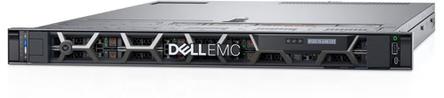

CPU | Intel Xeon Silver 4114 2.2G
RAM | 32GB RDIMM, 2400MT/s, Dual Rank
Storage | 1000 + 1000GB
Management | iDRAC9, Enterprise 16G  OpenManage Enterprise Advanced  Dell Connectivity Client - Enabled
Network | Broadcom 57414 Dual Port 10/25GbE SFP28 Adapter, V2
Security | iDRAC9, Enterprise 16G  OpenManage Enterprise Advanced
Price | 38,300
Quantity | 5

3 for high‑performance enterprise servers hosting ERP, CRM, and SQL workloads. Acts as the core computing engine, ensuring scalability and reliability for business applications.
2 for Redundant servers used for disaster recovery and high availability. Provides continuity and failover capacity, keeping operations running during outages. Also provide data management servies.
Synology RS3621RPxs SR-R3621RX
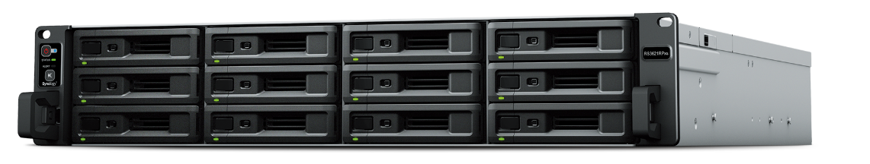
https://www.synology.com/zh-hk/products/SA6400
Storage | 12 Drive Bays
 | RAID Support
Management | Synology DSM Management System
Network | 25GbE Network Interface ( Synology E25G21-F2 )
Security | Supports Secure Boot and Volume Encryption
Backup | Snapshot Replication
Cluster | Synology High Availability
Price | 33,800 + 3422
Quantity | 2

Enterprise NAS with RAID6 protection and large storage capacity. Serves as the central storage hub, safeguarding documents and shared data against disk failures.
Synology HAT5300 24TB
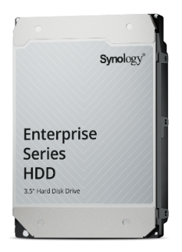
https://www.synology.com/zh-tw/products/drives/hdd/enterprise-hat?lang=zh-hk
Capacity | 24TB
Reliability | MTBF 2.5 million hours
Performance | 7200 RPM
Performance | 309 MB/s
Warranty | 5-Year Warranty
Price | 9149
Quantity | 24

Provide large storage capacity.

EC24250 Dell 24 多合一電腦

https://www.dell.com/zh-hk/shop/%E6%A1%8C%E4%B8%8A%E5%9E%8B%E9%9B%BB%E8%85%A6/dell-24-%E5%A4%9A%E5%90%88%E4%B8%80%E9%9B%BB%E8%85%A6/spd/dell-ec24250-aio/c24250-f5650
CPU | 13th Generation Intel® Core™ i5-1334U
RAM | 16 GB: 1 x 16 GB, DDR5, 5200 MT/s
Storage | 512 GB, M.2, PCIe NVMe, SSD
Monitor | 23.8", Non-Touch, FHD, Anti-Glare
Keyboard and Mouse | KM5221W - US English - Black
Price | 5,999.00
Quantity | 12

Integrated desktop workstations with built‑in display. Provides fixed workstation access, simplifying cabling and saving office space.

Latitude 3420 Laptop
CPU | Intel i5-1135G7
Operating System | Windows 11 Pro
Monitor | 14", Non-Touch, FHD, IPS, FHD Cam
RAM | 16 GB
Storage | 512 GB, SSD
Price | 6,958
Quantity | 40

Portable laptops supporting hot‑desk and remote work. Enables mobility and flexible work, allowing staff to move between desks or work off‑site.
Samsung Galaxy Tab A9+

CPU | Qualcomm Snapdragon 695
Operating System | Android 13
Monitor | 11inch 1920x1200
RAM | 8GB
Storage | 128GB
Price | 1,698
Quantity | 40

Lightweight tablets for warehouse and logistics staff. Supports real‑time ERP/CRM access, enabling mobile data entry and inventory updates.

5.2 Software
Dynamics 365 Business Central

https://www.microsoft.com/en-us/dynamics-365/products/business-central
Type | ERP + CRM Integration
Platform | Microsoft Azure
Management | Dynamics Admin Center, Power Platform integration
Security | Azure compliance (GDPR, ISO, SOC)
Price | 7521.55 / per year and 752.155 / per year
Quantity | 12 + 40

Customer relationship management fully integrated with ERP. Ensures consistent customer and order data, avoiding duplication.
Microsoft 365 E3

https://www.microsoft.com/zh-hk/microsoft-365/enterprise/e3?market=hk
Type | Productivity Suite
Platform | Cloud SaaS
Management | Microsoft Admin Center, Intune integration
Security | MFA, DLP, encryption, compliance features
Price | 3384.67 / per year
Quantity | 52 user licenses

Productivity suite with email, Office apps, and Teams collaboration. Provides communication and collaboration tools, connecting staff across the enterprise

SQL Server 2022

https://www.microsoft.com/zh-tw/sql-server/sql-server-2022-pricing
Type | Enterprise Database Engine
Platform | hybrid cloud
Management | SQL Server Management Studio (SSMS), Azure Data Studio
Security | Transparent Data Encryption, Always Encrypted, auditing
Price | 0
Quantity | 1

Enterprise database engine supporting Dynamics 365. Acts as the database backbone, storing and processing structured business data.
TrendVisionOne™EndpointSecurity
https://www.trendmicro.com/zh_hk/business/products/endpoint-security.html
Type | Endpoint Security Suite
Platform | Cloud-managed
Management | Centralized console, policy enforcement
Security | Malware protection, ransomware defense, threat detection
Price | 211.46
Quantity | 52 device licenses

Endpoint protection against malware and cyber threats. Secures all user devices, maintaining system integrity.

Zabbix On-Premise

https://www.zabbix.com/
Type | Monitoring Tool
Platform | On-premise server installation
Management | Web-based dashboard, alerting system
Security | Role-based access control, encrypted communication
Price | 0
Quantity | 1

Open‑source monitoring tool for servers and networks. Monitors system health and performance, alerting IT staff to issues.

5.3 Network Configuration
Cisco Catalyst 9500 Series Ethernet Switch C9500-48Y4C-A
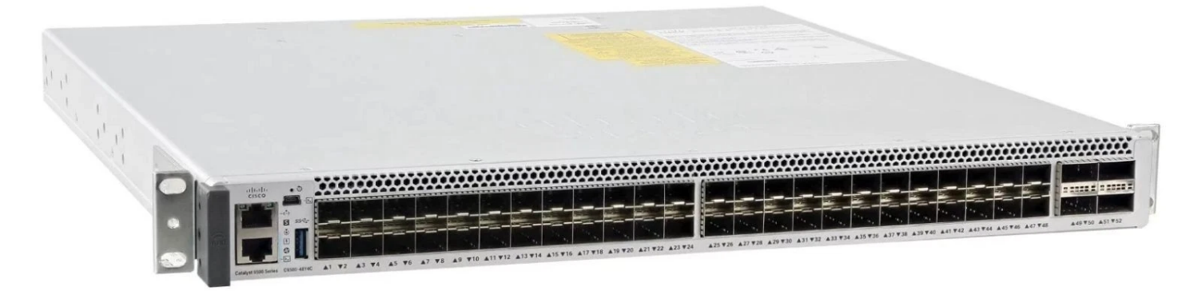
https://www.cisco.com/c/en/us/products/collateral/switches/catalyst-9500-series-switches/nb-06-cat9500-ser-data-sheet-cte-en.html
https://www.price.com.hk/product.php?p=575156&srsltid=AfmBOopkhrenA5SylAoHNZgoSUadnMr1VOOEHxZOBVIZ37leF7v2Jo8q
Capacity | 48 ports, high throughput
Throughput | 40/100GbE uplinks
Management | Cisco DNA Center, CLI
Security | Cisco TrustSec, MACsec encryption
Price | 115,000
Quantity | 2

High‑capacity backbone switch. Serves as the network backbone, connecting servers, storage, and distribution switches

Cisco Catalyst 9300 C9300-48P-E + C9300-NM-8X
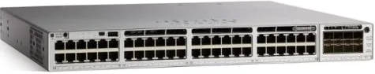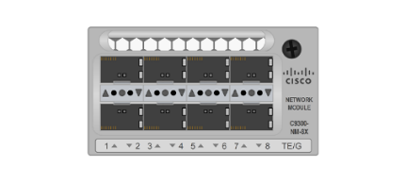
https://www.cisco.com/c/zh_tw/products/switches/catalyst-9300-series-switches/index.html
Capacity | 48 ports each, modular uplinks
Throughput | Enterprise-grade distribution switching
Management | 10/25GbE uplinks
Security | Cisco DNA Center, CLI
Price | 33,000 + 8,600
Quantity | 3

Distribution switches for end‑user devices. Provides access connectivity, linking PCs, laptops,
Netgear WAX218 WiFi6 AX3600 PoEAccessPoint
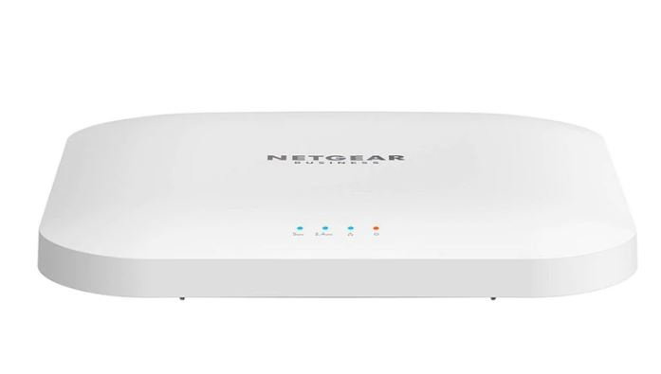
Capacity | Wi-Fi 6, 256 per AP
Power | POE
Throughput | 3.6 Gbps
Management | Local Web GUI
Security | WPA3
Price | 1,199
Quantity | 256

Wireless access points with secure, high‑speed connectivity. Delivers enterprise Wi‑Fi, enabling hot‑desk and mobile work.

FortiGate 2600F Series
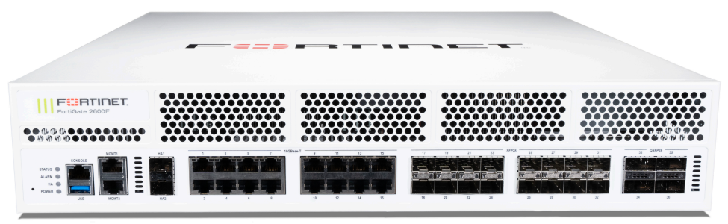
https://www.fortinet.com/tw/products/next-generation-firewall
Capacity | High throughput, VPN support
Performance | Intrusion prevention, SSL inspection
Throughput | 100Gbps+ firewall throughput
Management | FortiManager, FortiAnalyzer
Security | Deep packet inspection, threat intelligence
Price | 293090.57
Quantity | 2

Next‑generation firewall securing the network perimeter. Acts as the security gatekeeper, filtering traffic and preventing intrusions
Cisco Secure Client (including AnyConnect)

https://www.cisco.com/c/en_sg/products/security/anyconnect-secure-mobility-client/index.html
Capacity | Scalable VPN sessions
Performance | Secure remote connectivity
Throughput | Depends on VPN concentrator capacity
Management | Cisco SecureX integration
Security | Cisco AnyConnect VPN Security
Price | 24.21
Quantity | 200

Secure remote access solution. Ensures safe connectivity for remote staff, extending the corporate network securely

Network configuration graph
Factory in Mainland China Factory in Vietnam
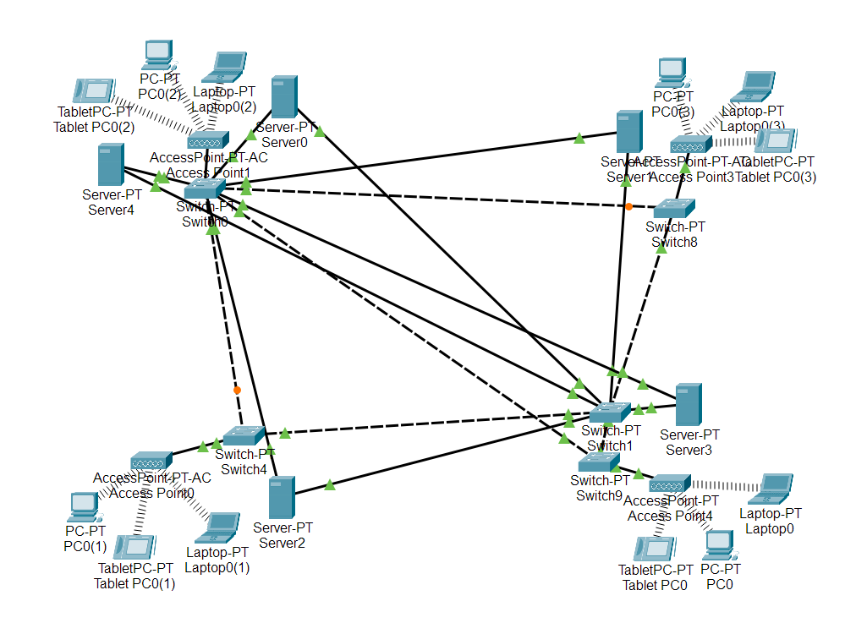 Factory in Thailand Factory in the Philippines

Price within 10 Years in HKD
Hardware Item Description | Quantity | Unit Price (HKD) | Total Amount (HKD)
Dell PowerEdge R640 Server | 5 | 38,300.00 | 191,500.00
Synology RS3621RPxs (Host + Cache) | 2 | 37,222.00 | 74,444.00
Synology HAT5300 24TB Enterprise HDD | 24 | 9,149.00 | 219,576.00
EC24250 Dell 24 All-in-One PC (AIO) | 12 | 5,999.00 | 71,988.00
Latitude 3420 Laptop | 40 | 6,958.00 | 278,320.00
Samsung Galaxy Tab A9+ Tablet | 40 | 1,698.00 | 67,920.00
Cisco Catalyst 9500 Series Core Switch | 2 | 115,000.00 | 230,000.00
Cisco Catalyst 9300 Series + Network Modules | 3 | 41,600.00 | 124,800.00
WiFi 6 AX3600 PoE Access Point | 256 | 1,199.00 | 306,944.00
FortiGate 2600F Series Firewall | 2 | 293,090.57 | 586,181.14
Total Hardware Cost |  |  | 2,151,673.14

Software Item Description | Quantity | Annual Unit Price (HKD) | 10-Year Total (HKD)
Dynamics 365 Business Central (Core) | 12 | 7,521.55 | 90,258.60
Dynamics 365 Business Central (General) | 40 | 752.155 | 30,086.20
Microsoft 365 E3 | 52 | 3,384.67 | 176,002.84
Trend Vision One™ Endpoint Security | 52 | 211.46 | 10,995.92
Cisco Secure Client (VPN License) | 200 | 24.21 | 4,842.00
SQL Server 2022 | 1 | 0 | 0.00
Zabbix On-Premise Monitoring | 1 | 0 | 0.00
Total Software Cost (10 Years) |  |  | 312,185.56

10-Year Software Subscriptions | 3,121,855.60
One-time Hardware Investment | 2,151,673.14
10-Year Estimated Total Expenditure | 5,273,528.74

6. How can an organization benefit from this central computerized management system?
The adoption of a centralized computerized management system provides Premium Living Furniture Co. Ltd. with significant advantages across its operations. By replacing fragmented departmental tools and manual processes with a unified platform, the company can achieve greater efficiency, transparency, and responsiveness.
The benefits extend beyond immediate problem‑solving, offering long‑term strategic value that supports the company’s transformation into a hybrid B2B and B2C enterprise.

6.1 Enhanced inventory control
The current system suffers from procurement delays and production disruptions due to non‑trackable emails and manual verification. With the centralized system, material requests are logged digitally, assigned unique identifiers, and made accessible across departments in real time. This guarantees consistency in updated information across the organization.
By implementing a central computerized management system, requests made by production or manufacturing representatives can be tracked online, this ensures transparency, reduces duplication, and allows inventory staff to respond quickly to shortages.
Automated alerts for low stock levels and real‑time updates on raw materials and finished goods further strengthen resource utilization. As a result, production schedules become more reliable, downtime is minimized, and accountability is improved.

6.2 Better customer service
Customer complaints are currently handled exclusively through phone calls, with handwritten logs that are inconsistent and difficult to trace.
The new system introduces a structured, digital platform where customers can log into their accounts, submit complaints, and provide feedback directly. Each interaction is recorded, categorized, and tracked until resolution, ensuring standardized workflows and faster response times.
Customer service representatives gain access to complete communication histories, reducing repetition and improving continuity. Managers can analyze complaint trends to identify recurring issues and implement corrective measures. This transformation builds stronger customer trust, enhances satisfaction, and reinforces the company’s brand reputation.

6.3 A new communication channel
Sales representatives currently rely on manual email exchanges with logistics staff to update delivery dates or product quantities, leading to delays and errors.
The centralized system establishes a new communication channel that empowers sales staff to directly modify authorized order details within the system. Changes are automatically logged, time‑stamped, and shared across relevant departments, ensuring transparency and immediate synchronization.
Notifications alert logistics, production, and inventory teams to updates, reducing administrative burdens and improving coordination. Customers benefit from faster confirmations and more accurate information, while internal teams experience smoother collaboration and reduced risk of miscommunication.

7. Constrains and limitation
Technical Limitations
In terms of technology selection, the system heavily relies on the Microsoft and Cisco/Fortinet ecosystems. While this ensures stability and compatibility, it also results in high long-term licensing and maintenance costs and a lack of flexibility. Server and network equipment typically have a 5-7 year upgrade cycle, requiring at least one replacement within a 10-year planning period, increasing additional capital expenditure. Furthermore, while All-in-One PCs simplify cabling, they require complete machine replacement for repairs, leading to higher maintenance costs than traditional desktop computers.

Data Protection Limitations
Regarding data protection, while RAID 6 can prevent hard drive failures, it cannot protect against accidental deletion, ransomware attacks, or data center disasters. Cold backup processes rely on manual handling and management; if procedures are not rigorous, backup delays or data loss may occur. More importantly, cold backups are slower to recover from; in the event of a major disaster, business recovery time will be much longer than with automated cloud backups, posing a significant challenge to business continuity.

Software Limitations
At the software level, Dynamics 365, SQL Server, and Microsoft 365 E3 all require ongoing payment, potentially exceeding the budget in the long run. Future version updates also depend on the vendors, and changes in licensing or integration models by Microsoft could cause compatibility issues. While Zabbix is ​​free, it requires maintenance by the IT team and lacks official technical support, posing a risk to long-term stability.

Network Limitations
Although the network architecture uses Cisco Catalyst and Meraki equipment, offering powerful functionality, its high complexity requires professional management, increasing manpower demands. Wi-Fi 6 may still experience interference or performance bottlenecks in high-density environments. VPN (AnyConnect) provides secure connections, but insufficient protection on user devices can become a weakness, impacting overall security.

Overall Project Limitations
From an overall project perspective, the system operation is complex, requiring a professional IT team to manage the multi-vendor system; otherwise, integration and security may be compromised. Cold backup processes rely on manual processes, resulting in lower reliability compared to automated cloud backups. Hardware upgrade cycles mean that at least one replacement is required within a 10-year period, adding extra costs. In the event of a major disaster, slow cold backup recovery may delay business restoration.

8. Use Case Actor Description
Actor | Salesperson
Description | A Salesperson is a user responsible for handling customer sales activities. The Salesperson uses the system to create quotations, convert accepted quotations into orders, modify order details, and check order information. The Salesperson must log into the system before performing any operations.

Actor | Customer
Description | A Customer uses the system to view quotations and orders, track logistics status, report issues, request returns, and complete customer surveys. Customers may access certain functions using order or quotation identifiers and may be required to log in for specific operations.

Actor | Marketing clerk
Description | A Marketing Clerk manages market research activities. The Marketing Clerk uses the system to create customer surveys, view and analyze survey results, and review customer feedback to support marketing decisions and service improvement.

Actor | Logistics clerk
Description | A Logistics Clerk manages delivery and shipment operations. The Logistics Clerk uses the system to create delivery notes, arrange delivery schedules, update logistics status, and coordinate shipment activities to ensure orders are delivered on time.

Actor | Finance Clerk
Description | A Finance Clerk is handling financial operations related to customer orders. The Finance Clerk uses the system to create invoices, process customer payments and refunds, and monitor the company’s fund status to ensure accurate financial management.

Actor | Customer Service Clerk
Description | A Customer Service Clerk is handling customer inquiries, complaints, and after‑sales services. The Customer Service Clerk uses the system to view reported issues, process customer complaints, manage return requests, and communicate with customers to resolve issues efficiently.

Actor | Production Clerk
Description | A Production Clerk is an internal system user responsible for managing production‑related activities. The Production Clerk uses the system to view production orders, update production progress, and submit raw material requests when materials are insufficient for ongoing production.

Actor | Inventory Clerk
Description | An Inventory Clerk manages raw materials and inventory records. The Inventory Clerk uses the system to check inventory levels, process raw material requests from the production department, update stock information, and ensure sufficient inventory is maintained for ongoing operations.

9. Use Case
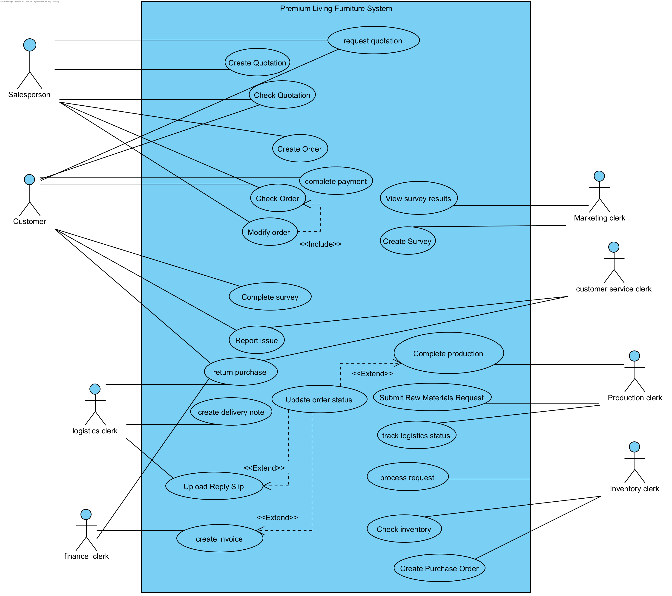

10.Initial use case description
Use case name: | Login
Use case ID: | UC-001
Primary actor: | Salesperson, Production Staff, Inventory Staff, Logistics Staff, Finance Staff, Marketing Staff
Brief description: | The company offers a quotation when a customer makes an inquiry about the price and details of furniture they are interested in buying. The salesperson creates a quotation for a customer by entering product details, quantity, price, and delivery information.
Preconditions: | The user has a valid system account.
Flow of events: | 1. The user opens the system login page. The system displays the login form.  2. The user enters employee ID and password.  3. The user clicks the Log In button. The system verifies the user's credentials.  4. The system redirects the user to the main menu.
Postconditions: | The user is successfully logged into the system.
Alternative flows and exceptions: | The user resets the password if forgotten

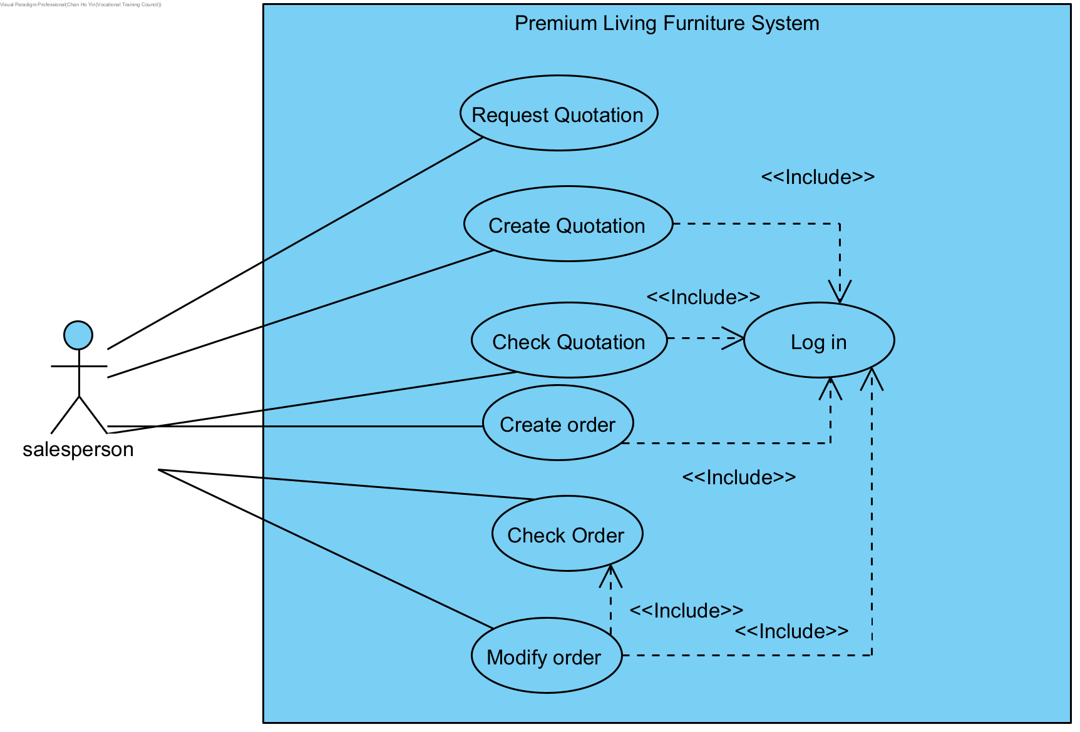
Use case name: | Create Quotation
Use case ID: | UC-100
Primary actor: | Salesperson
Brief description: | The company offers a quotation when a customer makes an inquiry about the price and details of furniture they are interested in buying. The salesperson creates a quotation for a customer by entering product details, quantity, price, and delivery information.
Preconditions: | The salesperson log in the system
Flow of events: | 1. include (login)  2. The salesperson selects Create Quotation. The system displays the quotation creation form.  3. The salesperson enters customer information, product details, quantities, unit prices, and estimated delivery date. The system automatically calculates the total quotation amount.  4. The salesperson submits the quotation. The system generates a unique Quotation ID and saves the quotation.  5. The system displays a confirmation message.
Postconditions: | The quotation is successfully stored in the system.
Alternative flows and exceptions: | The salesperson can edit and cancel the creation.

Use case name: | Check Quotation
Use case ID: | UC-110
Primary actor: | Customer, Salesperson
Brief description: | The customer and salesperson use the unique QuotationID to check the quotation details.
Preconditions: | The user has a valid QuotationID.
Flow of events: | 1. The user can use QuotationID to search for the quotation. The displays the quotation details, including products, quantity, price, and delivery information.  2. The user checks the quotation for detailed information.
Postconditions: | The system displays the quotation
Alternative flows and exceptions: | The system cannot find the quotation and asks the user to enter the number again.

Use case name: | Create Order
Use case ID: | UC-120
Primary actor: | Salesperson
Brief description: | The customer wants to place an order after reading the Quotation. The salesperson enters customer name, customer phone number, shipping address, and the name quantity of the ordered items, item price.
Preconditions: | The salesperson log in the system
Flow of events: | 1. include (log in)  2. The salesperson selects Create Order. The system displays the order creation form.  3. The salesperson selects or enters customer information.  4. The salesperson enters ordered products, quantities, prices, and delivery address. The system automatically calculates the total order amount.  5. The salesperson submits the order. The system generates a unique Order ID and saves the order.  6. The system notifies the production, logistics, and finance departments.  7. The system displays a confirmation message.
Postconditions: | The order sends production, logistics, and finance to processing.
Alternative flows and exceptions: | The salesperson can edit and cancel the creation.

Use case name: | Check Order
Use case ID: | UC-130
Primary actor: | Customer, Salesperson
Brief description: | The customer and salesperson use the unique OrderID to check the order details
Preconditions: | The user has a valid OrderID
Flow of events: | 1. The user can use OrderID to search for the order. The system displays the order details, including products, quantity, price, and delivery information.  2. The user checks the quotation for detailed information.
Postconditions: | The system displays the order
Alternative flows and exceptions: | The system cannot find the order and asks the user to enter the number again.

Use case name: | Modify order
Use case ID: | UC-140
Primary actor: | Salesperson
Brief description: | The salesperson updates an existing order by modifying information such as product quantity, delivery date, or customer details. The system records the changes and updates the order while keeping a history of all modifications.
Preconditions: | The salesperson is logged into the system
Flow of events: | 1. include (log in)  2. include (check order)  3. The salesperson modifies the needed information. The system saves the updated order and records the modification history.
Postconditions: | The order is successfully updated in the system
Alternative flows and exceptions: | The salesperson cannot modify completed orders. The system will prompt the salesperson to modify other orders or return to the main directory.

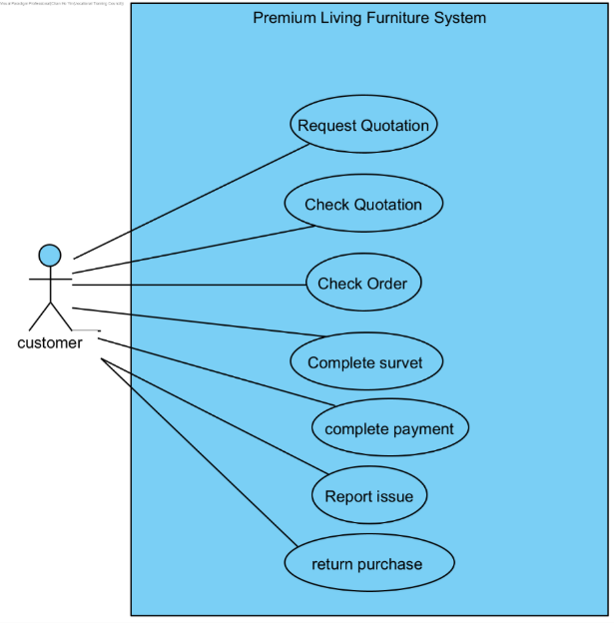

Use case name: | Track logistics status
Use case ID: | UC-210
Primary actor: | Customer, Logistics Staff
Brief description: | Customers and logistics staff track the current status of deliveries, including shipment progress, estimated arrival, and any delays. The system retrieves logistics data and displays realtime updates.
Preconditions: | The actor must have a valid OrderID or DeliveryID.  The system has recorded logistics updates for the order.
Flow of events: | - The actor enters the OrderID or DeliveryID into the system.  - The system retrieves logistics information from delivery records.  - The system displays the status (e.g., dispatched, in transit, out for delivery, delivered).  - The actor reviews the logistics status and estimated delivery time.
Postconditions: | The system successfully displays the latest logistics status for the order.
Alternative flows and exceptions: | If the Order ID entered by the user is invalid or does not exist, the system displays an error message prompting the user to re‑enter a valid Order ID.

Use case name: | Complete survey
Use case ID: | UC-160
Primary actor: | Customer
Brief description: | A customer to complete an online survey sent by the company. The customer answers several questions about their shopping experience or product satisfaction, and the system records the responses for later analysis by the marketing department.
Preconditions: | The customer has received a survey invitation from the system.
Flow of events: | 1. The customer opens the survey link or survey page provided by the system. The system loads and displays all survey questions.  2. The customer reads each question and selects or enters an answer.  3. The customer submits the completed survey. The system displays a confirmation message page.
Postconditions: | The survey submission is recorded for the marketing team to check.
Alternative flows and exceptions: | The customer changes answers before final submission.

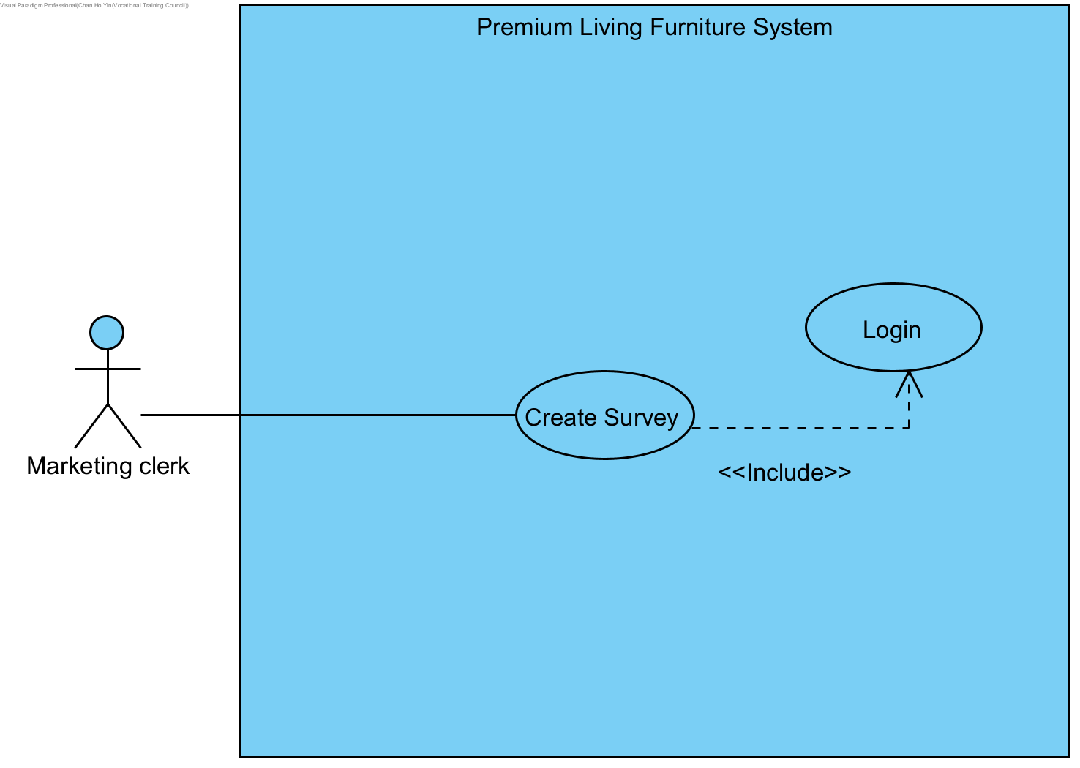
Use case name: | Create Survey
Use case ID: | UC‑290
Primary actor: | Marketing Staff
Secondary actors: | Logistics Staff, Customer Service Staff
Brief description: | Marketing staff to create a new survey enter questions, answer options, and system send customers to respond
Preconditions: | Marketing staff are logged into the system.  Marketing staff have permission to create and publish surveys.
Flow of events: | 1. include (log in)  2. The marketing staff selects to create a survey. The system displays a blank survey creation form for users to enter.  3. The marketing staff enters the survey description and creates a button. The system publishes the survey and makes it available to customers
Postconditions: | The survey is saved in the system and send to customer to write
Alternative flows and exceptions: | If marketing staff cancel the process before submission, no survey data is saved.  If required fields (e.g., survey description or questions) are missing or invalid, the system prompts for correction.  If the system fails to publish or send the survey, it logs the error and notifies marketing staff to retry later.  If customers’ contact information is invalid or unavailable, the system flags the issue and prevents sending.

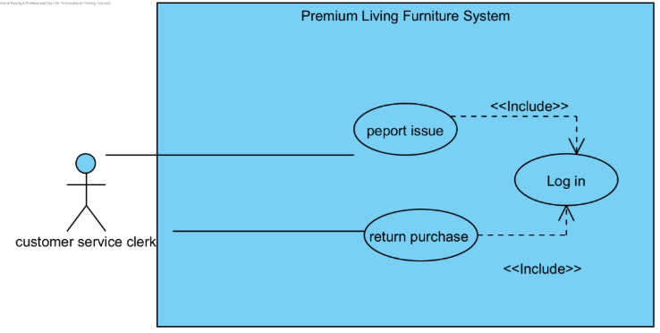
Use case name: | Report issue
Use case ID: | UC-170
Primary actor: | Customer
Secondary actor: | customer service staff
Brief description: | Customer reporting a problem related to an order. The system records the issue and forwards it to customer service staff, who can view, track, and handle the reported problem.
Preconditions: | The customer has a valid orderID to report.
Flow of events: | 1. The customer want to Report Issue. The system display Report Issue application form.  2. The customer enters the orderID, contact information, and enters the issue.  3. The customer submits the issue report. The system sends to Customer Service Staff for follow‑up.  4. Customer Service Staff logs into the system and views issues contacts the customer to answer questions
Postconditions: | The issue report is successfully saved in the system.
Alternative flows and exceptions: | The customer cancels the reporting process and no data is saved.

Use case name: | Return purchase
Use case ID: | UC-180
Primary actor: | Customer
Secondary actor: | Customer Service Staff, Delivery Personnel, Finance Department Staff
Brief description: | Customer requests a return for an item. The system records the request, forwards it to customer service staff for review, notifies the delivery personnel to collect the returned item, and finally sends the approved case to the finance department for refund processing.
Preconditions: | Returned goods must be returned within the refund period.
Flow of events: | 1. The customer wants to return the purchase. The system displays the Return Purchase Application.  2. The customer enters the return reason, uploads optional photos, and contact information.  3. The customer submits the return request. The system forwards the request to Customer service staff.  4. Customer service staff check and approves the return request.  5.If approved return request the system notifies the Delivery Personnel to arrange pick up the product  6. If rejects the system notifies the customer can no return item.  7. Delivery personnel receives the pickup request and collects the returned item from customer.  8. The system send the approved application to Finance Departments staff.  9. Finance staff calculates and processes.
Postconditions: | The return request is submitted, assigned for the department to processing.
Alternative flows and exceptions: | If the customer cancels the return request before submission, no data is saved in the system.  If the return request is submitted outside the refund period, the system rejects the request and notifies the customer.  If customer service staff reject the return request, the system sends a notification to the customer explaining the reason for rejection.  If delivery personnel cannot collect the item (e.g., customer unavailable), the system reschedules pickup and notifies both the customer and delivery staff.  If finance staff encounter discrepancies in refund calculation, the system flags the case for manual review.

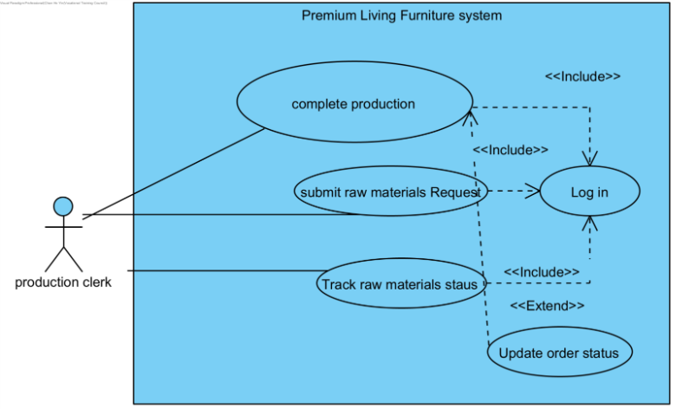
Use case name: | Complete Production
Use case ID: | UC-190
Primary actor: | Production staff
Brief description: | Production staff submit a raw materials request when materials are insufficient for ongoing production. The system generates a request number, and forwards it to the inventory and purchasing departments for further processing.
Preconditions: | The production staff is logged into the system.
Flow of events: | - The production staff selects the option to complete production.  - The system checks available raw materials against production requirements.  - If materials are sufficient, the system records the production completion and updates inventory levels.  - If materials are insufficient, the system prompts the staff to submit a raw materials request (linked to UC‑200).  - The system generates a unique production completion ID and displays a success message.
Postconditions: | The production completion record is saved in the system.  Inventory levels are updated.  If materials are insufficient, a raw materials request is generated and forwarded to inventory and purchasing departments.

Use case name: | Submit Raw Materials Request
Use case ID: | UC-200
Primary actor: | Production Staff
Secondary actor: | Inventory Staff
Brief description: | Production staff to submit a raw materials request when materials are insufficient for ongoing production. The system forwards it to the inventory and purchasing departments to processing request
Preconditions: | The production staff is logged into the system.  The system has detected insufficient raw materials for production.
Flow of events: | - The production staff selects the option to submit a raw materials request.  - The system displays a request form requiring material type, quantity, and urgency level.  - The production staff enters the required details and submits the request.  - The system validates the input and generates a unique RequestID.  - The system forwards the request to the inventory staff and purchasing department for processing.  - The system displays a confirmation message to the production staff.
Postconditions: | The raw materials request is recorded in the system.  Inventory and purchasing departments receive the request for further action.
Alternative flows and exceptions: | If the production staff cancels the request before submission, no data is saved.  If required fields are missing or invalid, the system prompts the staff to correct the input.  If the system fails to forward the request to inventory or purchasing, it logs the error and notifies the staff to retry later.

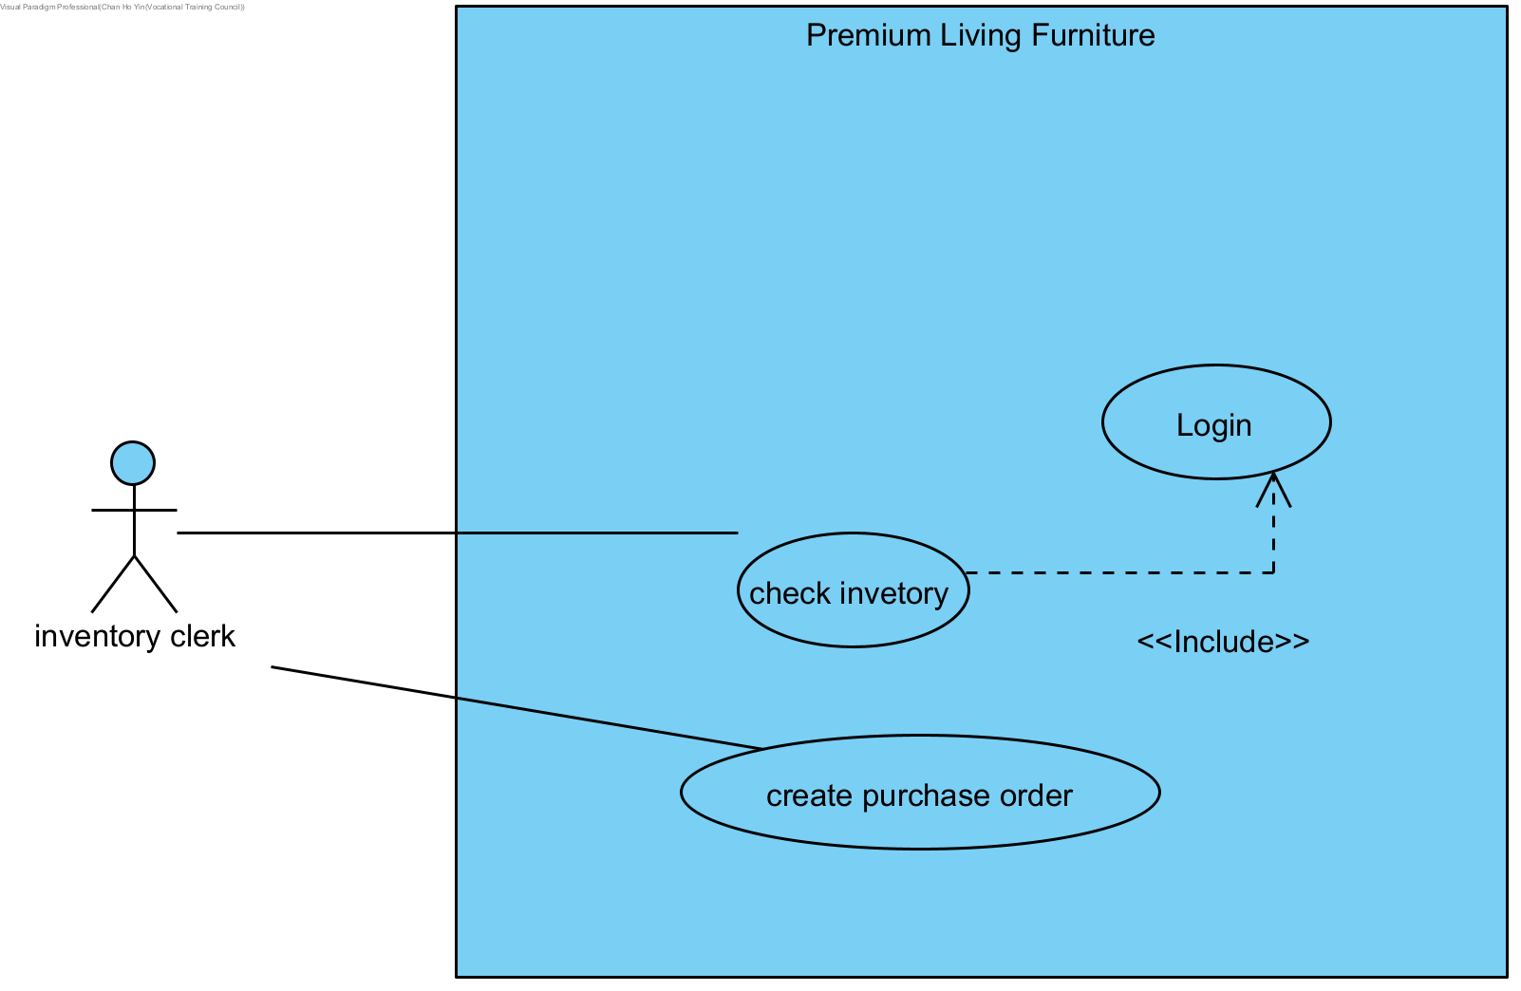

Use case name: | Check inventory
Use case ID: | UC‑230
Primary actor: | Inventory Staff
Secondary actors: | Purchasing Staff, Production Staff
Brief description: | Inventory staff check the current stock levels of raw materials and finished goods. The system displays available quantities, reserved items, and reorder alerts. This helps production staff plan and purchasing staff initiate procurement when stock is low.
Preconditions: | The inventory staff is logged into the system.  Inventory records are up to date.
Flow of events: | - Inventory staff select the option to check inventory.  - The system retrieves and displays stock details, including material type, available quantity, reserved quantity, and reorder thresholds.  - Inventory staff review the displayed information.  - If stock levels are below threshold, the system highlights items requiring replenishment.  - Inventory staff may forward low‑stock alerts to purchasing staff for procurement.
Postconditions: | The system displays accurate inventory levels.  Low‑stock items are flagged for replenishment.
Alternative flows and exceptions: | If the system cannot retrieve inventory data (e.g., database error), it logs the issue and prompts staff to retry later.  If inventory records are incomplete or outdated, the system notifies staff to update records before proceeding.  If unauthorized users attempt to access inventory data, the system denies access and logs the attempt.

Use case name: | Create Purchase Order
Use case ID: | UC‑240
Primary actor: | Purchasing Staff
Secondary actors: | Inventory Staff, Finance Staff
Brief description: | Purchasing staff create a purchase order when raw materials or goods need to be procured. The system generates a unique Purchase Order ID, records the details, and forwards the order to suppliers and finance staff for approval and payment processing.
Preconditions: | Purchasing staff are logged into the system.  A valid procurement request exists (e.g., from inventory or production).
Flow of events: | - Purchasing staff select the option to create a purchase order.  - The system displays a purchase order form requiring supplier details, item description, quantity, unit price, and delivery date.  - Purchasing staff enter the required information and submit the purchase order.  - The system validates the input and generates a unique Purchase Order ID.  - The system forwards the purchase order to the supplier and notifies finance staff for payment processing.  - The system displays a confirmation message to the purchasing staff
Postconditions: | The purchase order is recorded in the system.  Supplier and finance staff receive the purchase order for further action.

Use case name: | Upload Reply Slip
Use case ID: | UC-270
Primary actor: | Delivery Personnel
Secondary actors: | Logistics Staff, Customer Service Staff
Brief description: | delivery personnel to upload a signed reply slip after completing a delivery, enabling the system to update the order status and store
Preconditions: | The customer has already signed the reply slip.  Delivery personnel are logged into the system.
Flow of events: | - Delivery personnel select the option to upload a reply slip.  - The system displays an upload form requiring OrderID and slip file.  - Delivery personnel attach the signed reply slip and submit.  - The system validates the input and stores the slip in the database.  - The system updates the order status to “Delivered.”  - The system notifies logistics staff and customer service staff of the updated status.  - The system displays a confirmation message to delivery personnel.
Postconditions: | The signed reply slip is stored in the system.  The order status is updated to “Delivered.”  Logistics and customer service staff can view the uploaded slip for verification

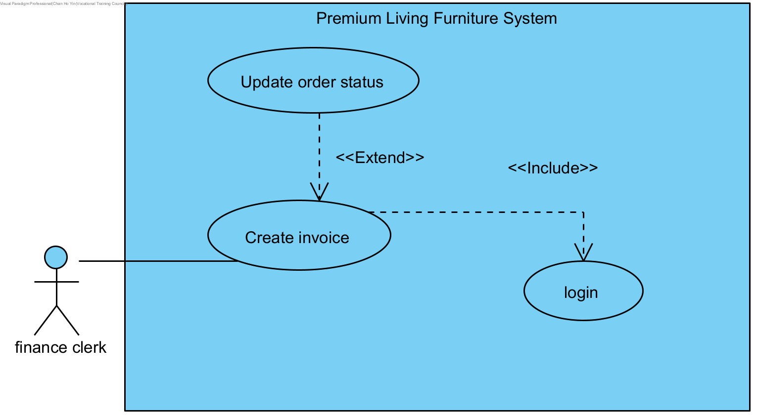
Use case name: | Create invoice
Use case ID: | UC-300
Primary actor: | Finance Department Staff
Brief description: | Finance department staff create an invoice about an order. The system retrieves order details, calculates the total amount, applies any discounts, and generates a unique invoice number for the customer.
Preconditions: | A valid order in the system
Flow of events: | 1. The finance department staff create the invoice. The system requests to enter the orderID.  2. The finance staff enters the orderID. The system displays the order details.  3. The staff confirms that everything is correct to enter create. The system generates a unique invoiceID and send the invoice to the customer's email.
Postconditions: | The invoice is created and save in the system
Alternative flows and exceptions: | If Finance staff cancels the invoice creation before submission, no data is saved.  If Order ID is invalid or not found, the system displays an error message and prompts for re-entry.  If the Order has already been invoiced, the system displays the existing invoice details and prevents duplicate creation.  If the Order status is Pending or Cancelled, the system displays "Cannot create invoice for this order status" and blocks the operation.  If the system fails to save the invoice to the database, it logs the error and notifies Finance staff to retry later.  If email delivery to the customer fails, the system saves the invoice and notifies Finance staff to resend manually.

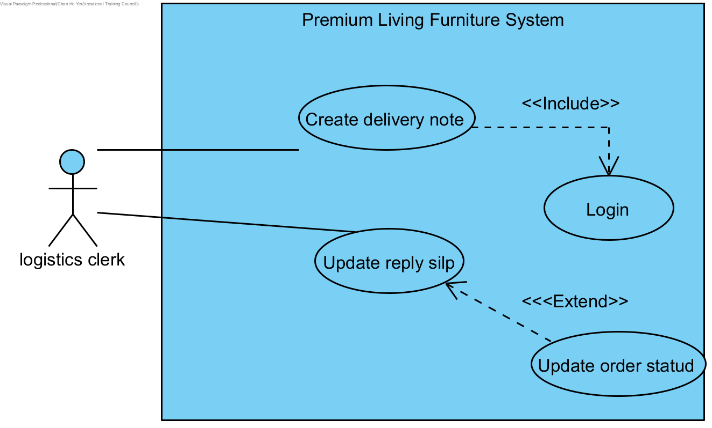

Use case name: | Create delivery notes
Use case ID: | UC‑250
Primary actor: | Logistics Staff
Secondary actors: | Inventory Staff, Finance Staff
Brief description: | Logistics staff create delivery notes to accompany shipments. The system generates a unique Delivery Note ID, records shipment details (items, quantities, customer information, delivery address), and forwards the note to delivery personnel and finance staff for tracking and billing purposes.
Preconditions: | Logistics staff are logged into the system.  A valid order exists in the system, ready for shipment.
Flow of events: | - Logistics staff select the option to create a delivery note.  - The system displays a delivery note form requiring order details, customer information, items, quantities, and delivery address.  - Logistics staff enter the required information and submit the delivery note.  - The system validates the input and generates a unique Delivery Note ID.  - The system forwards the delivery note to delivery personnel for shipment and finance staff for billing.  - The system displays a confirmation message to logistics staff
Postconditions: | The delivery note is recorded in the system.  Delivery personnel and finance staff receive the delivery note for further action.
Alternative flows and exceptions: | If logistics staff cancel the process before submission, no data is saved.  If required fields are missing or invalid, the system prompts staff to correct the input.  If the system fails to forward the delivery note to delivery personnel or finance staff, it logs the error and notifies logistics staff to retry later.  If the order is incomplete or invalid, the system prevents delivery note creation and alerts logistics staff.

Use case name: | Update order status
Use case ID: | UC‑310
Primary actor: | Logistics Staff
Secondary actors: | Delivery Personnel, Customer Service Staff
Brief description: | Logistics staff update the status of customer orders (e.g., pending, dispatched, in transit, delivered, returned). The system records the update, synchronizes with delivery and customer service modules, and notifies customers of the new status.
Preconditions: | Logistics staff are logged into the system.  A valid order exists in the system.
Flow of events: | Logistics staff select the option to update order status.  The system displays a list of orders with current statuses.  Logistics staff select the order and choose the new status (e.g., dispatched, delivered).  The system validates the update and records the new status.  The system synchronizes the update with delivery and customer service modules.  The system notifies the customer of the updated order status.  The system displays a confirmation message to logistics staff.
Postconditions: | The order status is updated in the system.  Delivery personnel and customer service staff have access to the updated status.  Customers are notified of the change.
Alternative flows and exceptions: | If logistics staff cancel the process before submission, no changes are saved.  If the order ID is invalid or missing, the system prompts for correction.  If the system fails to update the status due to connectivity or database errors, it logs the issue and notifies staff to retry later.  If unauthorized users attempt to update order status, the system denies access and logs the attempt.

11. Class Diagram
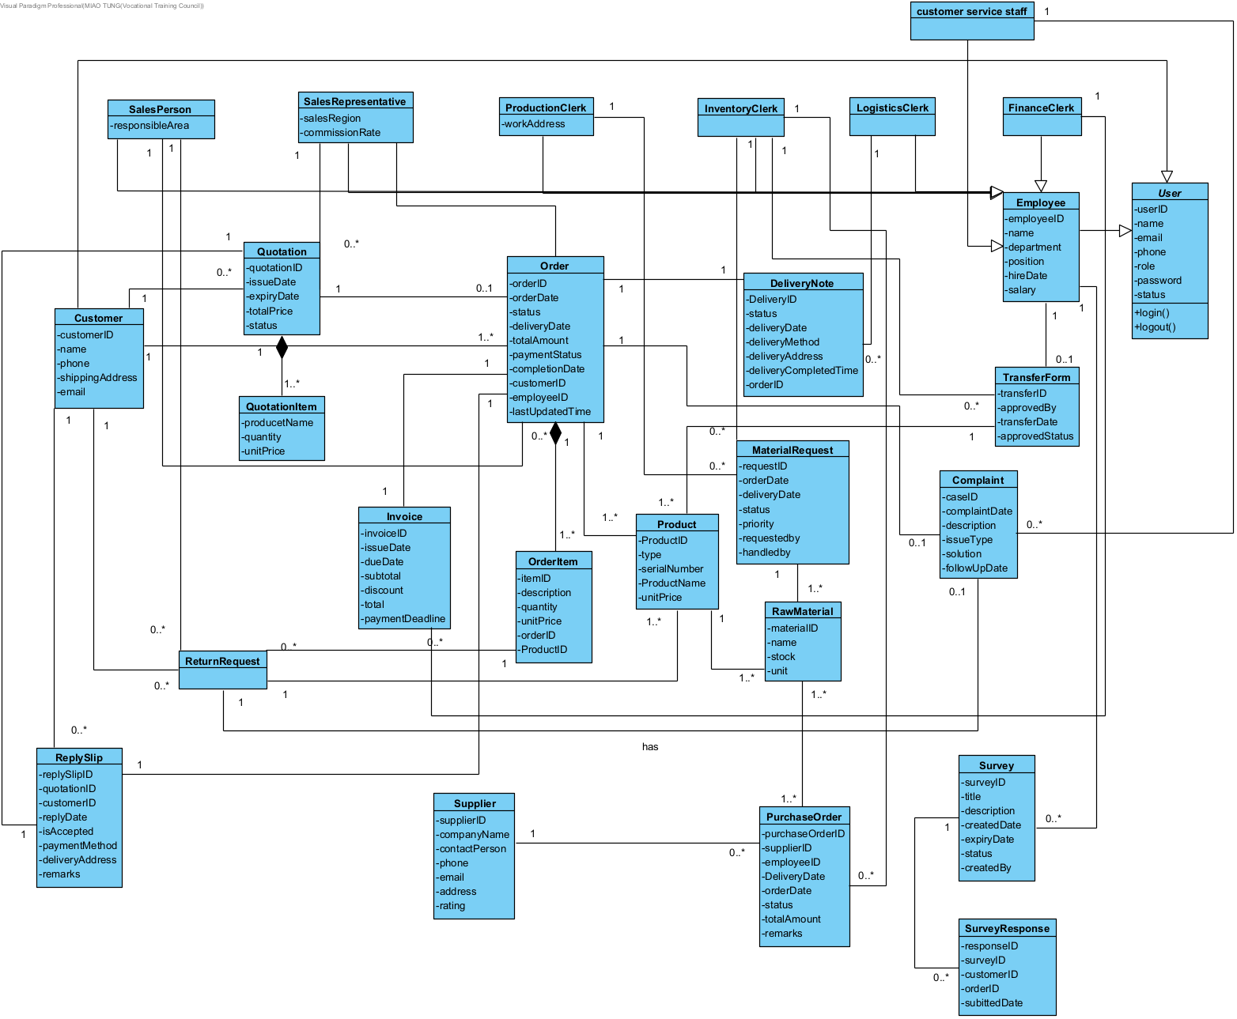

Login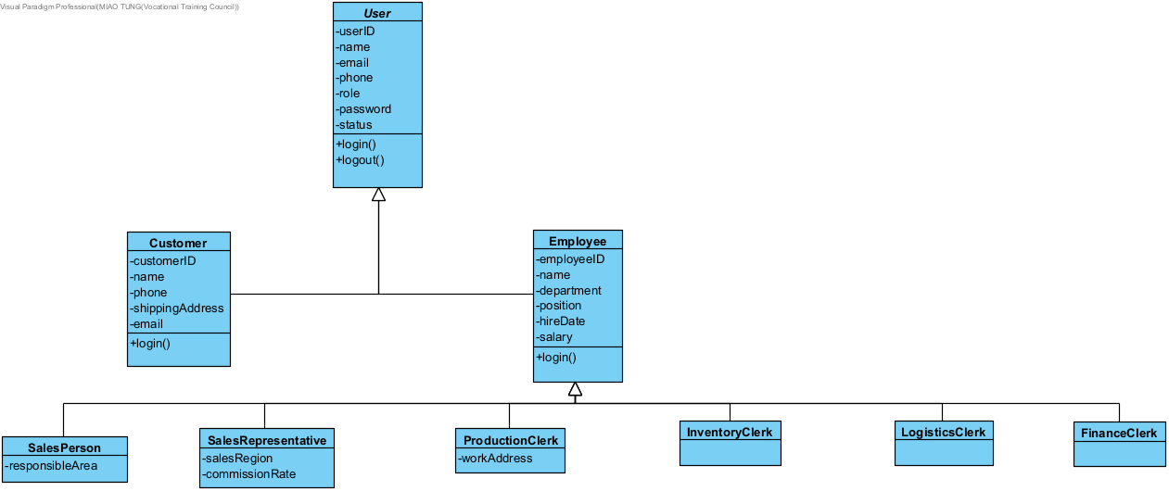

Create Quotation
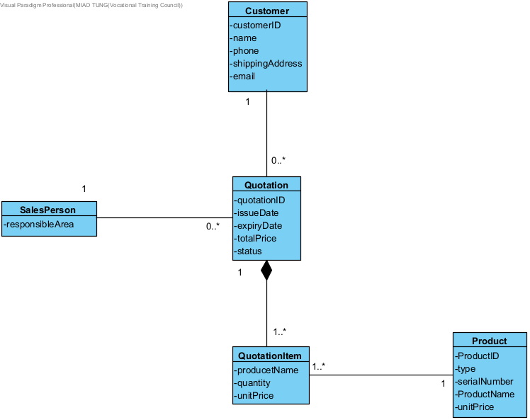

Create Order
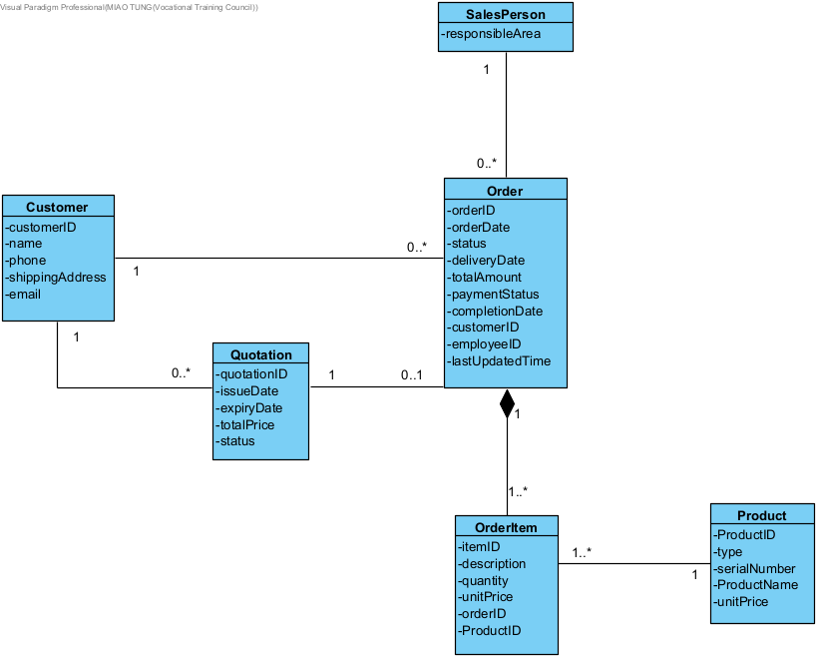
Modify order
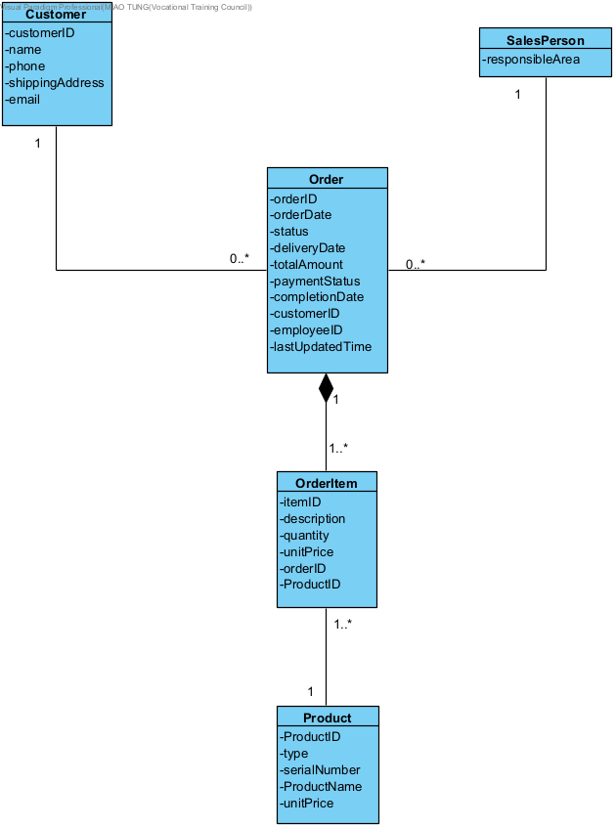
Check Quotation
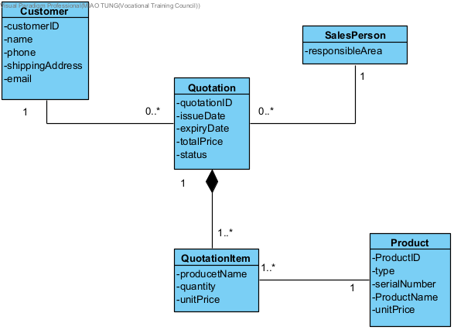
Check Order
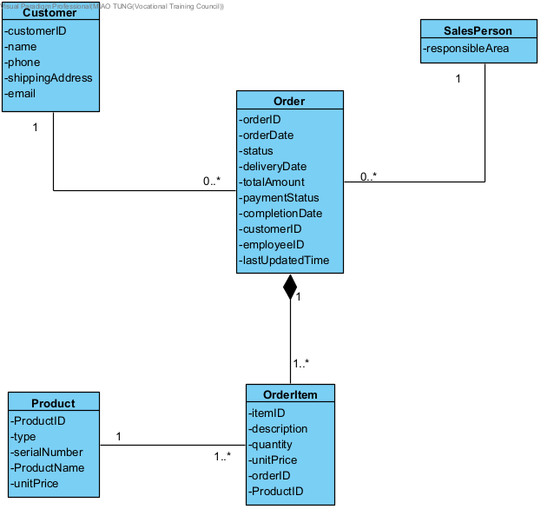

Track logistics status
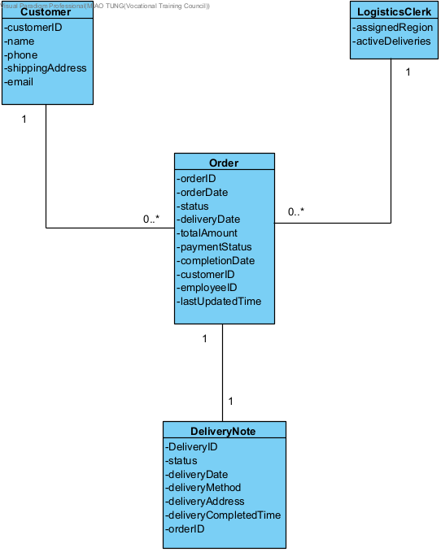
Complete survey
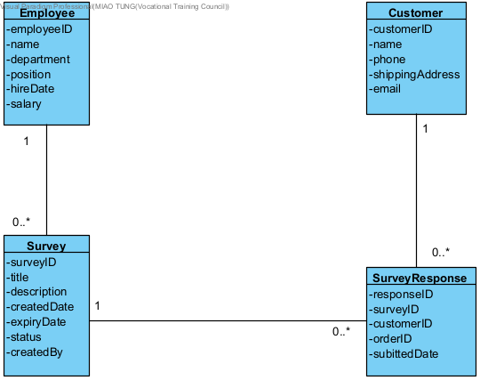

Create Servey
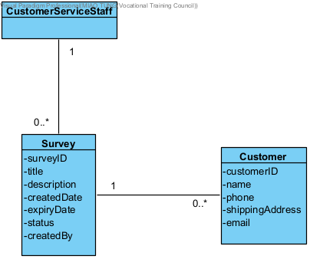
Report issue
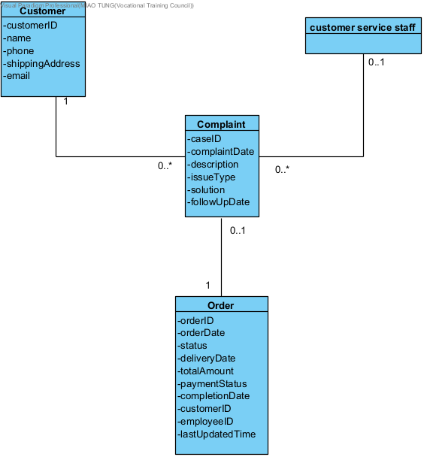
Return purchase
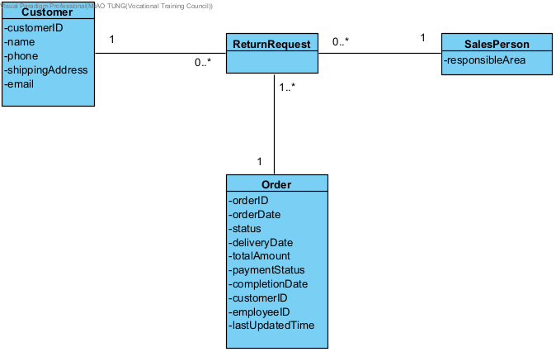
Complete Production
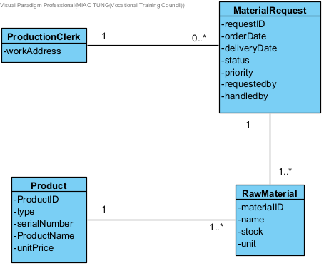

Submit Raw Materials Request
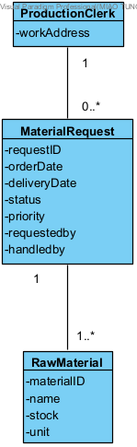

Check inventory
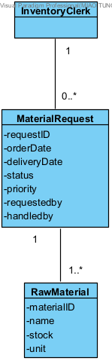

Create Purchase Order
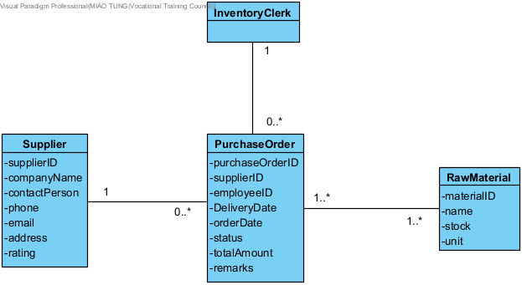

Create delivery notes
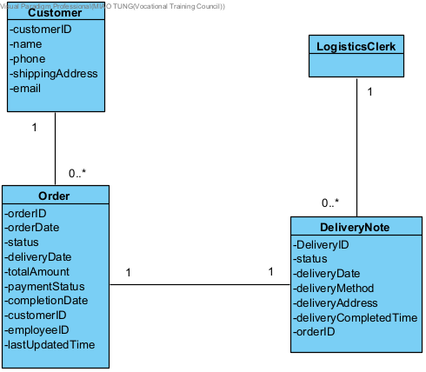

Upload Reply Slip
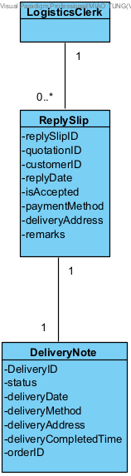
Create invoice
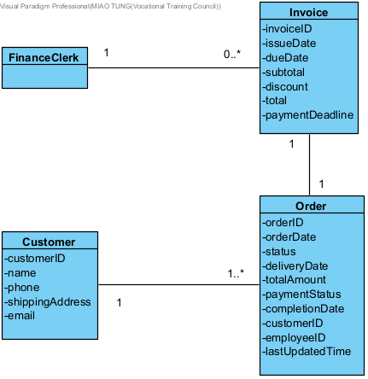
Update order status
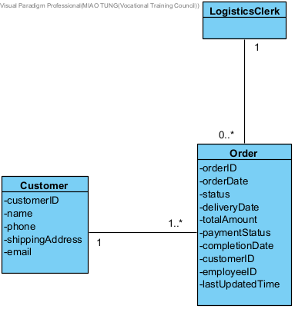

12. Sequence Diagram

12.1 Login
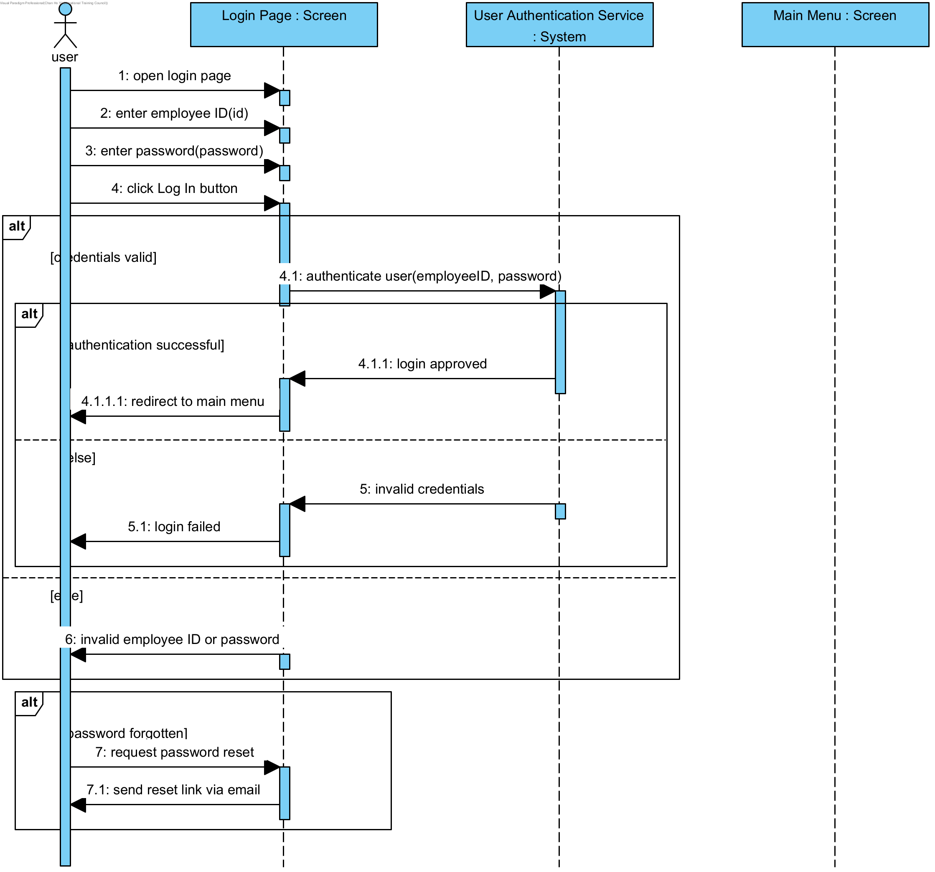

12.2 Create Quotation
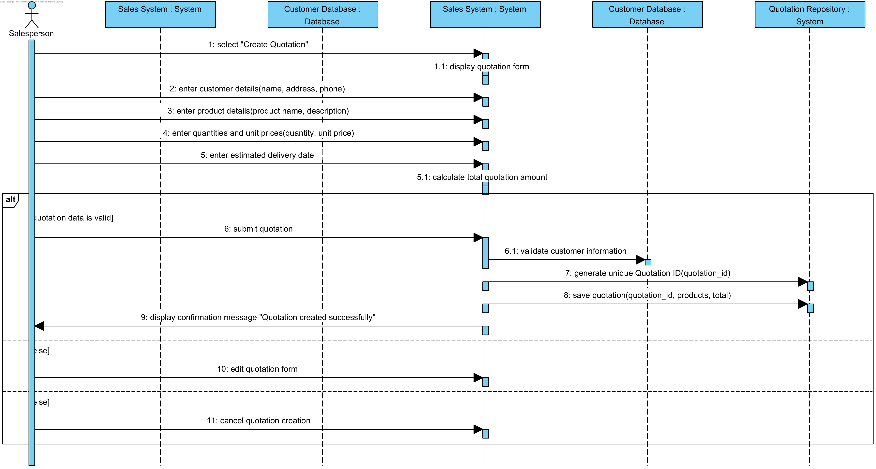

12.3 Create Order
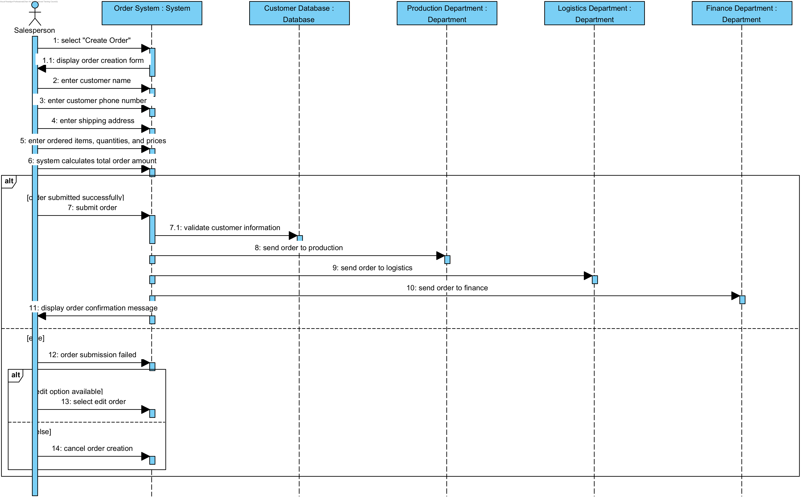

12.4 Modify order
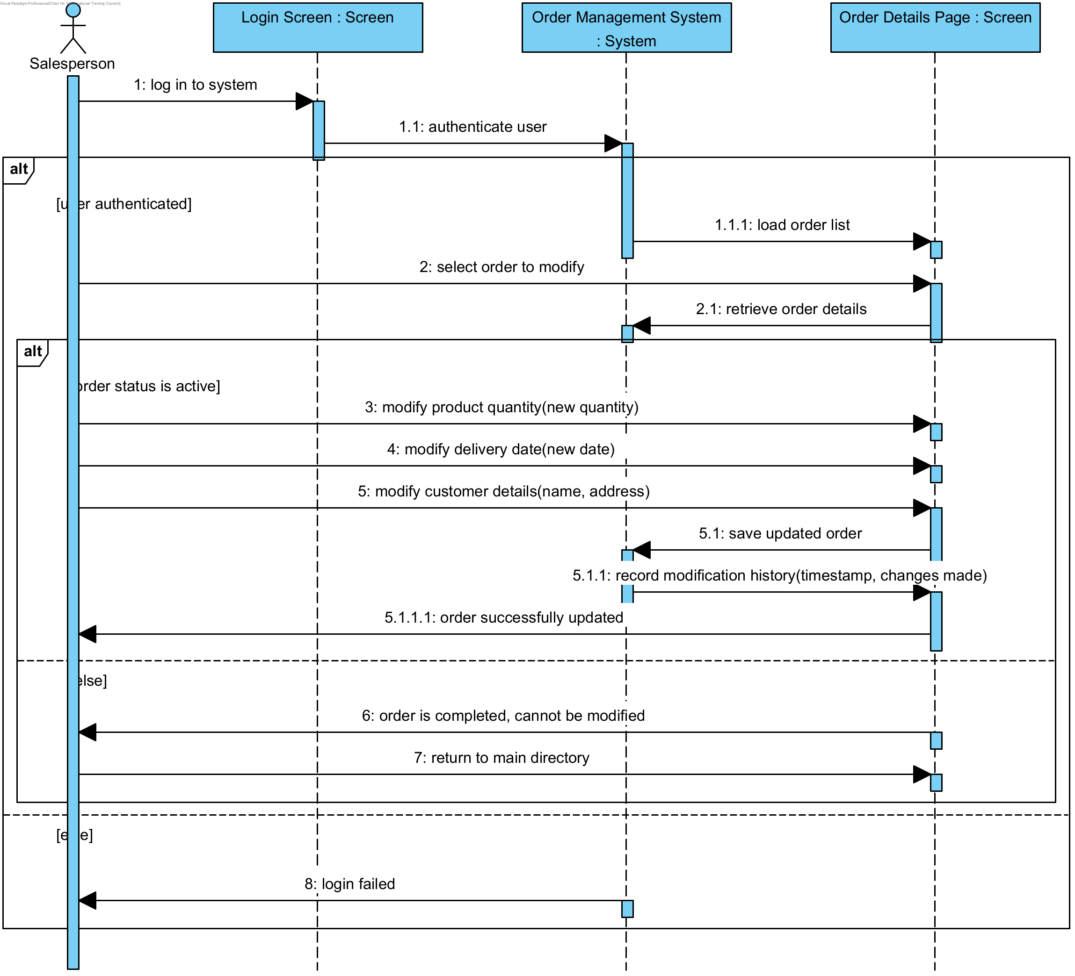

12.5 Track logistics status
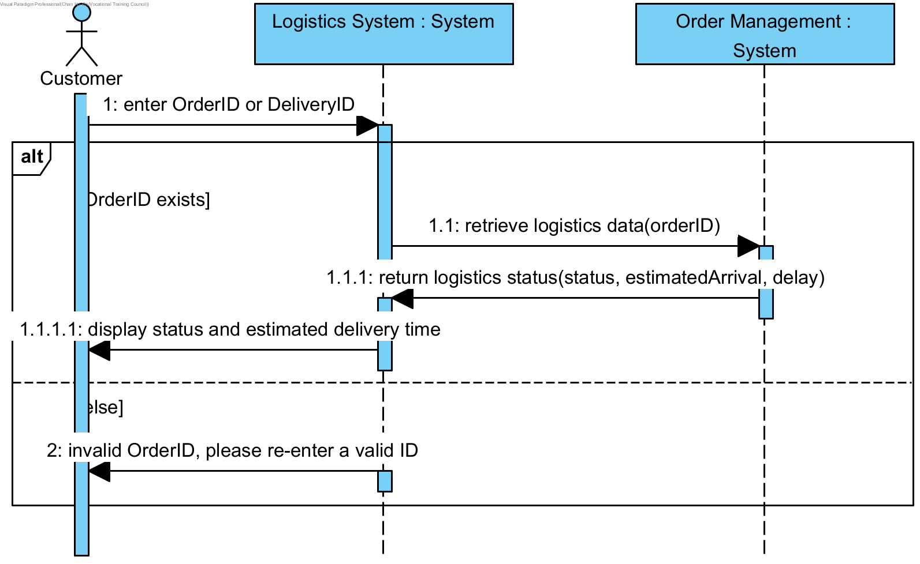

12.6 Complete survey
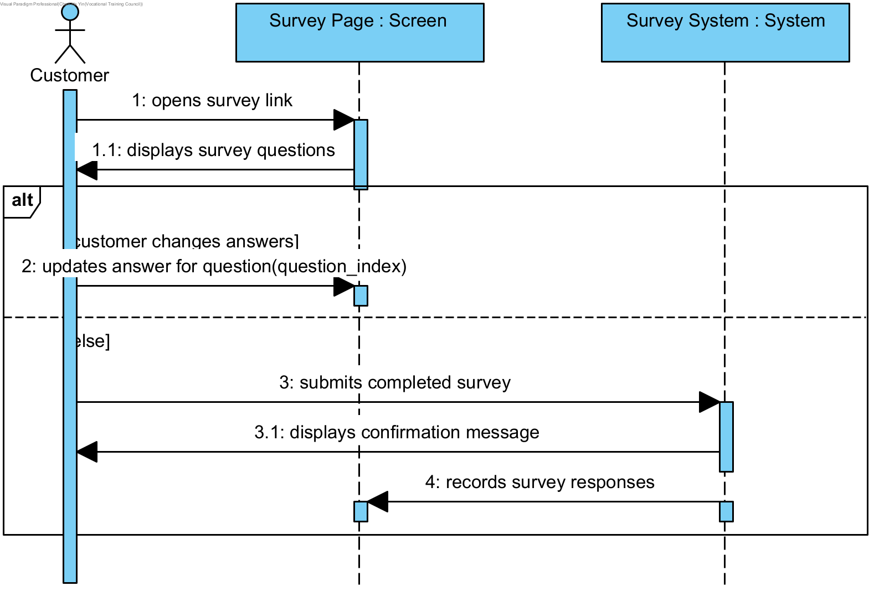

12.7 Create Survey
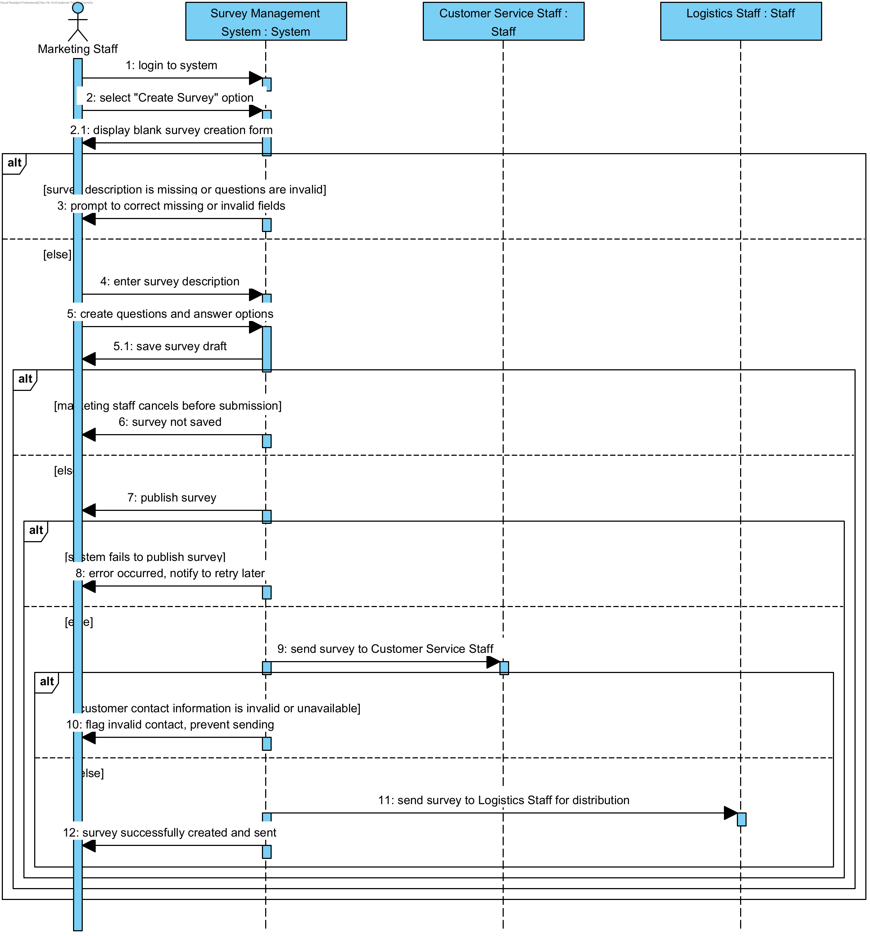

12.8 Return purchase
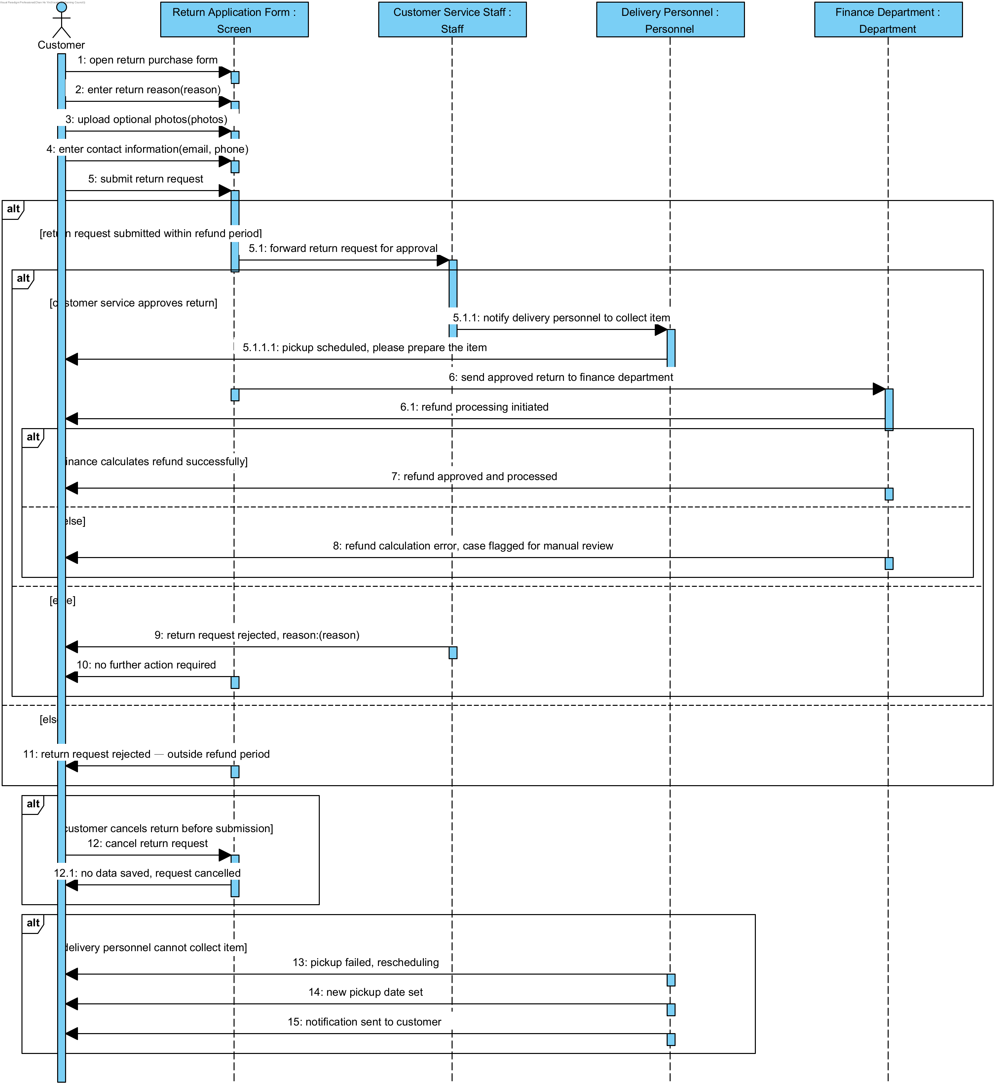

12.9 Complete Production
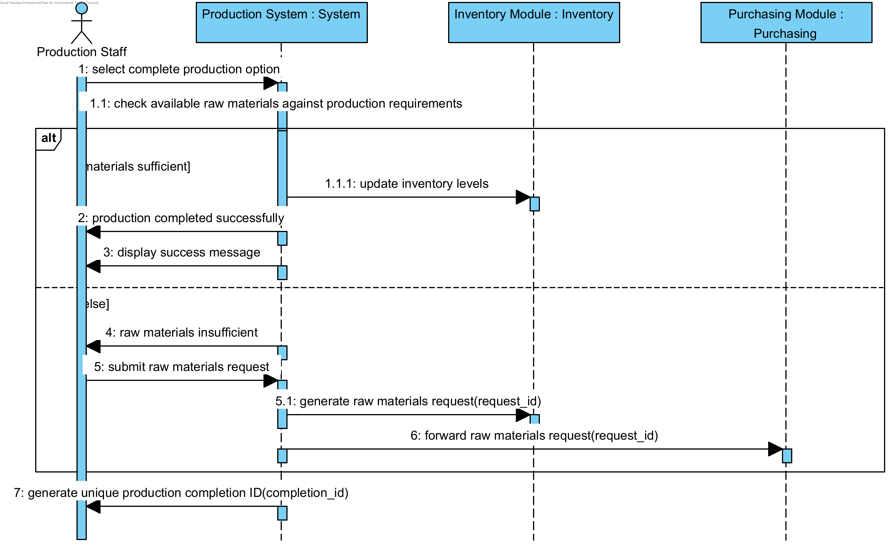

12.10 Submit Raw Materials Request
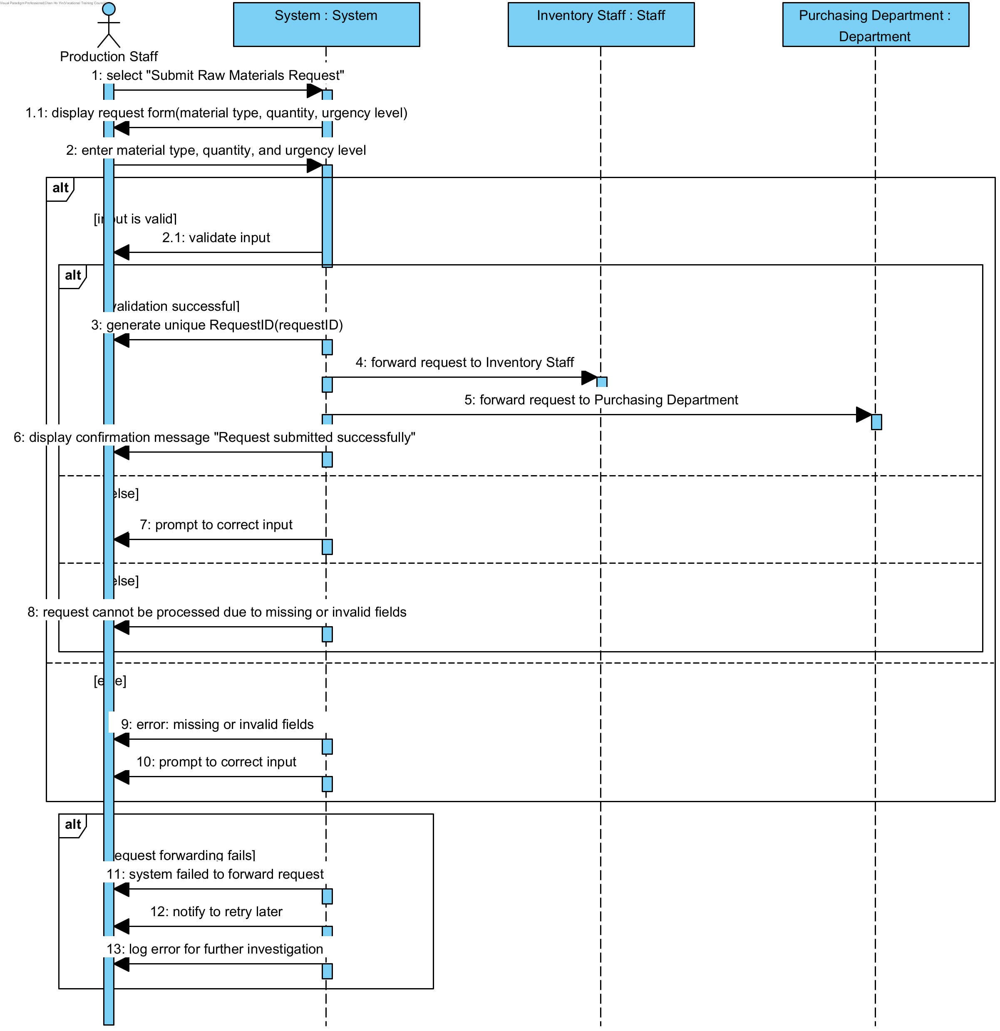

12.11 Create Purchase Order
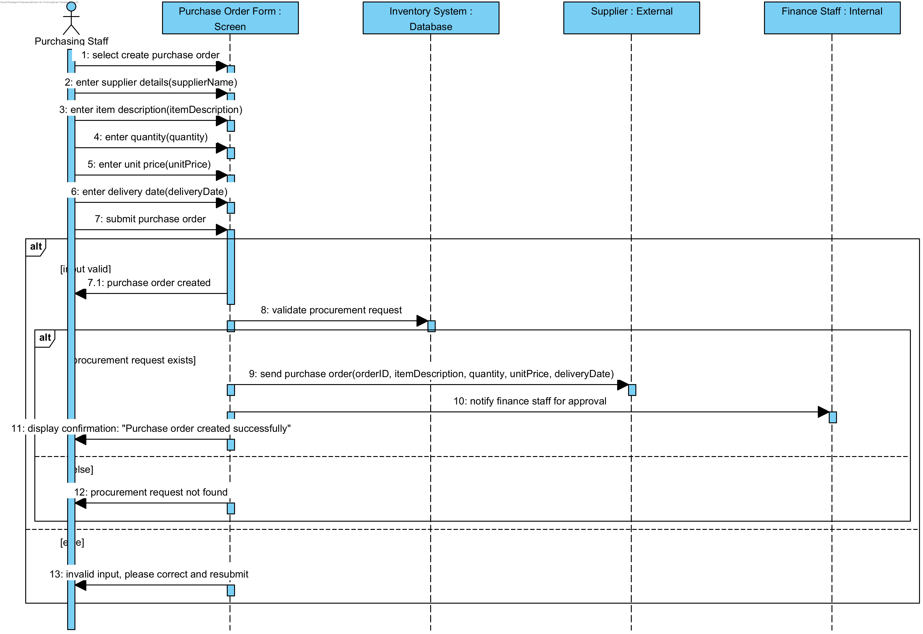

12.12 Upload Reply Slip
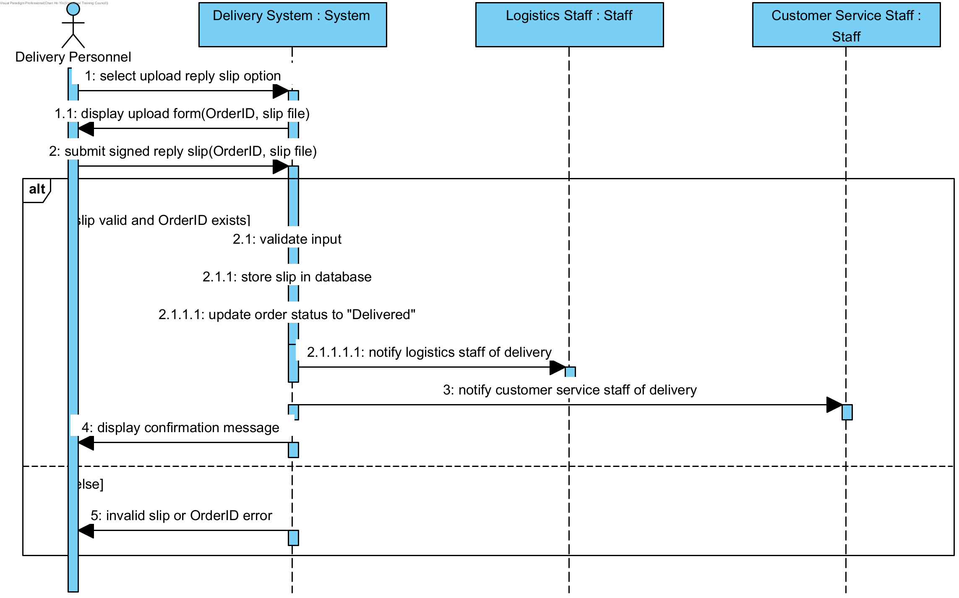

12.13 Create delivery notes
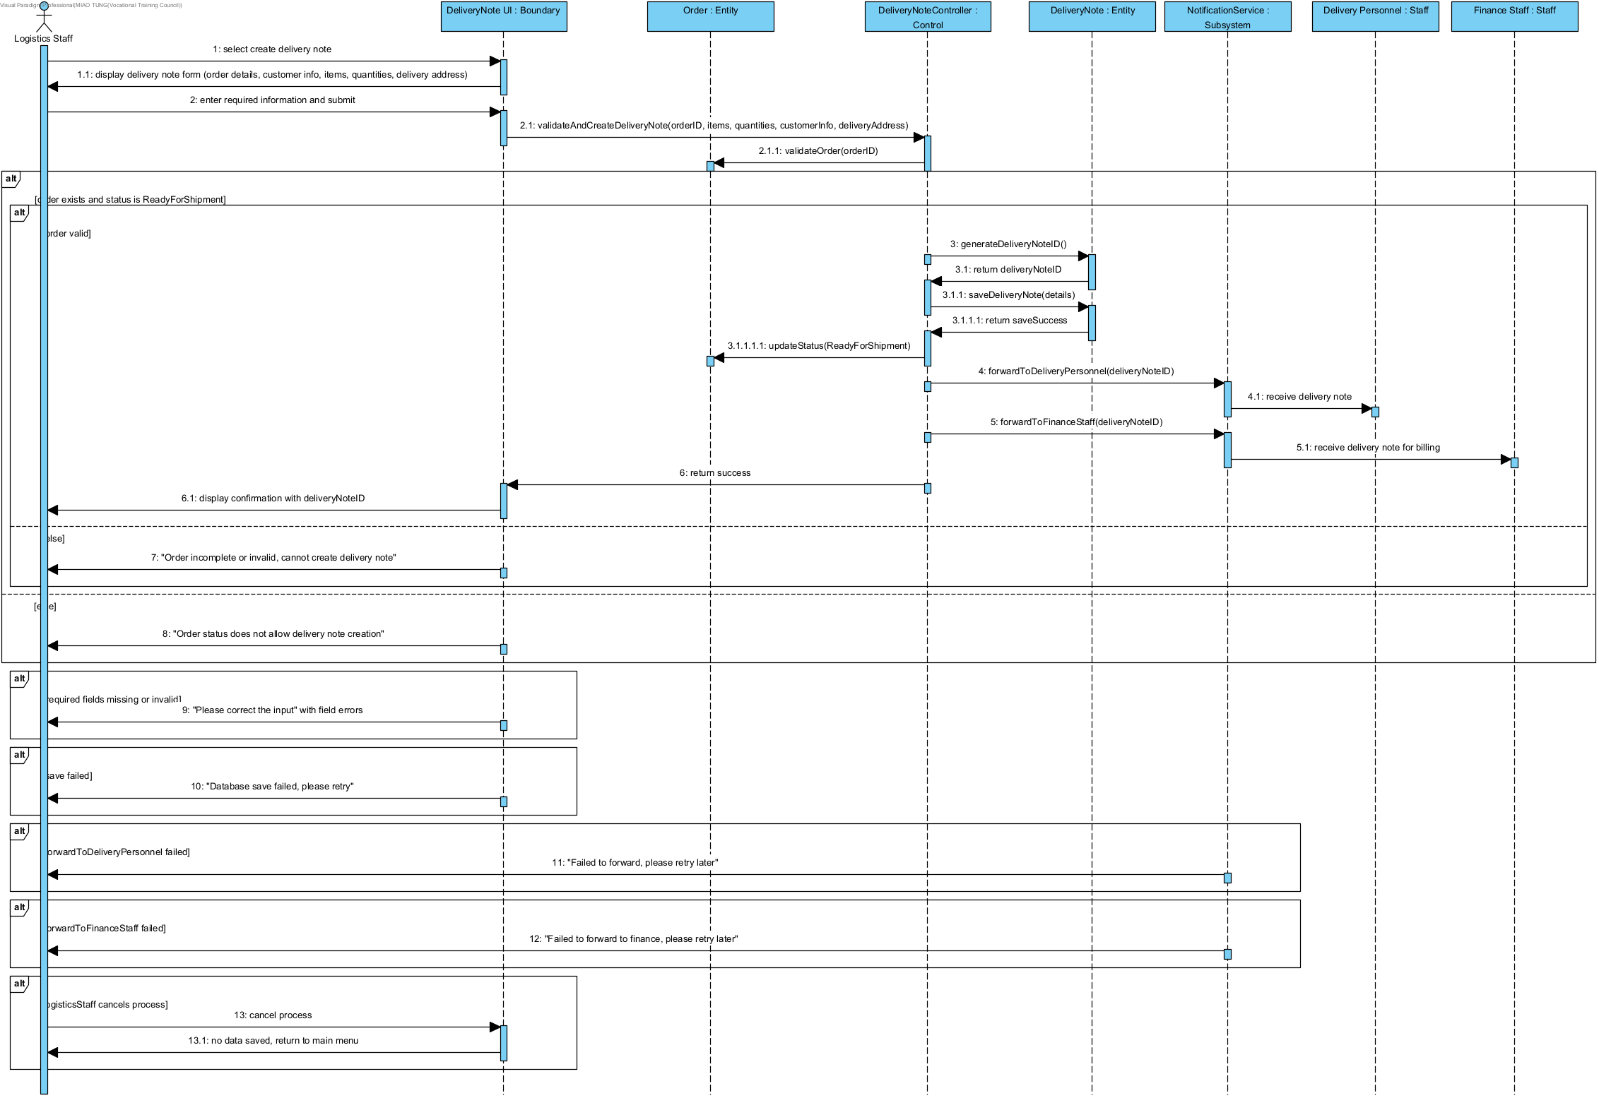

12.14 Create invoice
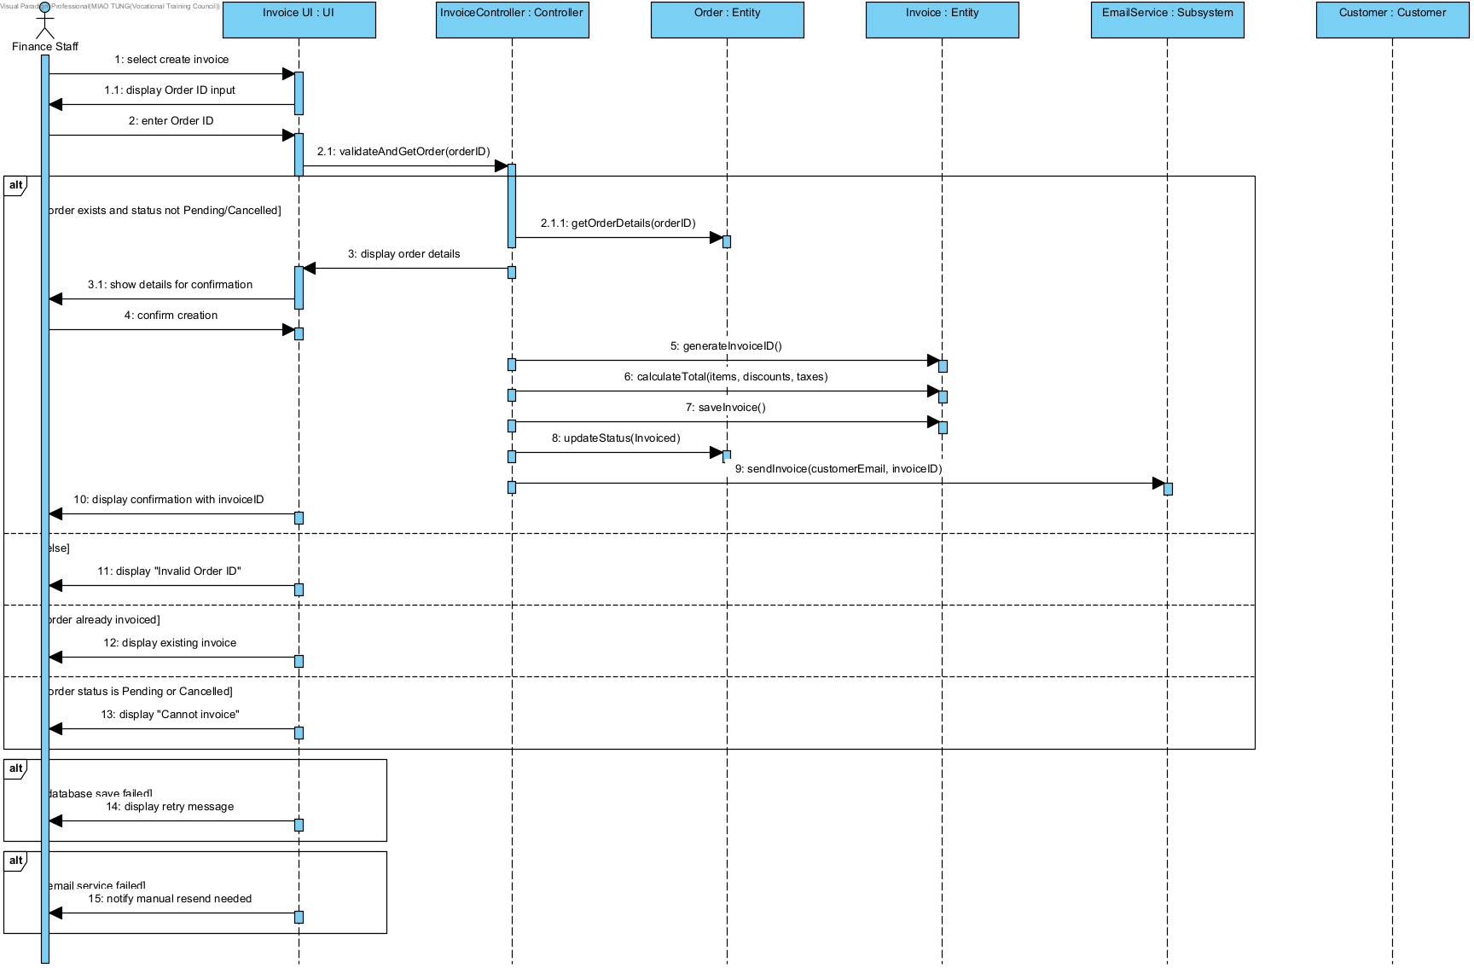

12.15 Update order status
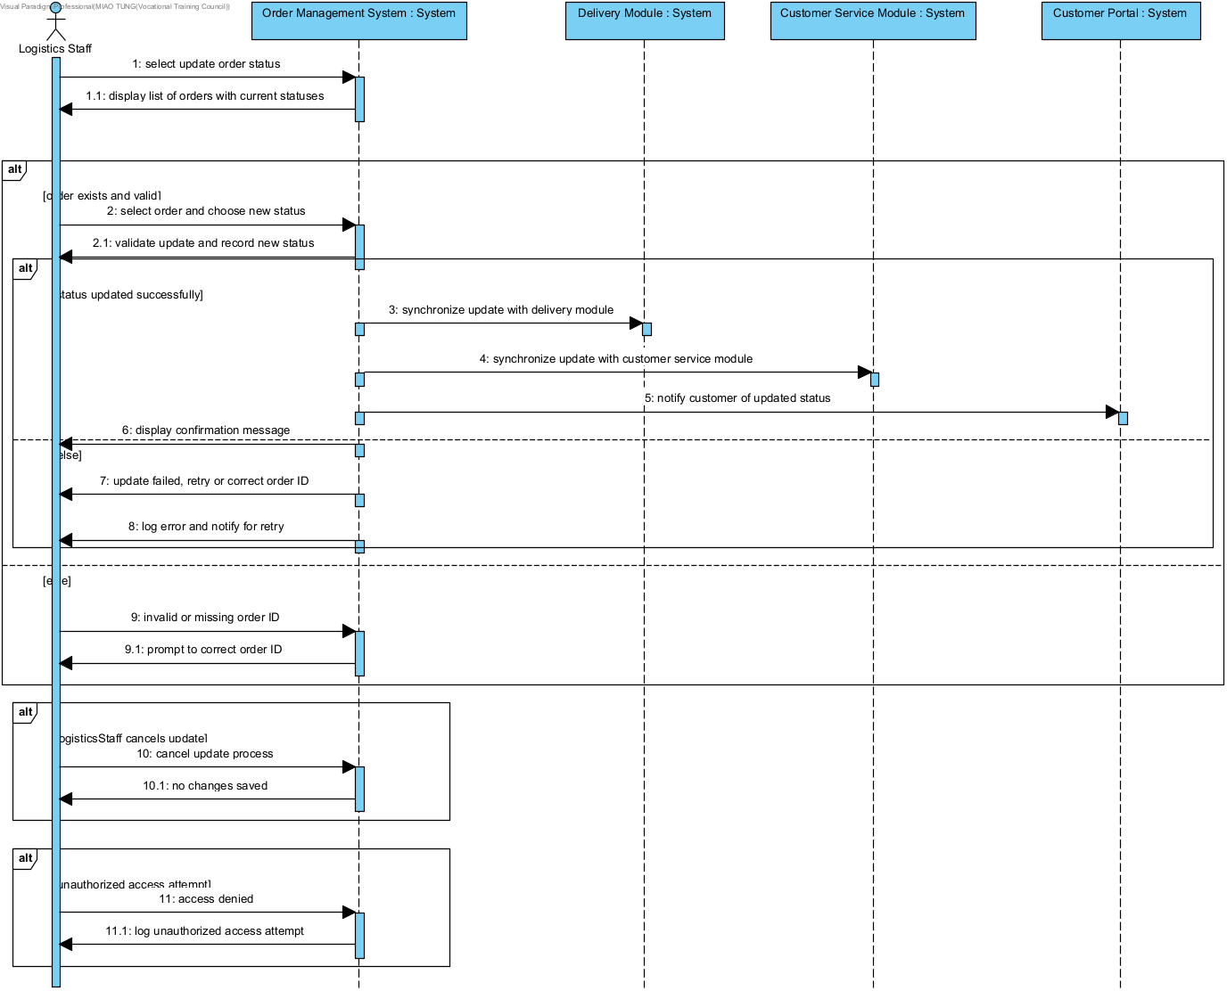

13. Entity Relation Diagram
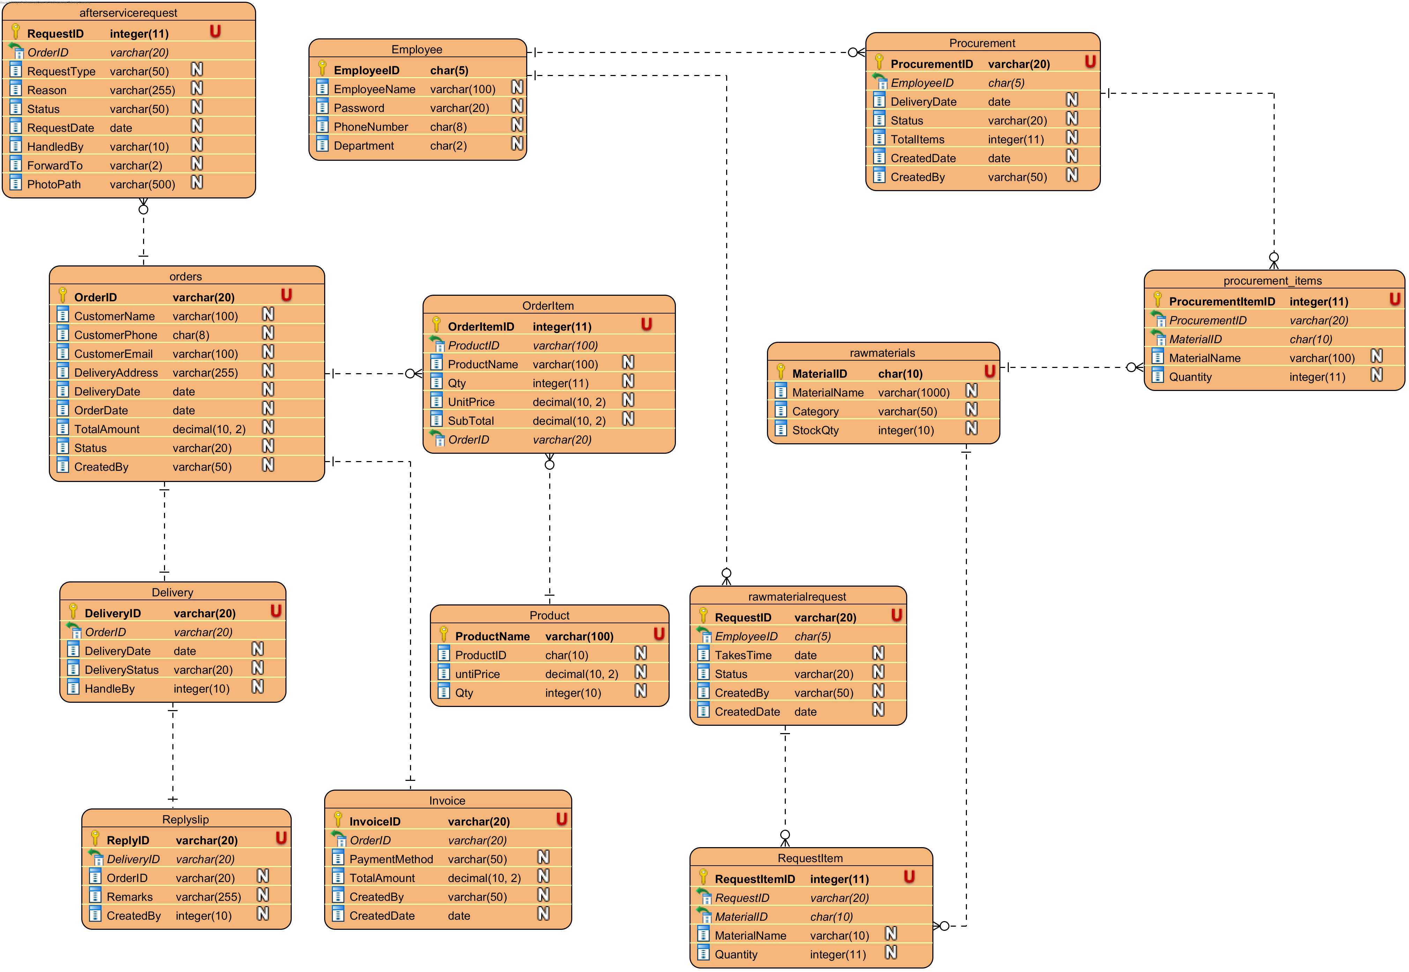

14. Detailed Database Design

Table: Order
Column Name | Datatype | Key? | Null? | Description
OrderID | varchar(20) | PK | No | Order Number
OrderDate | Date |  | No | Create order date
DeliveryDate | Date |  | No | Delivery order date
TotalAmount | Decimal(10,2) |  |  | The total amount of the Order.
Status | Varchar(20) |  | No | Status of the Order  ‘pending’ is waiting to paid  ‘paid’ the customer paid the order  ‘Cancel’ the order is cancel  ‘Delivery’ is delivery  ‘compete’ the order has been completed.
CustomerName | Varchar(100) |  | No | Customer Name
CustomerPhone | Char(8) |  | No | Customer Phone Number
DeliveryAddress | Varchar(255) |  | No | Delivery Address
CreatedBy | Varchar(50) |  | No | Who employee create the order

Table: OrderItem
Column Name | Datatype | Key? | Null? | Description
OrderItemID | Int(11) | PK | No | Each Order item number  use ‘OI’ and 8 number composition
OrderID | Varchar(20) | FK | No | this order item belongs to what order
ProductID | Char(10) | FK | No | Product number
qty | Int(11) |  | No | Order Product quantity
unitPrice | Decimal(10,2) |  | No | Product unit Price
ProductName | Varchar(100) |  | No | Product Name
SubTotal | Decimal(10,2) |  | No | Subtotal Amount (Qty × Unit Price)

Table: Product
Column Name | Datatype | Key? | Null? | Description
ProductID | Char(10) | PK | No | Product Number  use ‘PR’ and 8 number composition
ProductName | Varchar(100) |  | No | The product name
unitPrice | Int(10,2) |  | No | The product until price
Qty | Int(10) |  | No | Product quantity

Table: Invoice
Column Name | Datatype | Key? | Null? | Description
InvoiceID | Varchar(20) | PK | No | Invoice Number  use ‘IV’ and 8 number composition
CreatedDate | Date |  | No | Invoice create date
PaymentMethod | Varchar(50) |  | No | Payment method used
CreatedBy | Varchar(50) |  | No | Employee who created the invoice
total amount | Decimal(10,2) |  | No | order total amount
orderID | Varchar(20) | FK | No | This invoice belongs to what order

Table: Employee
Column Name | Datatype | Key? | Null? | Description
employeeID | char(5) | PK | No | Employee Number
employeeName | Varchar(100) |  | No | Employee name
Password | Varchar(20) |  | No | Log in Password
department | Char(2) |  | No | Employee being what department  ‘SA’-Sales  ‘PR’-Production  ‘IV’-Inventory  ‘LO’-Logistics  ‘FI’-Finance  ‘MA’- Management  ‘CS’ – Customer Service
PhoneNumber | Char(8) |  | No | Employee phone number

Table: delivery
Column Name | Datatype | Key? | Null? | Description
deliveryID | Varchar(20) | PK | No | Delivery Note Number  use ‘DN’ and 8 number composition
deliveryDate | Date |  | No | Delivery Date
status | Char(10) |  | No | Status of delivery  ‘Pemding’ – Delivery is scheduled but not yet started  ‘Delivery’ – Delivery is in transit to customer  ‘Complete’ - Delivery has been successfully completed
orderID | Varchar(20) | FK | No | This delivery belongs to what order
HandledBy | Varchar(20) |  | No | Employee name responsible for the delivery

Table: RawMeterialRequest
Column Name | Datatype | Key? | Null? | Description
RequestID | varchar(20) | PK | No | Request number
EmployeeID | char(5) | FK | No | Employee ID who requested
TakesTime | datetime |  | Yes | Request delivery time
Status | varchar(20) |  | Yes | Status of the request (Pending, Pending-LO)
CreatedBy | varchar(50) |  | Yes | Employee name who created the request
CreatedDate | datetime |  | No | Request creation date and time

Tabl : RawMaterial
Column Name | Datatype | Key | Null | Description
MaterialID | char(10) | PK | No | Material number
MaterialName | varchar(100) |  | No | Name of the material
Category | varchar(50) |  | No | Category of the material (Wood, Metal, Polymer, Material)
StockQty | int(10) |  | No | Current stock quantity

Table: rawmaterialrequestitem
Column Name | Datatype | Key? | Null? | Description
RequestItemID | int(11) | PK | No | Request item number (auto-increment)
RequestID | varchar(20) | FK | No | Request number
MaterialID | char(10) | FK | No | Material number
MaterialName | varchar(100) |  | No | Material name
Quantity | int(11) |  | No | Requested quantity

Table: procurement
Column Name | Datatype | Key? | Null? | Description
ProcurementID | varchar(20) | PK | No | Procurement number
EmployeeID | char(5) | FK | No | Employee ID responsible
DeliveryDate | datetime |  | No | Expected delivery date
Status | varchar(20) |  | No | Status of the procurement
TotalItems | int(11) |  | No | Total number of items in the procurement
CreatedDate | datetime |  | No | Procurement creation date and time
CreatedBy | varchar(50) |  | No | Employee name who created the procurement

Table: procurement_items
Column Name | Datatype | Key? | Null? | Description
ProcurementItemID | int(11) | PK | No | Procurement item number
ProcurementID | varchar(20) | FK | No | Belong what procurement number
MaterialID | char(10) | FK | No | Material number
MaterialName | varchar(100) |  | No | Material name
Quantity | int(11) |  | No | Procurement quantity

Table: replyslip
Column Name | Datatype | Key? | Null? | Description
ReplyID | varchar(20) | PK | No | Reply slip number
DeliveryID | varchar(20) | FK | No | belong to what delivery number
OrderID | varchar(20) | FK | No | belong to what order number
Remarks | text |  | Yes | Additional remarks or notes
CreatedBy | varchar(50) |  | Yes | Employee who created the reply slip

Table: afterservicerequest
Column Name | Datatype | Key? | Null? | Description
RequestID | int(11) | PK | No | Request number
OrderID | varchar(20) | FK | No | Belong what order number
RequestType | varchar(50) |  | Yes | Type of request
Reason | text |  | Yes | Reason for the request
Status | varchar(50) |  | Yes | Status of the request
RequestDate | datetime |  | Yes | Request creation date and time
HandledBy | varchar(100) |  | Yes | Employee name handling the request
ForwardTo | varchar(2) |  | Yes | Department code to forward to (CS, SA, LO, FI, PR, )
PhotoPath | varchar(500) |  | Yes | Path to uploaded photos

15. User Interface and Report Design

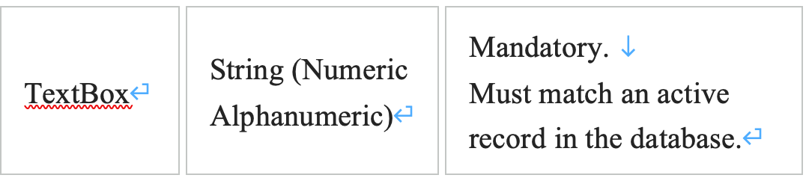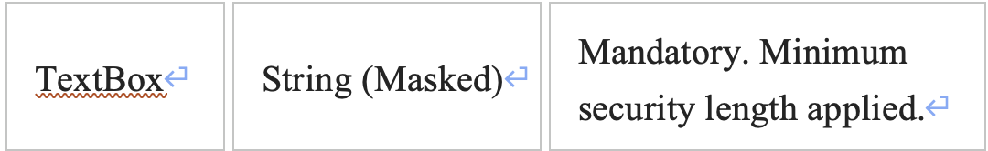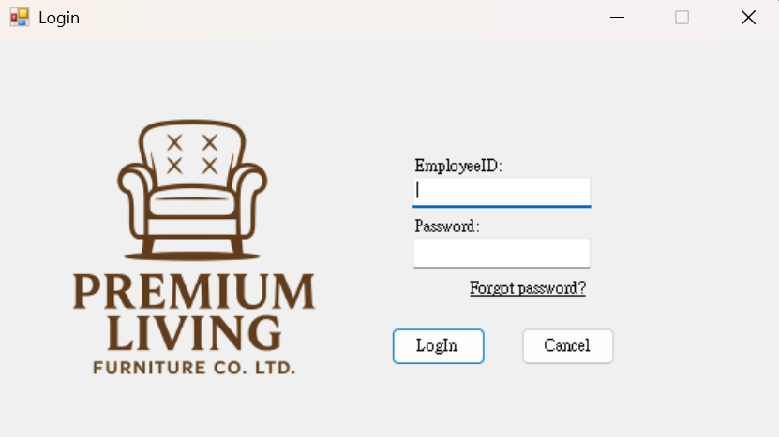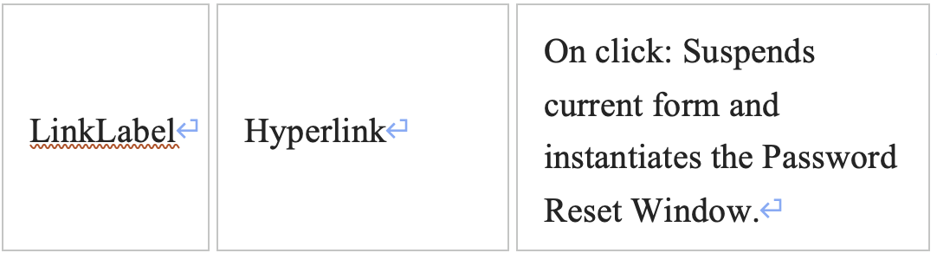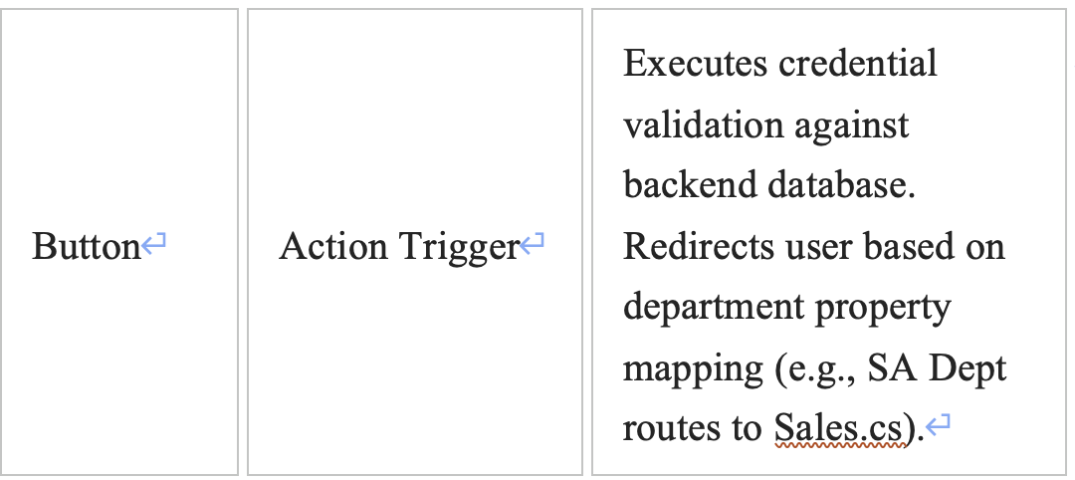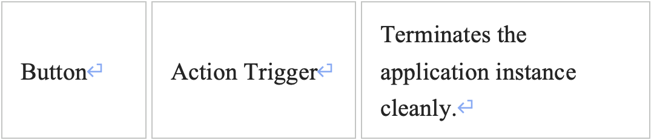

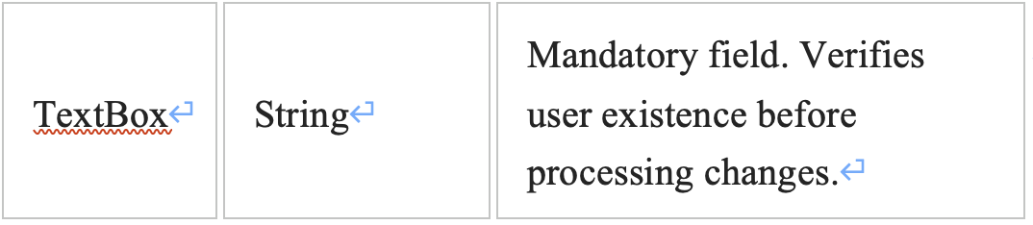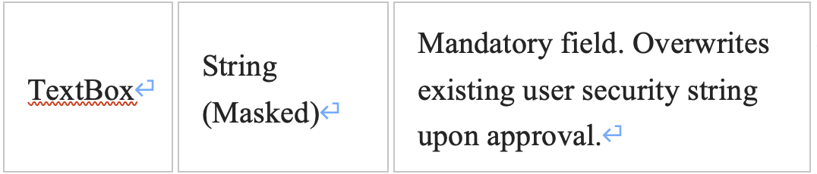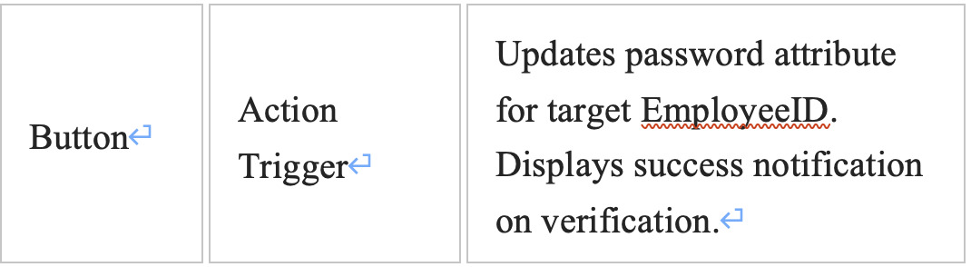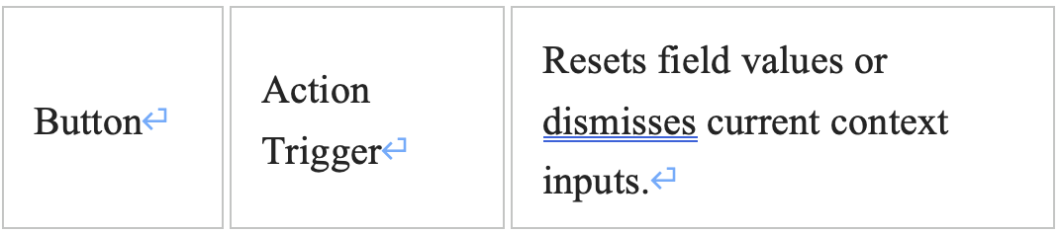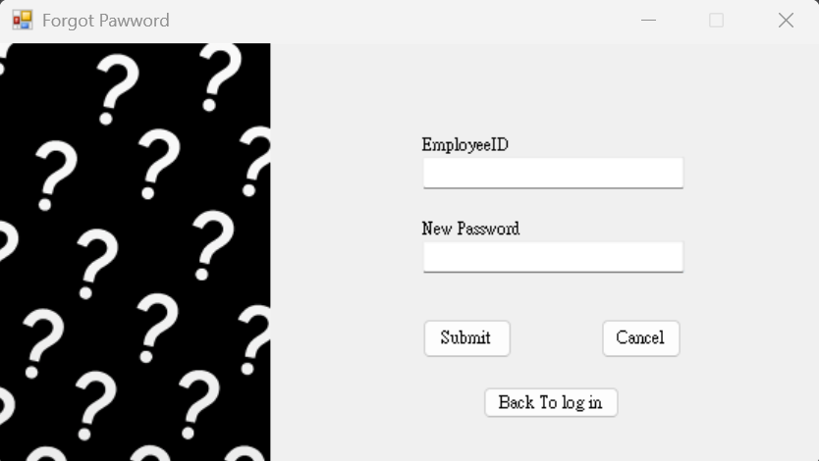
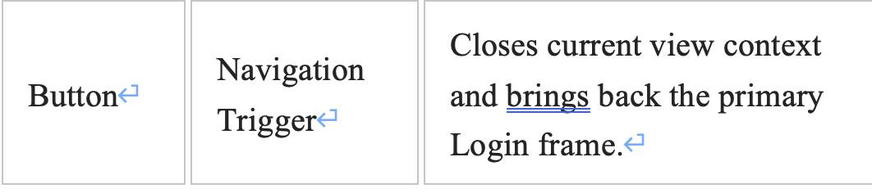

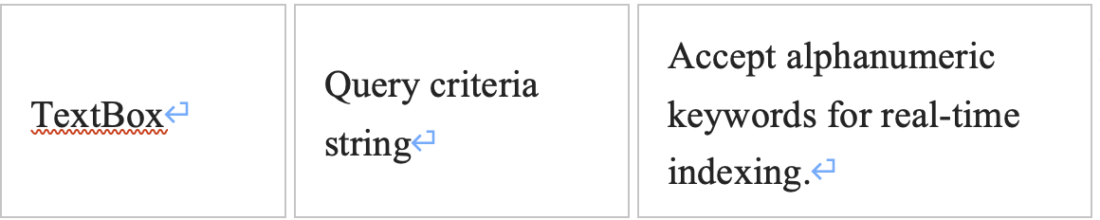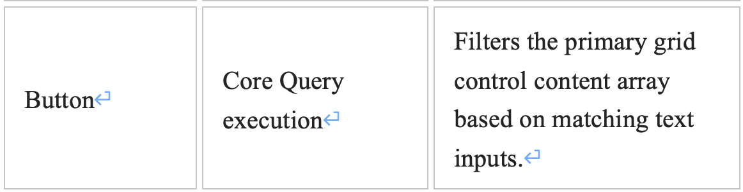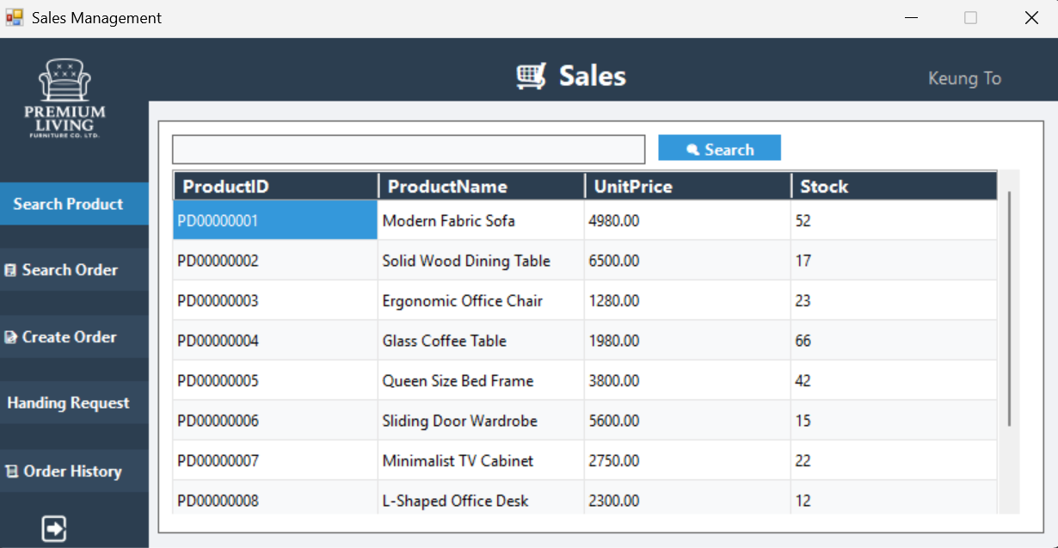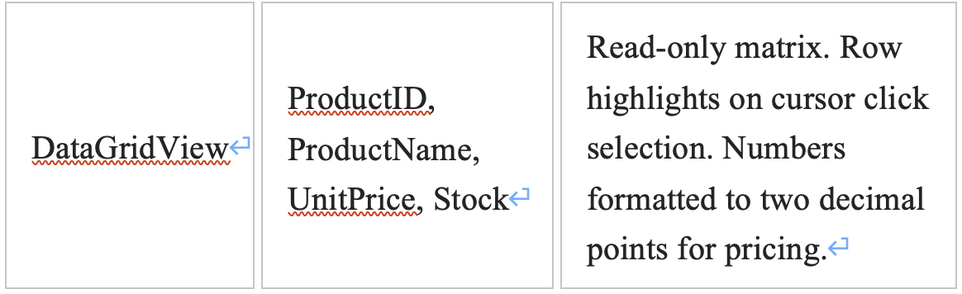

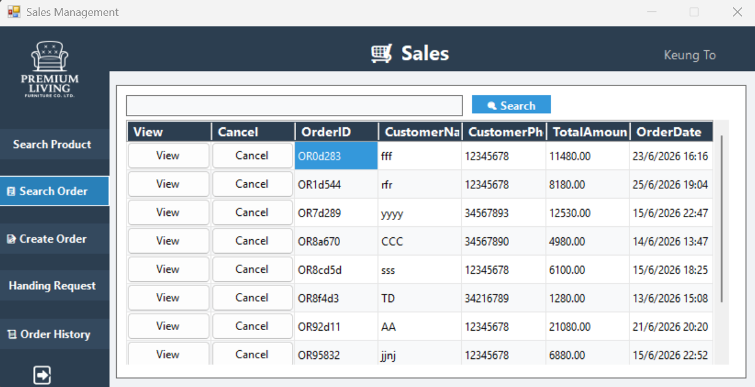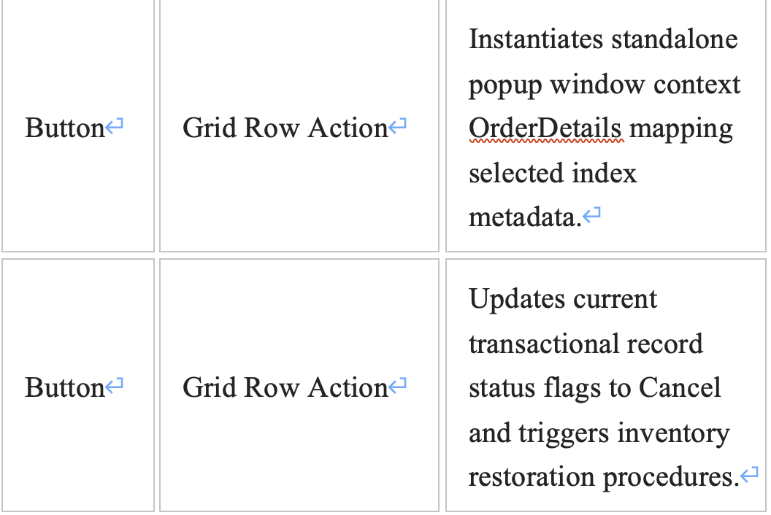

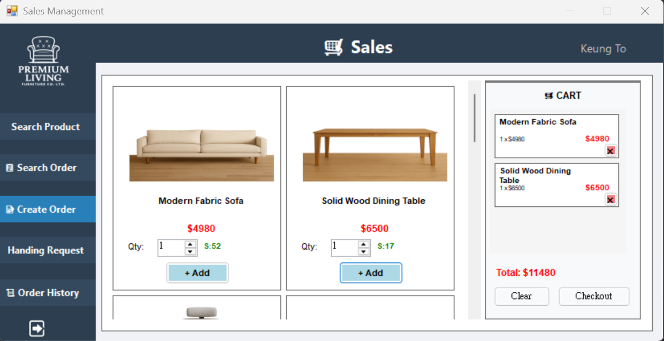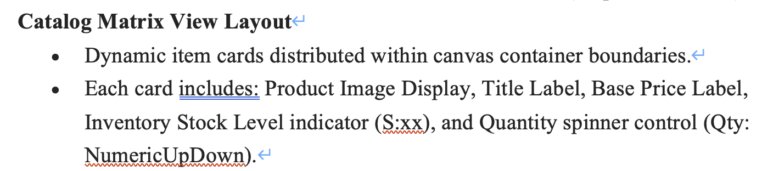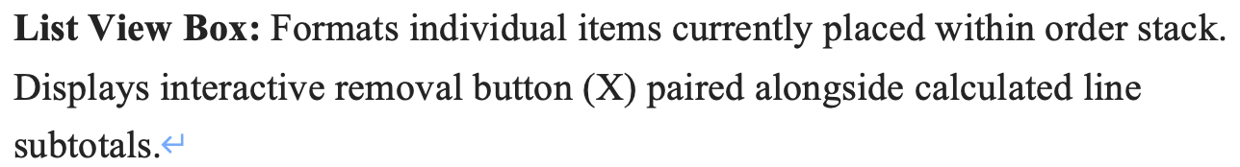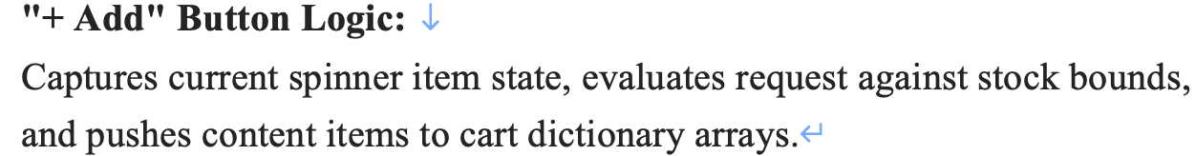 .
. 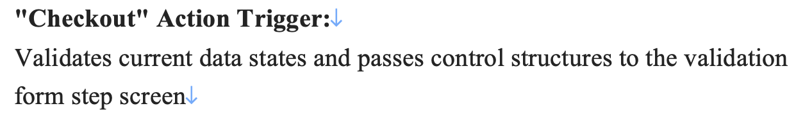

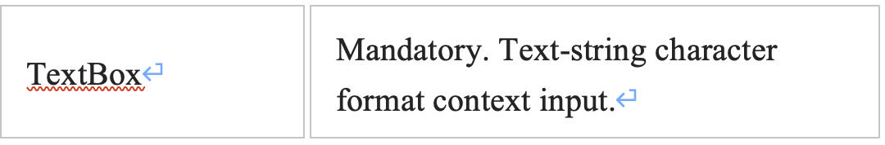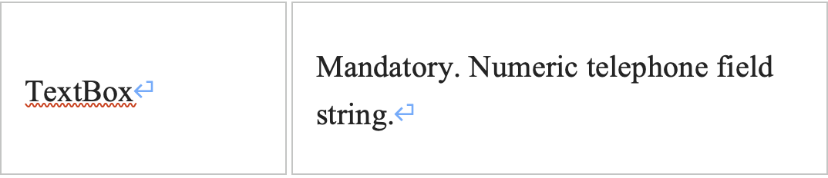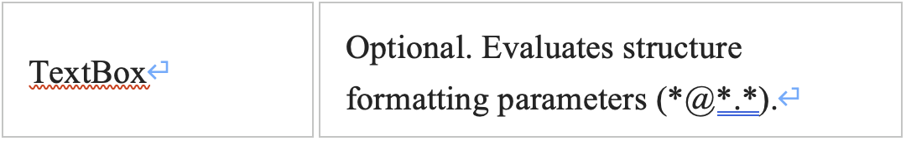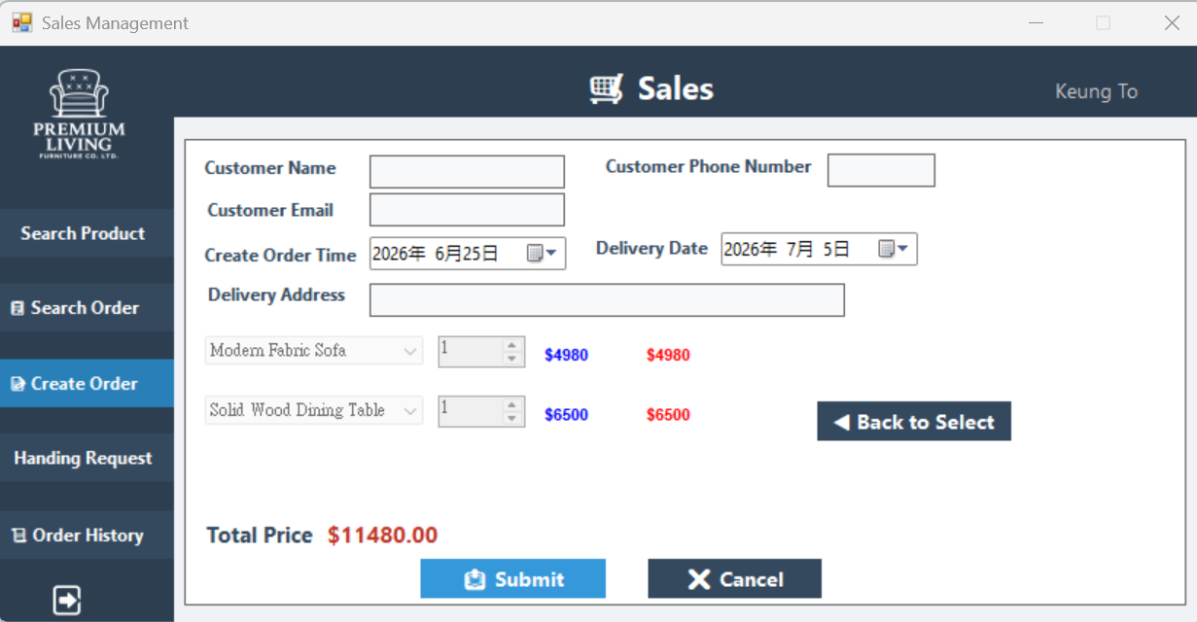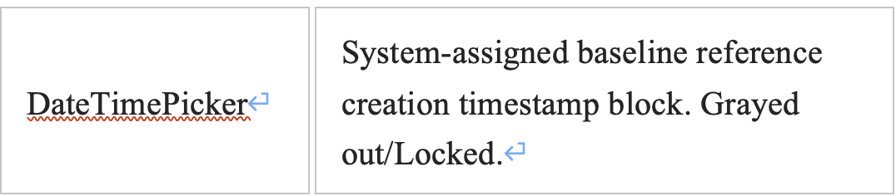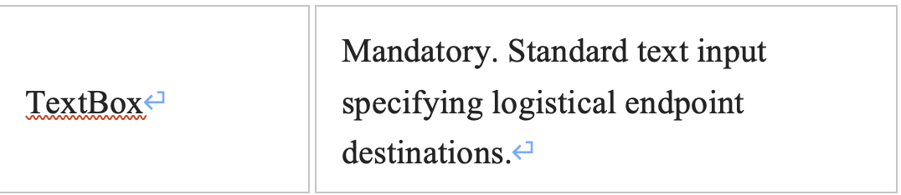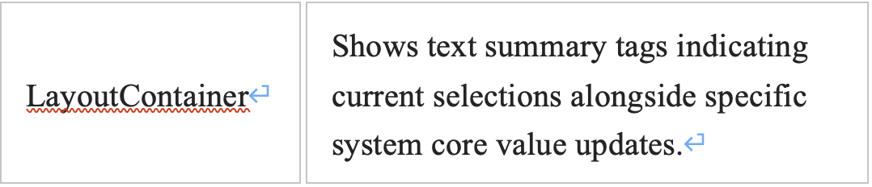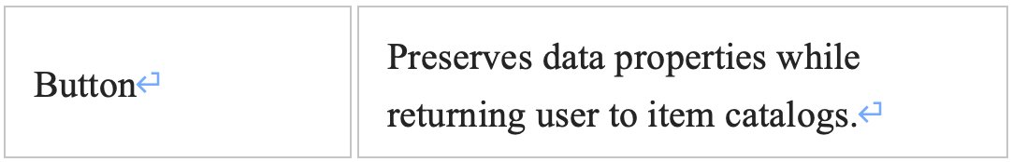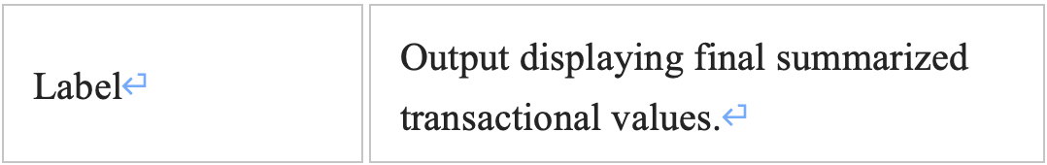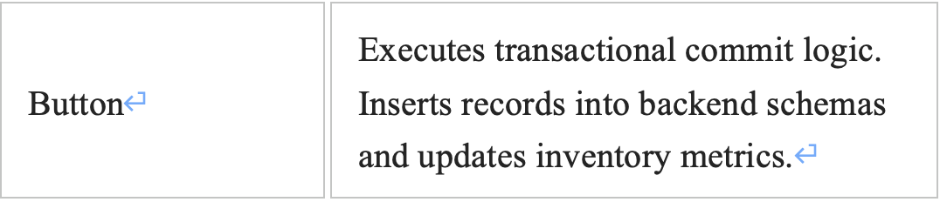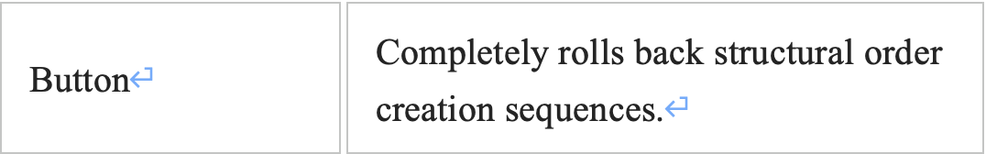

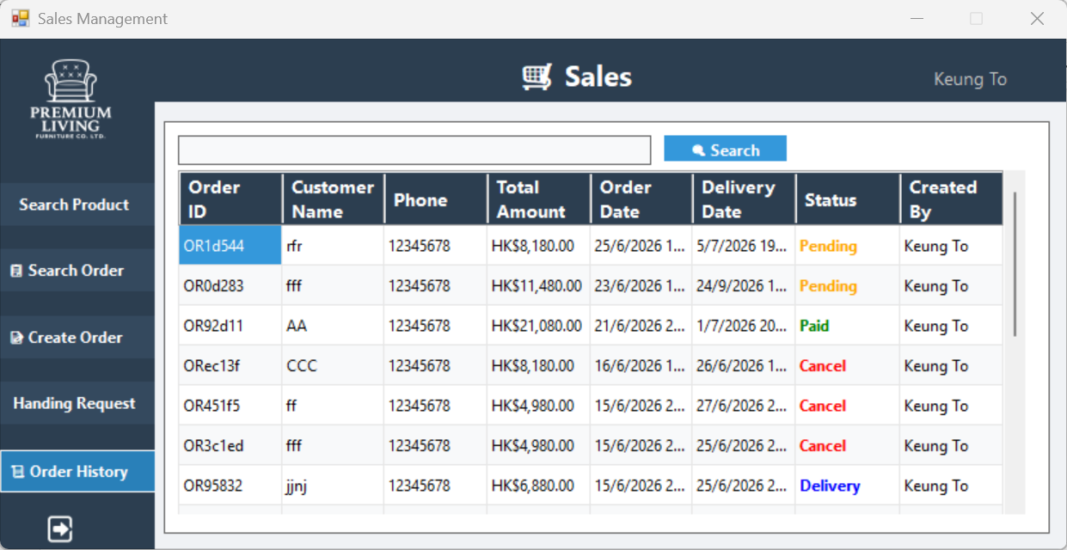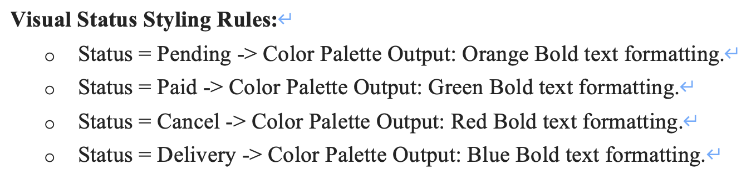

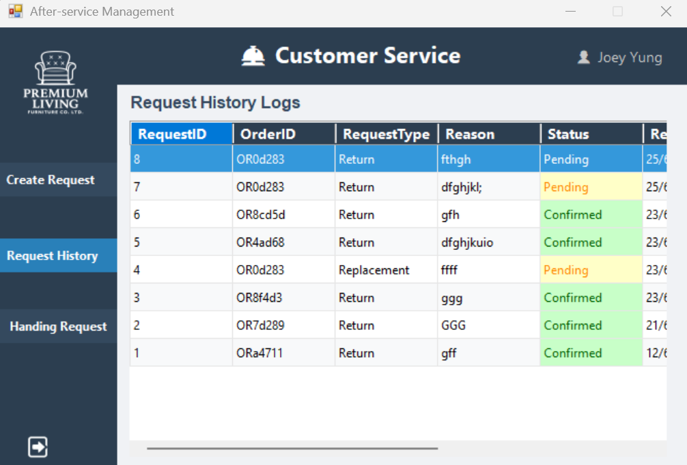

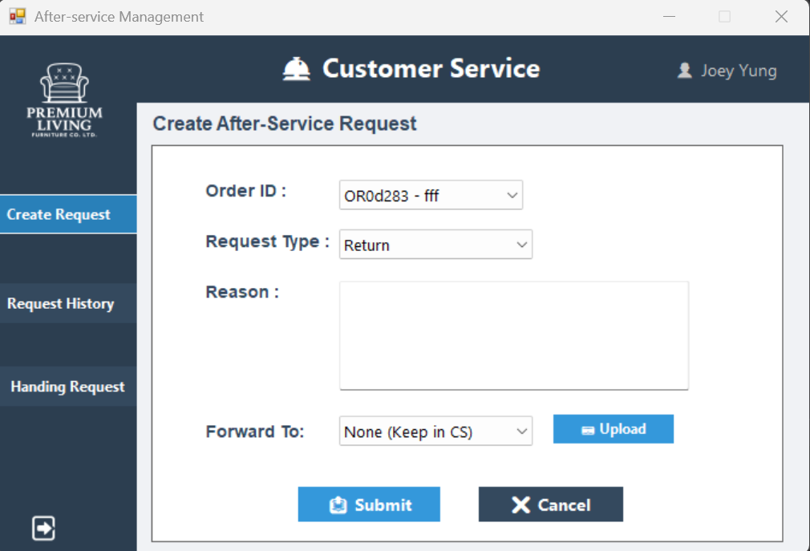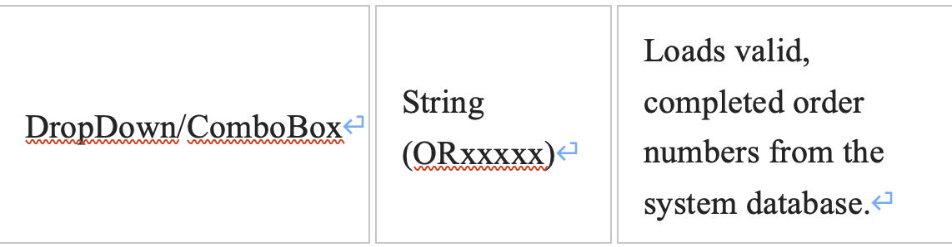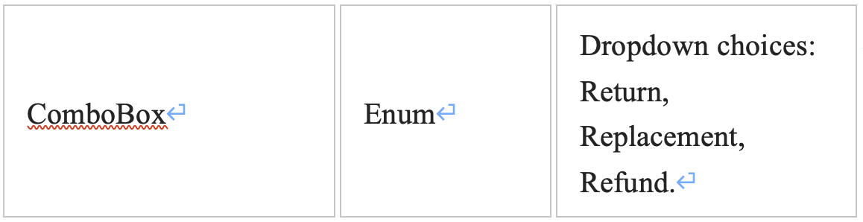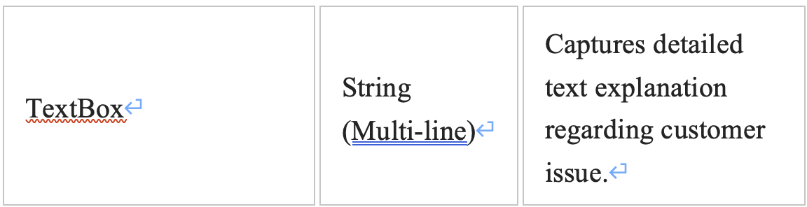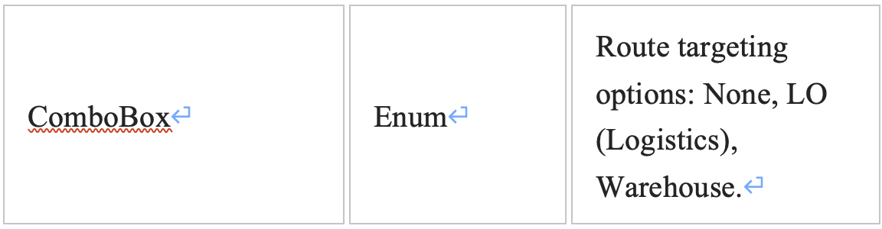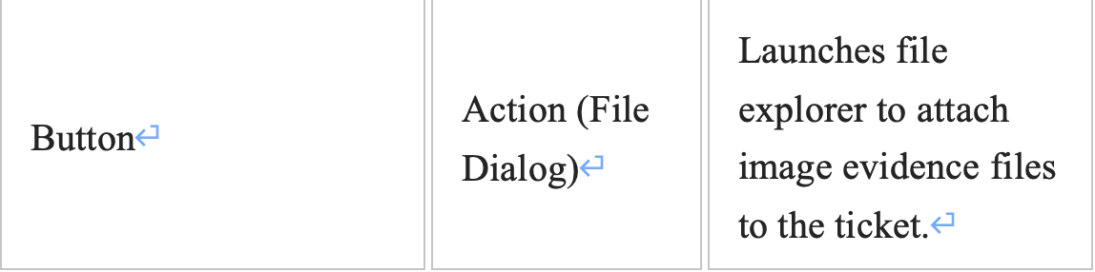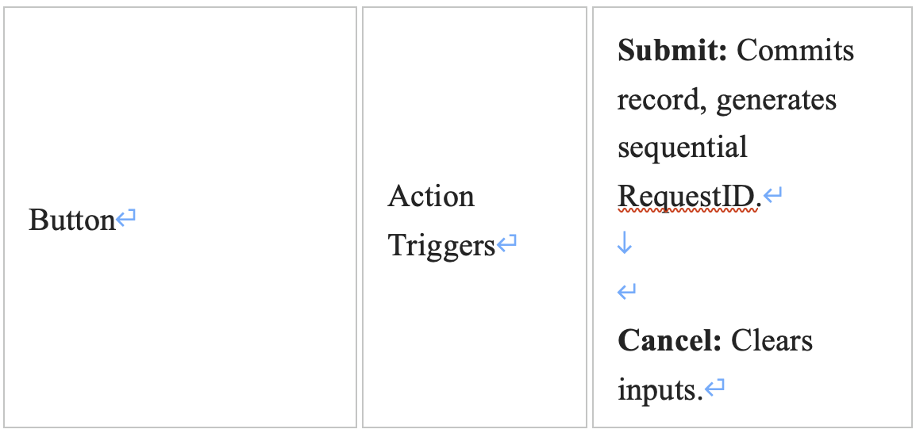

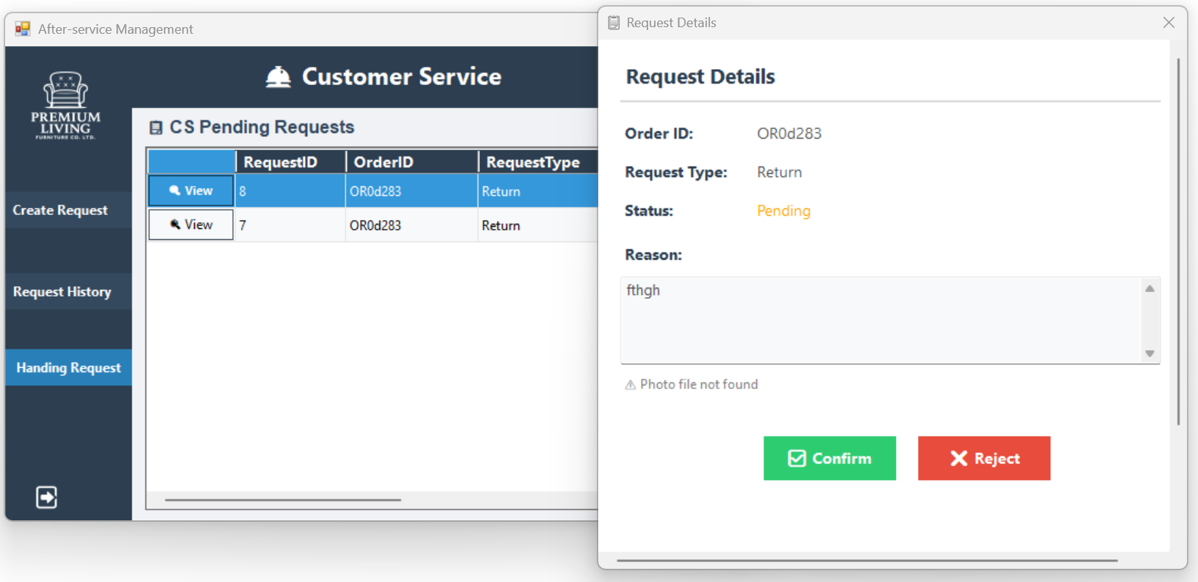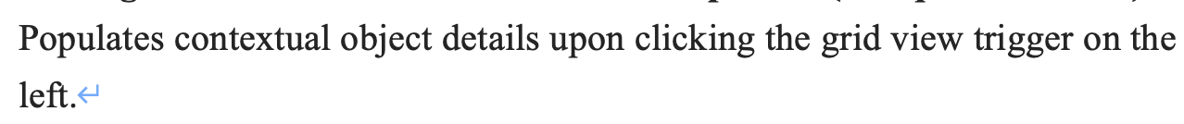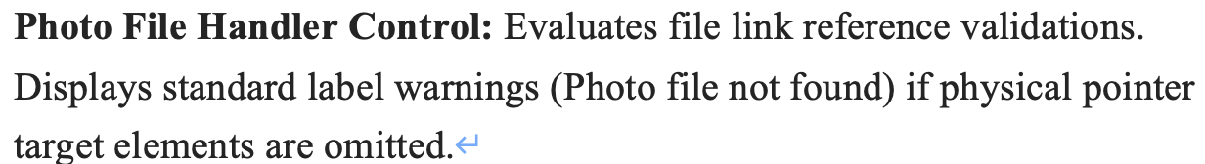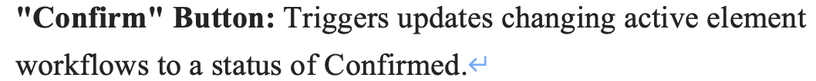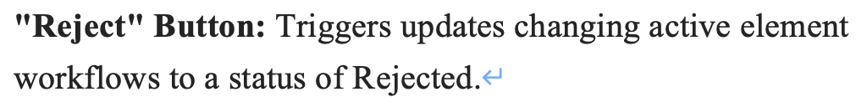

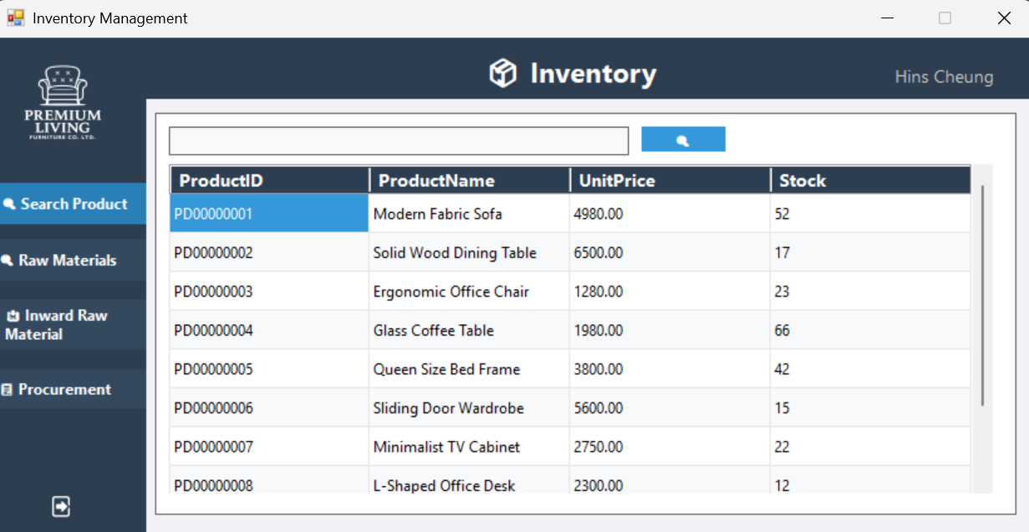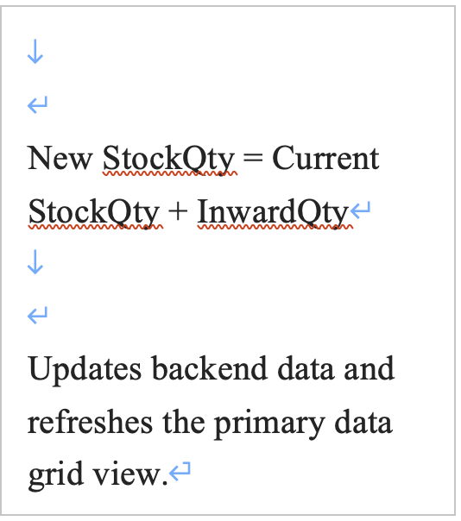

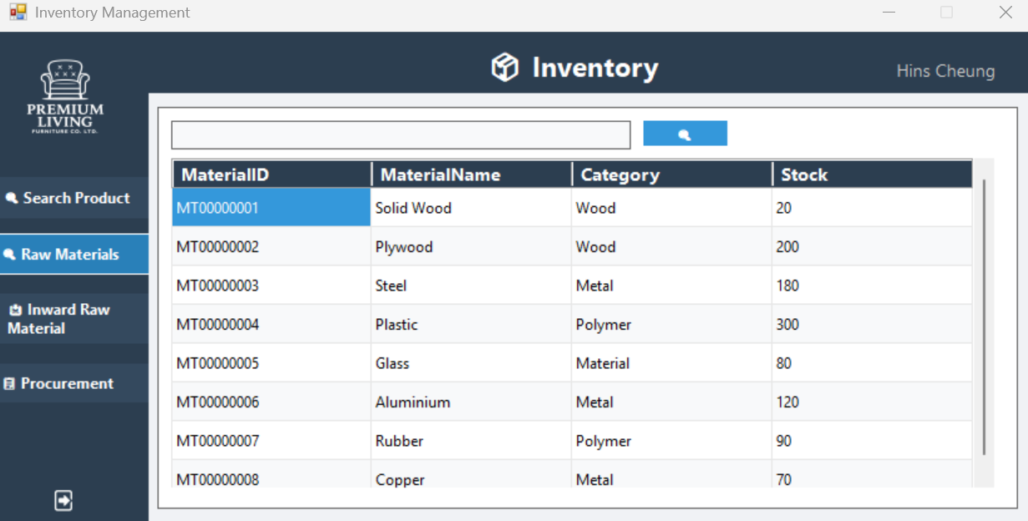

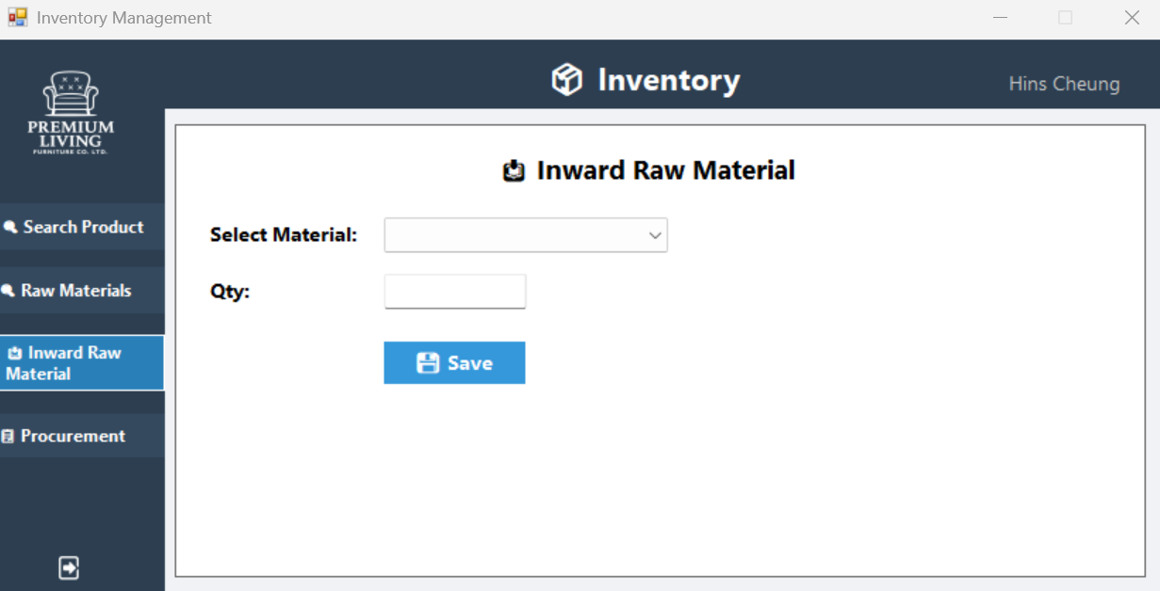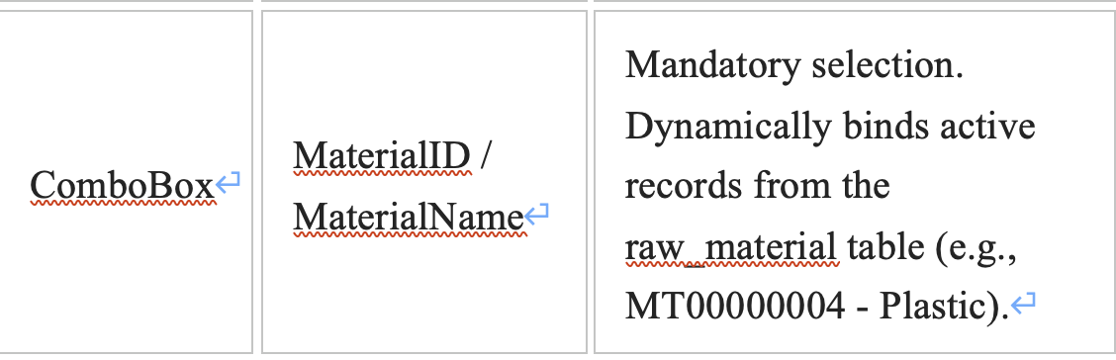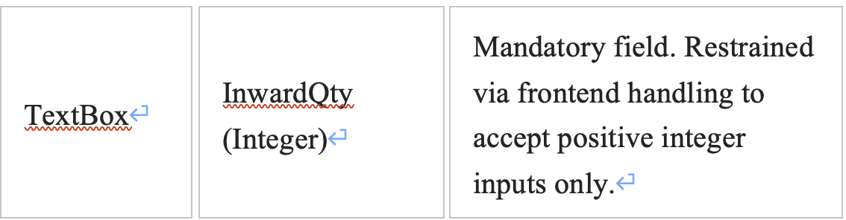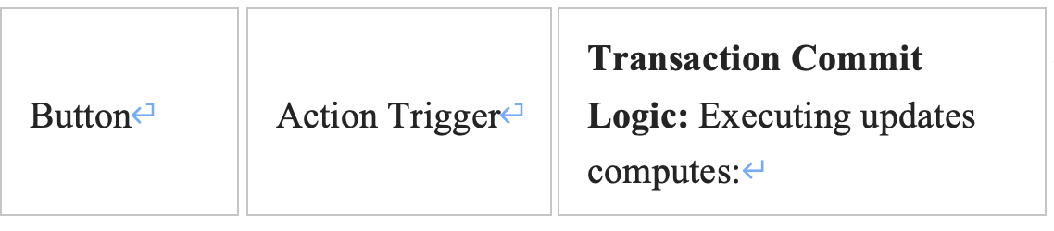

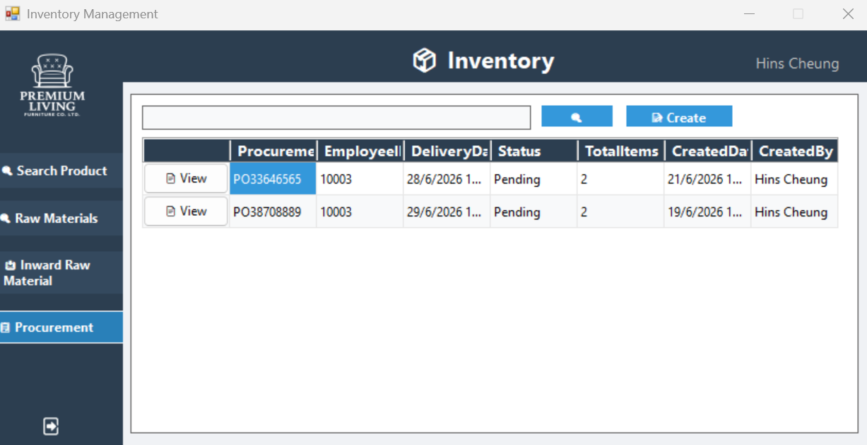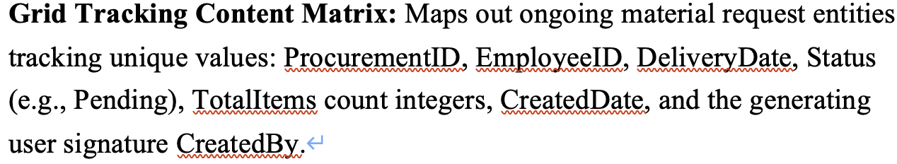

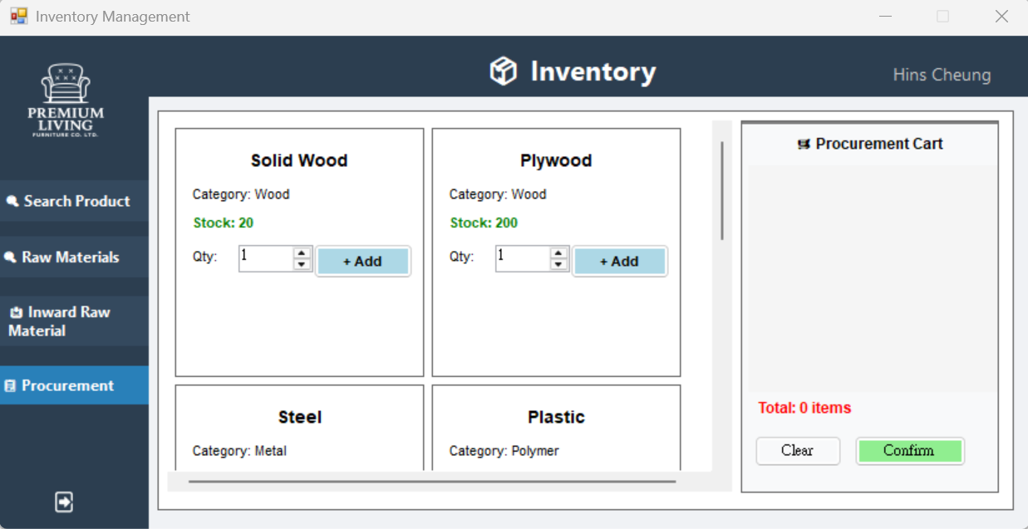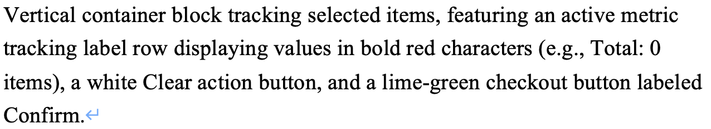

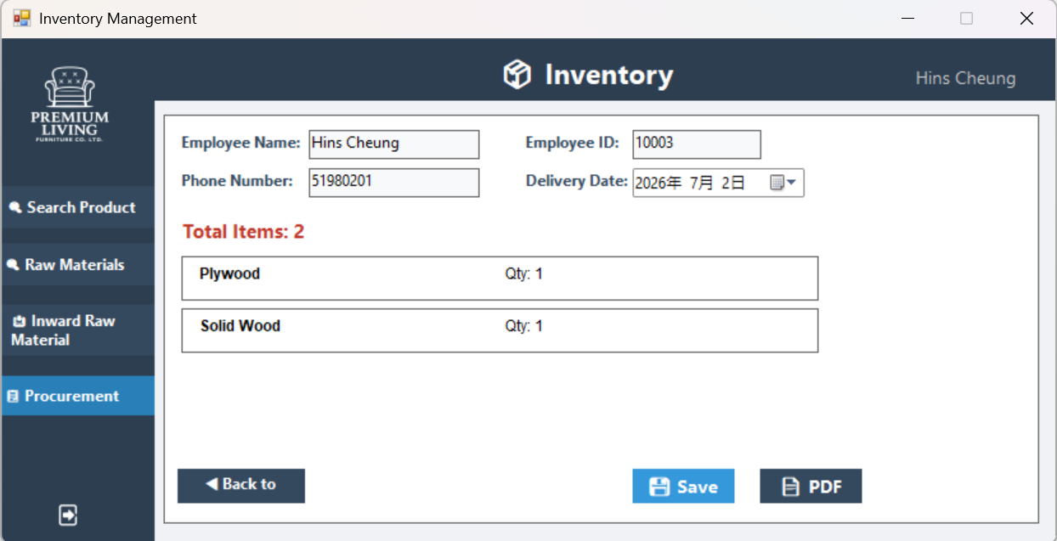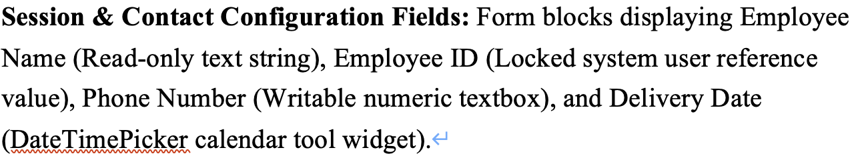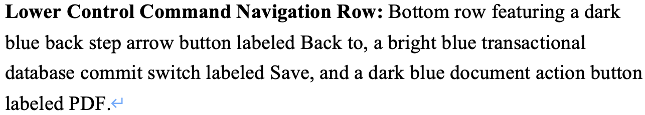

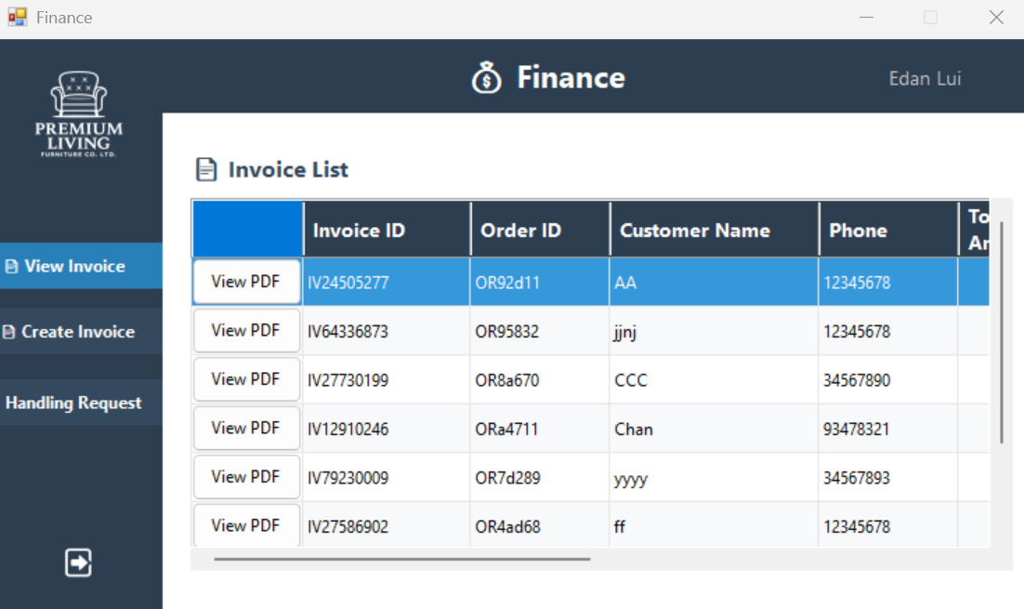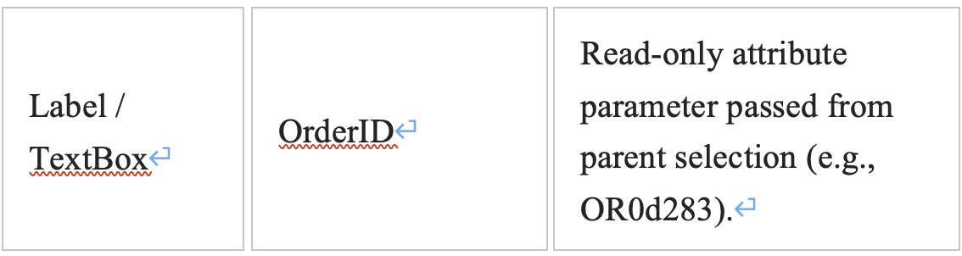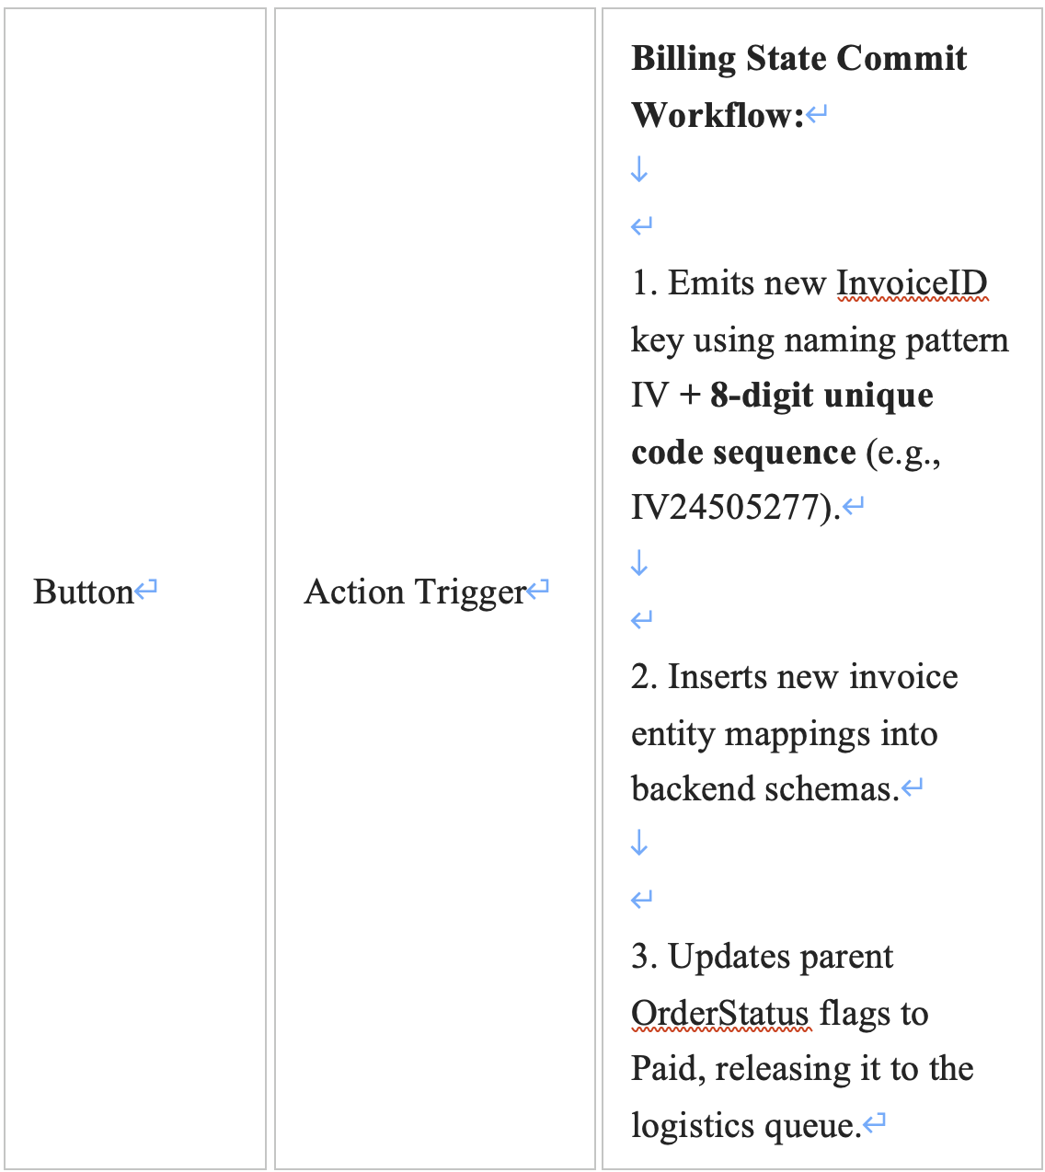

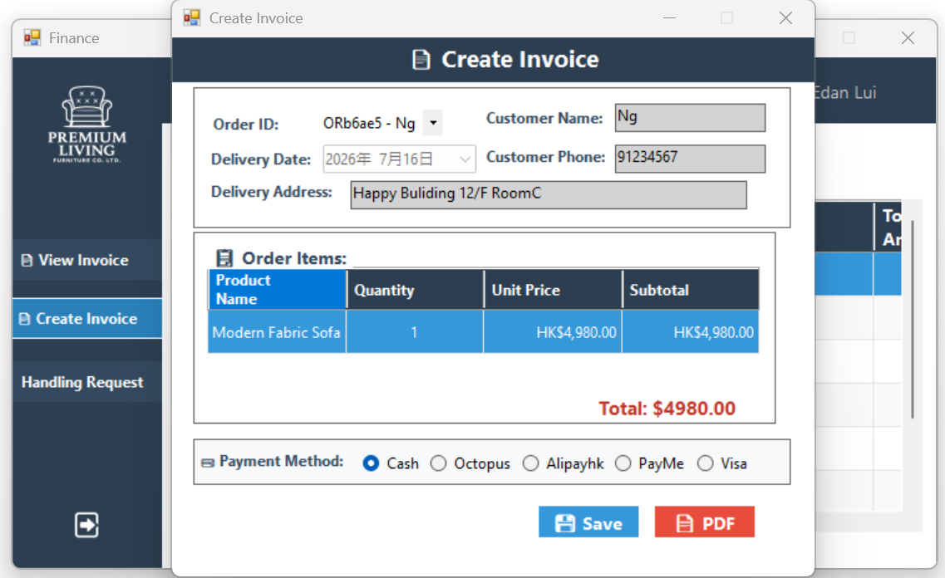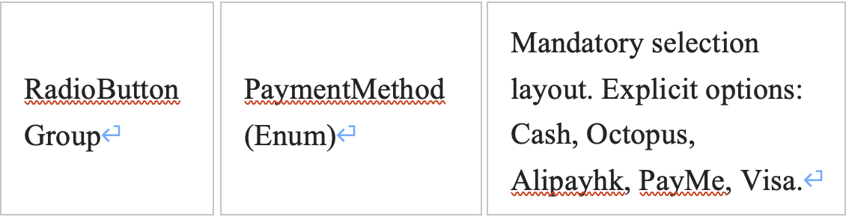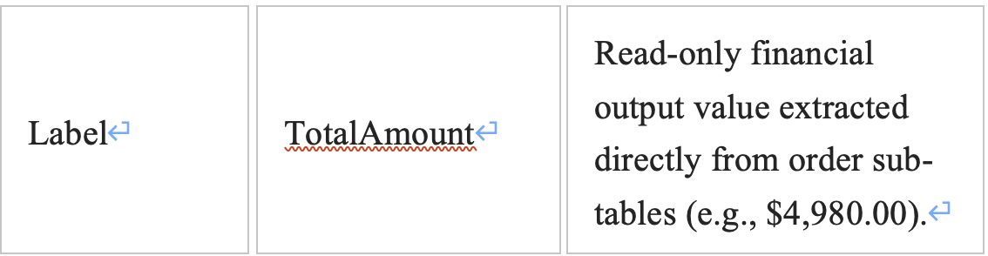

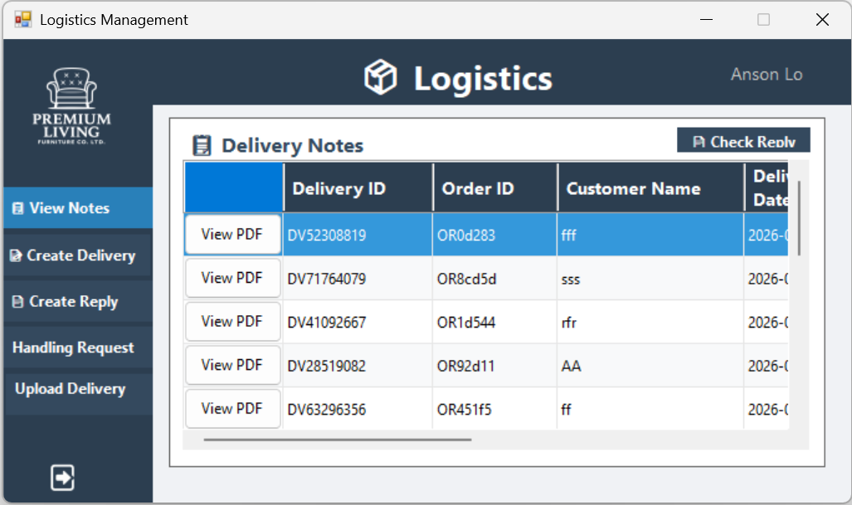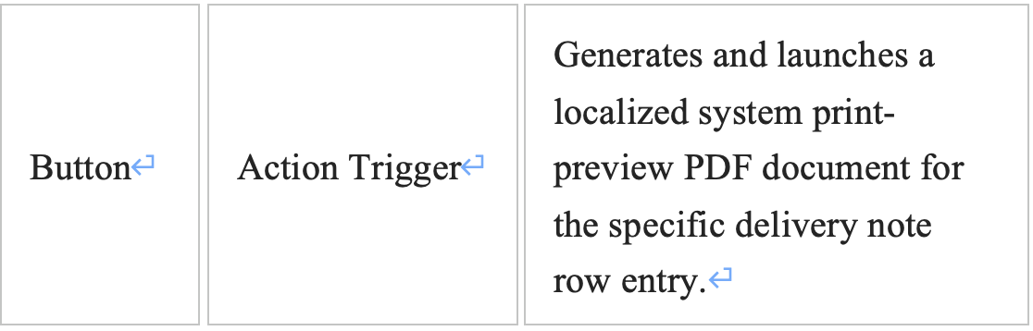

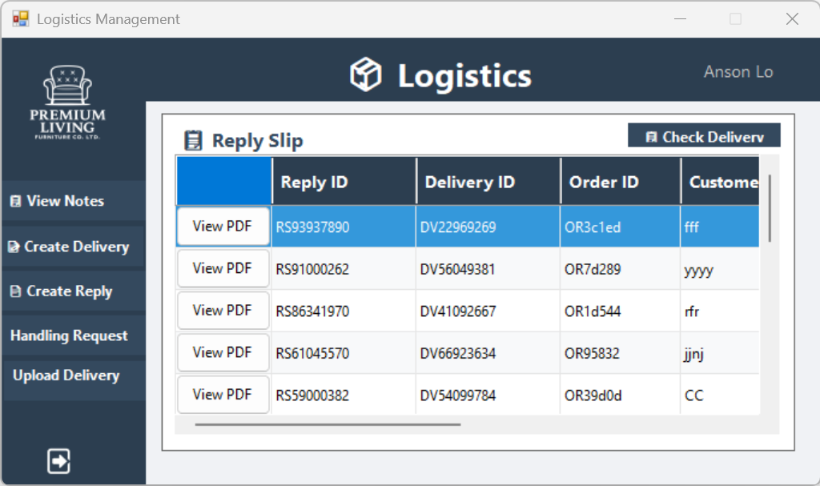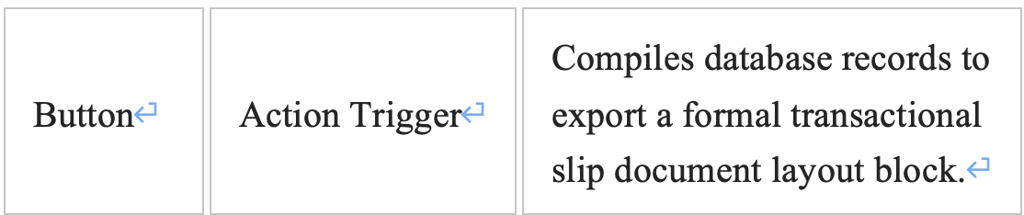

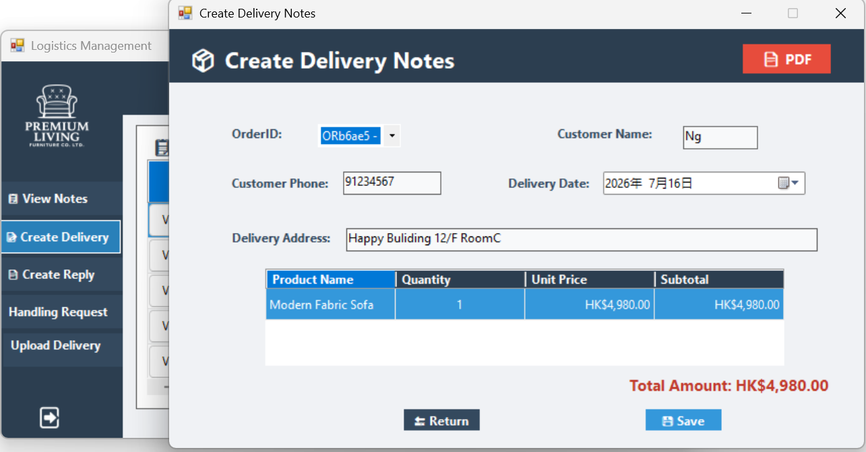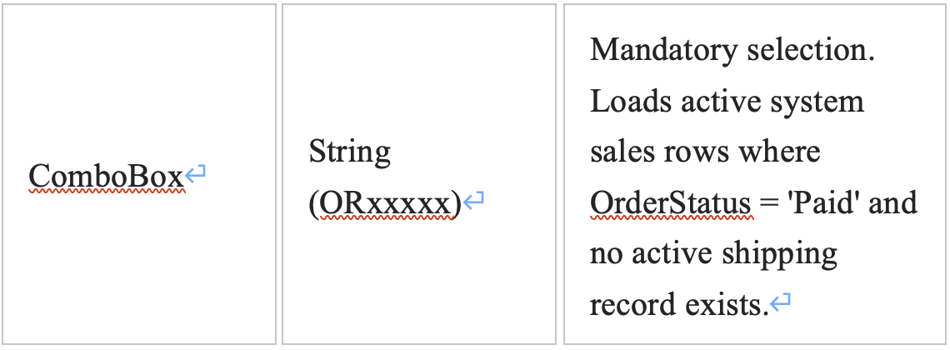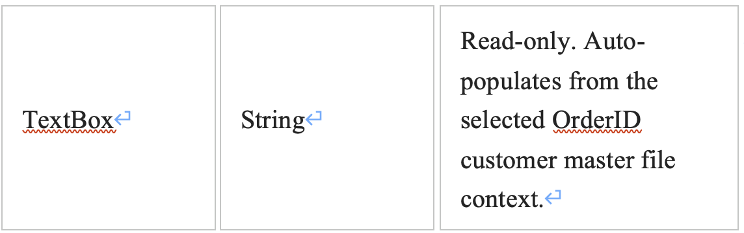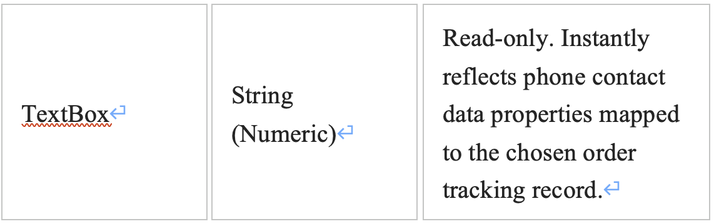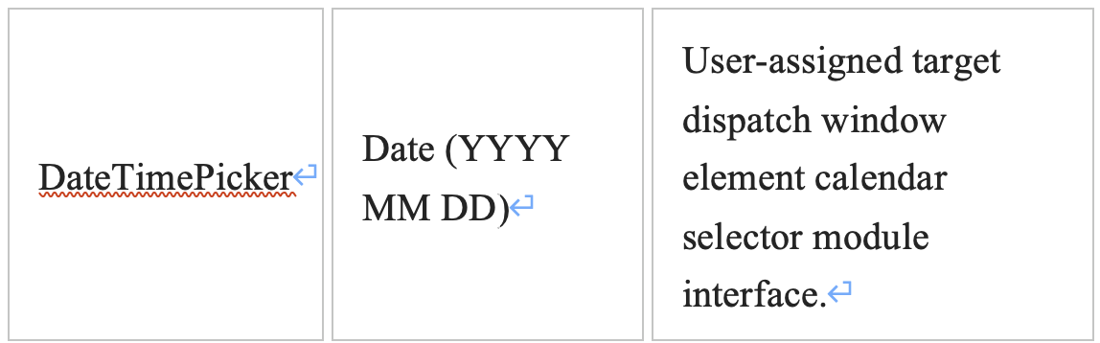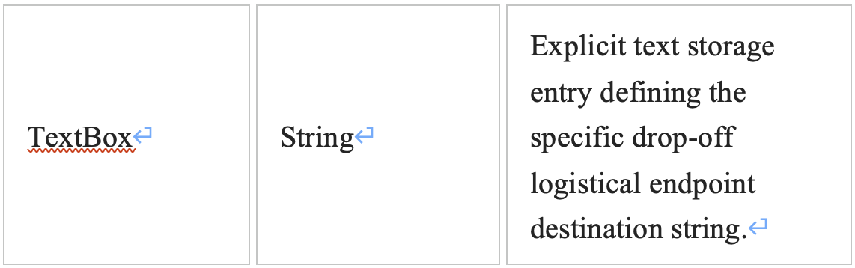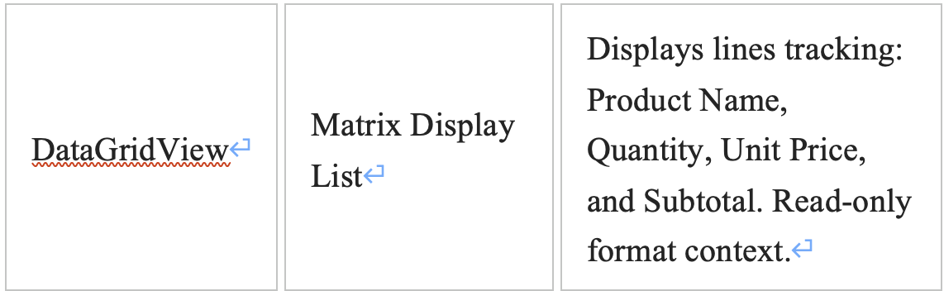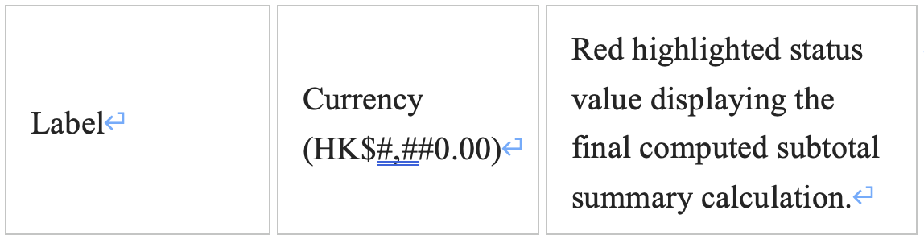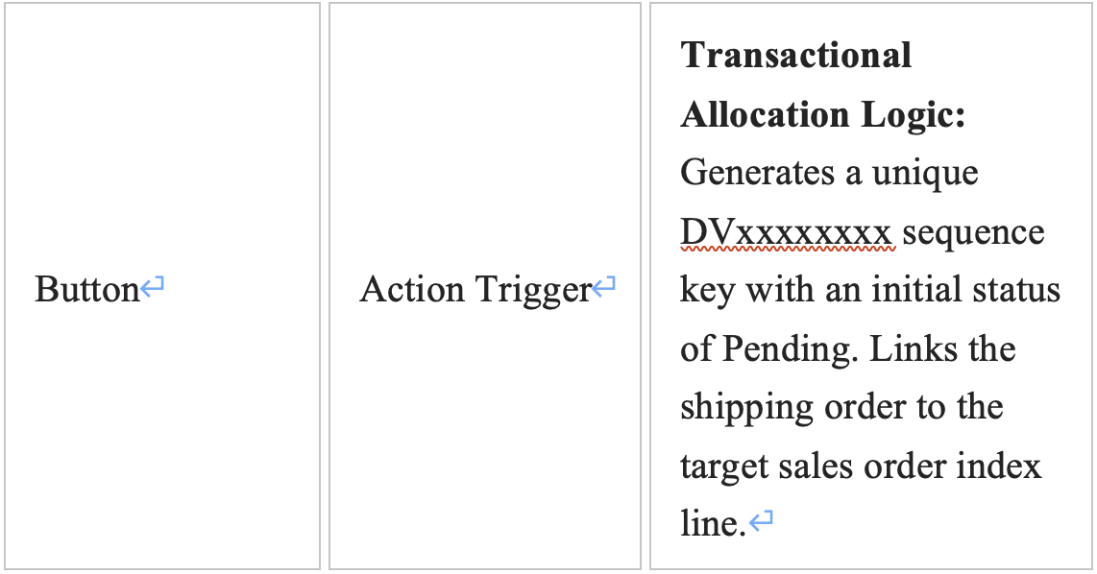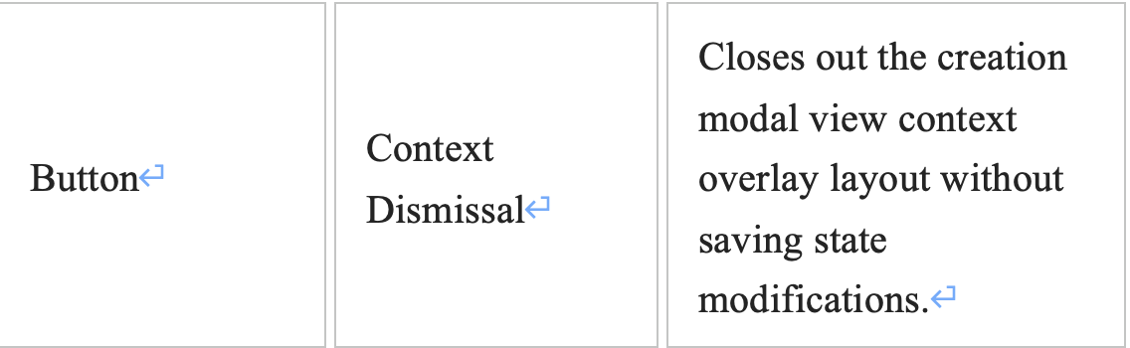

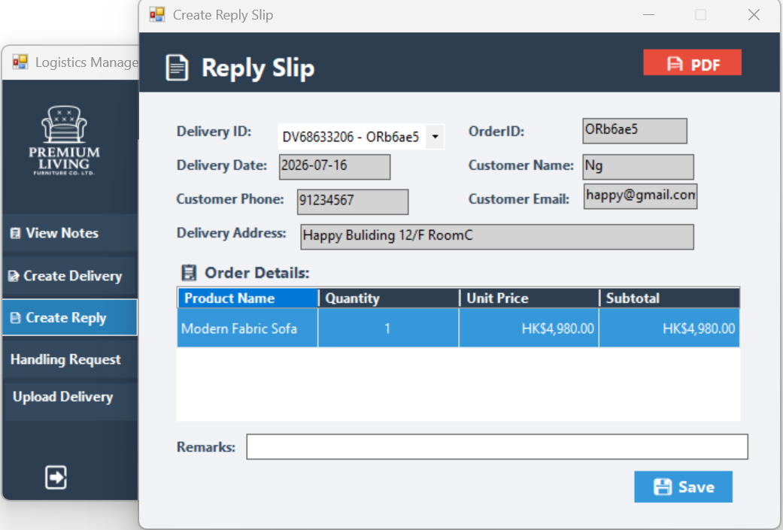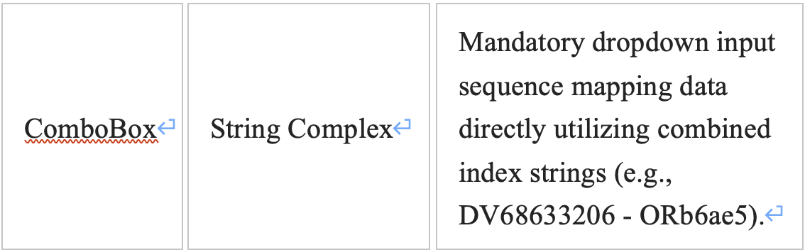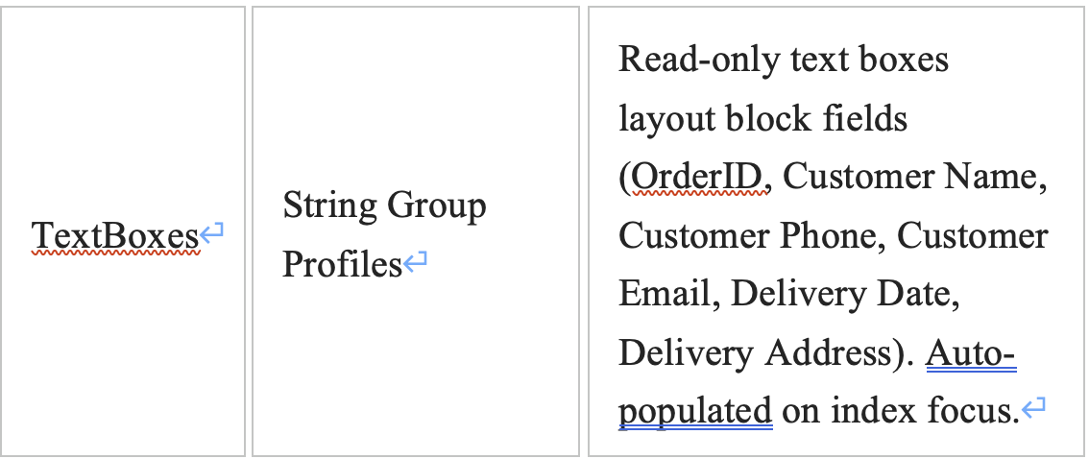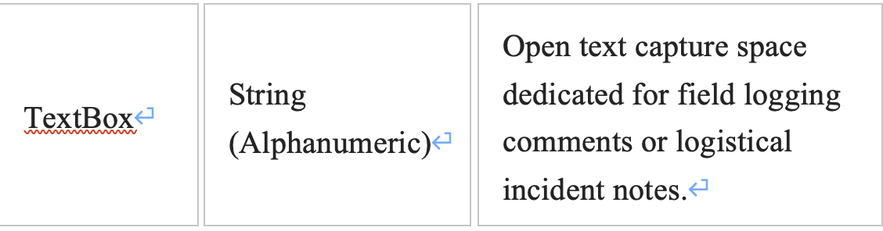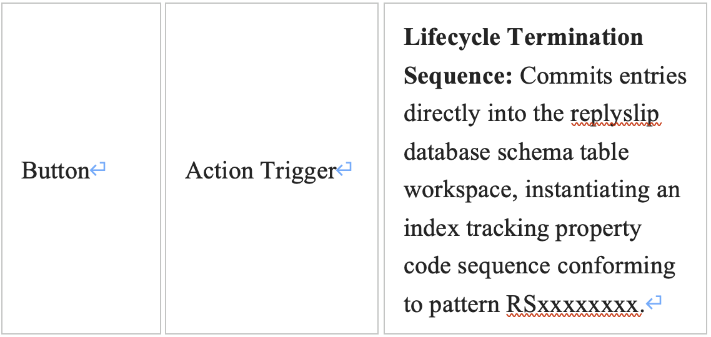

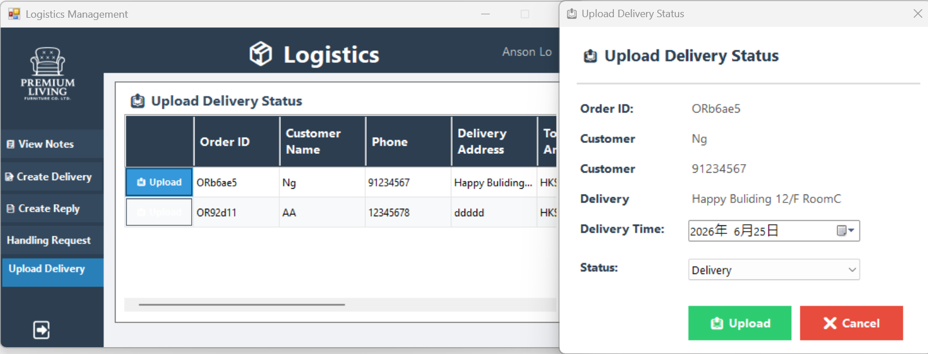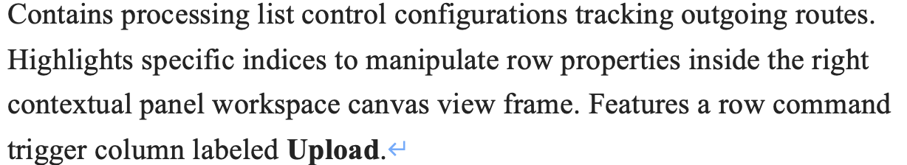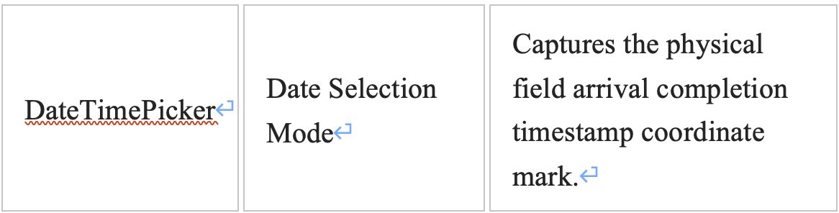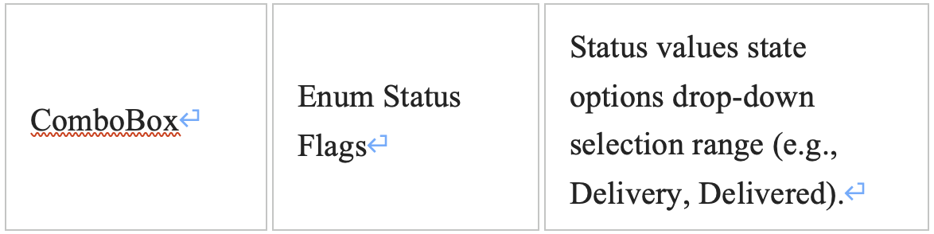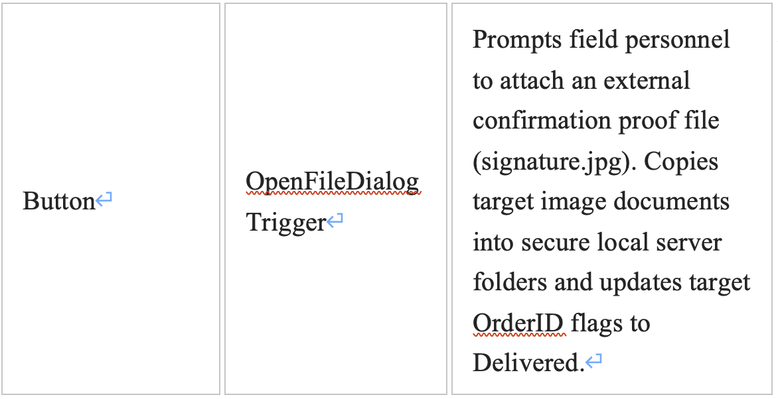

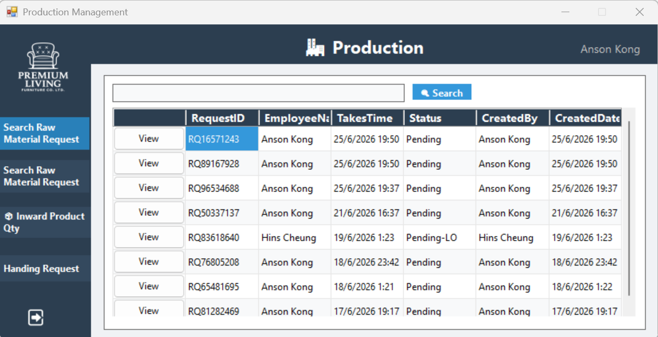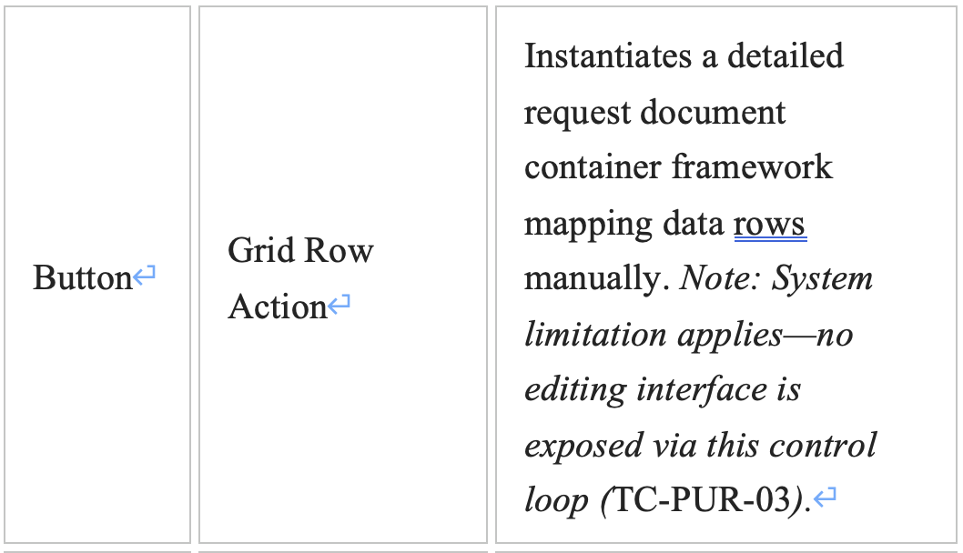

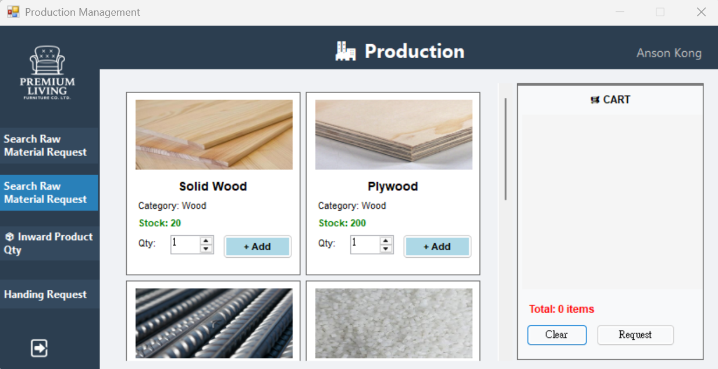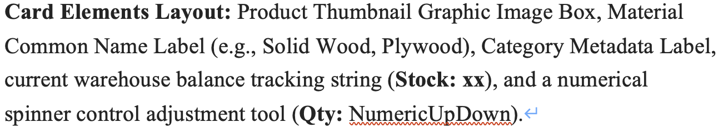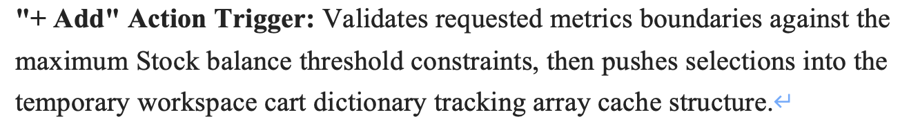

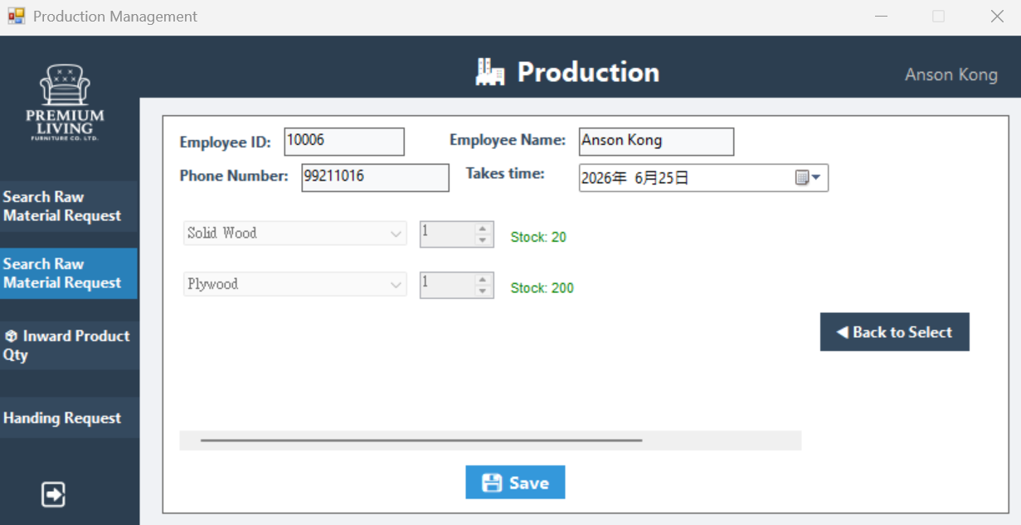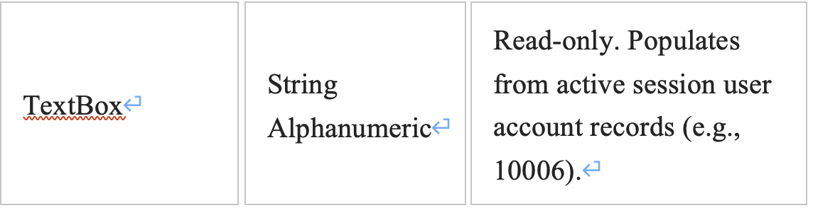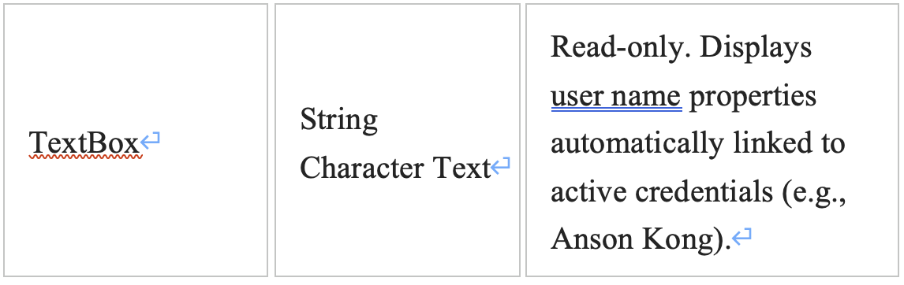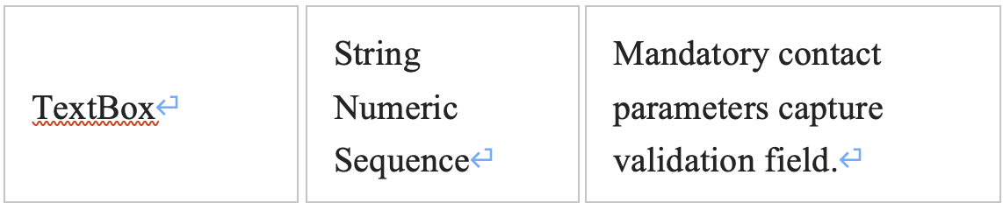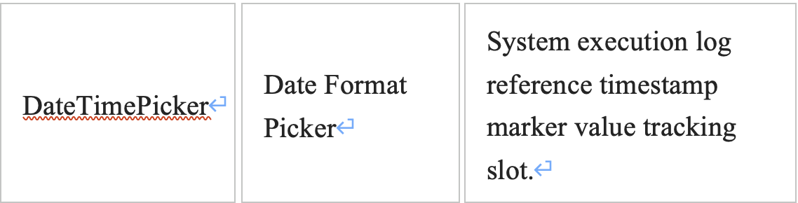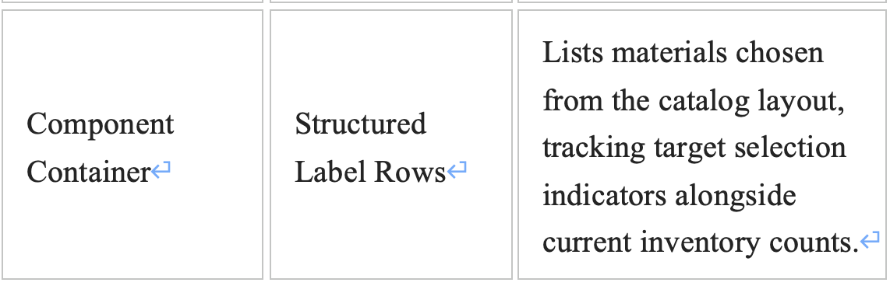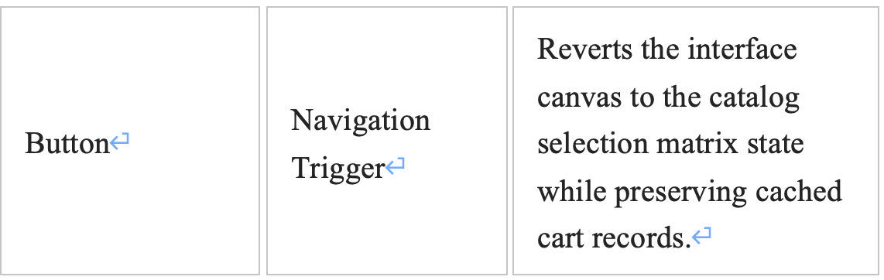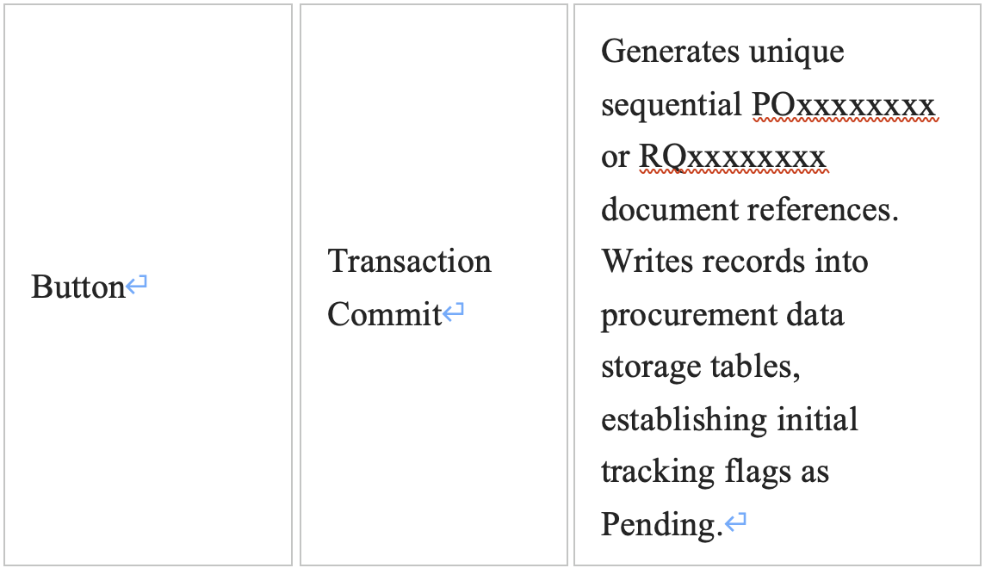

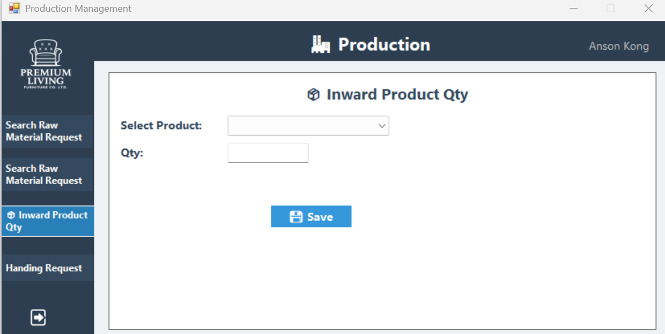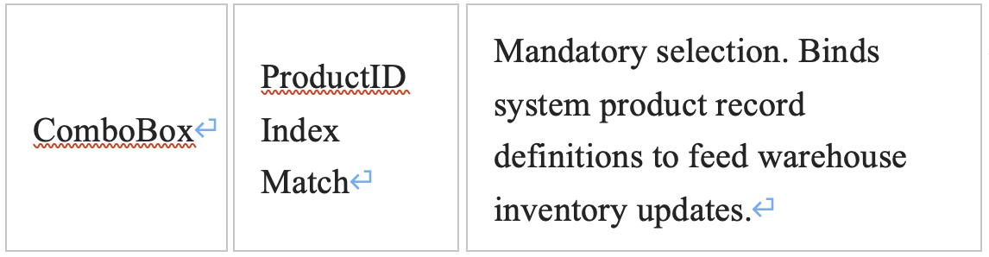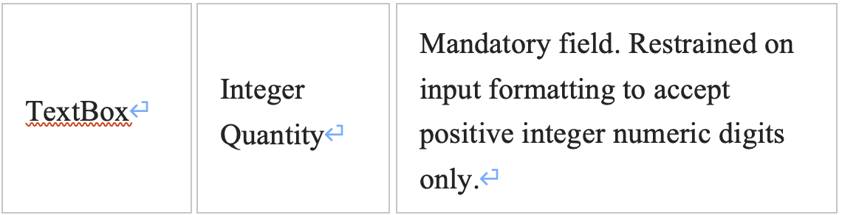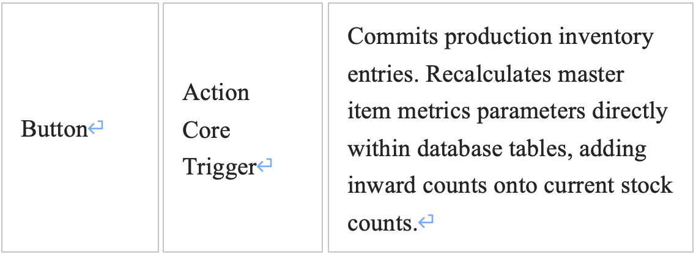

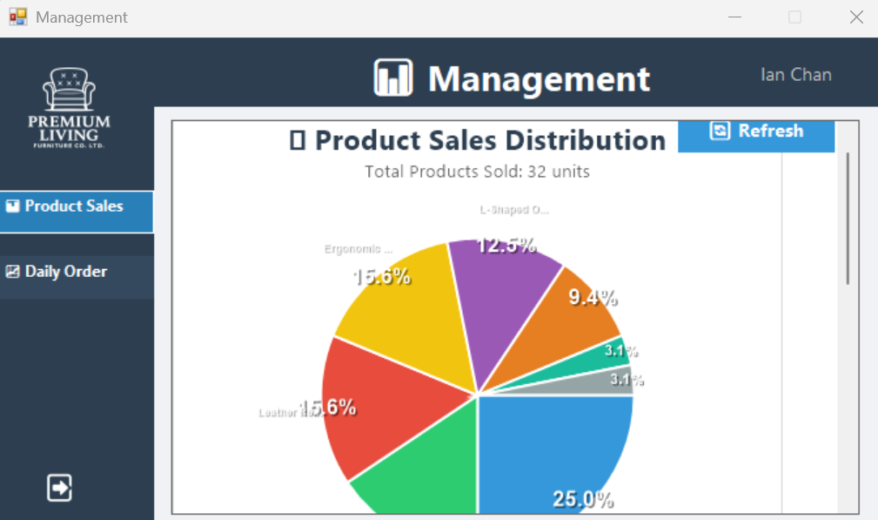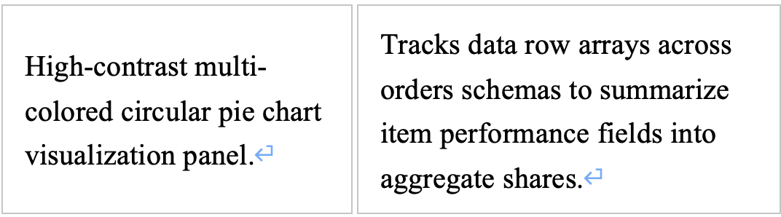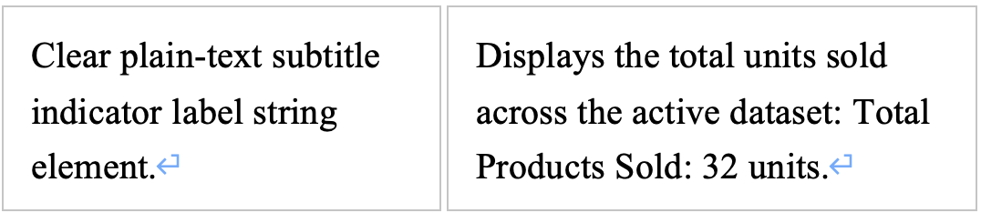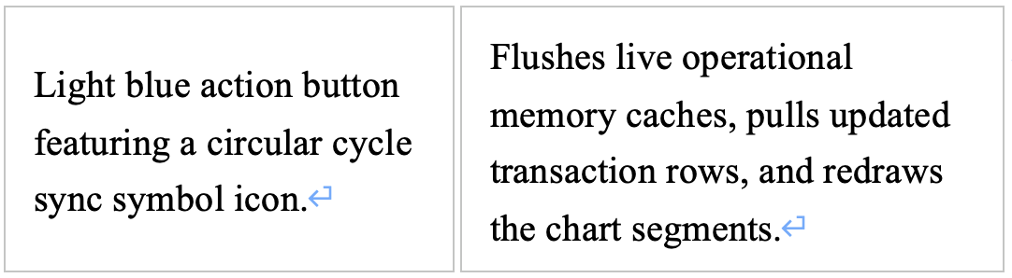

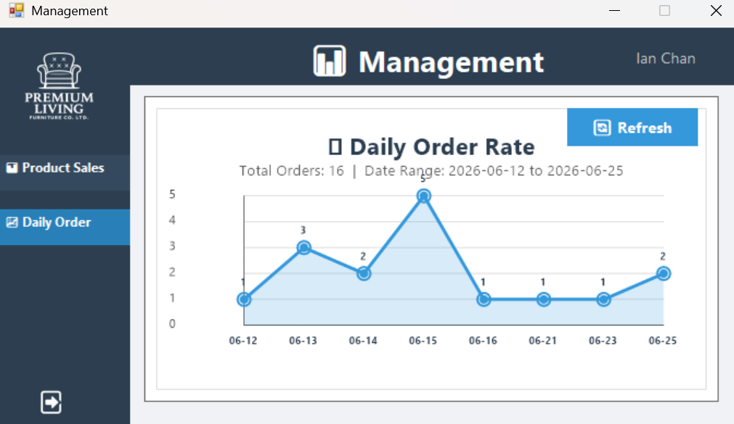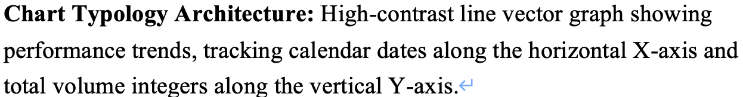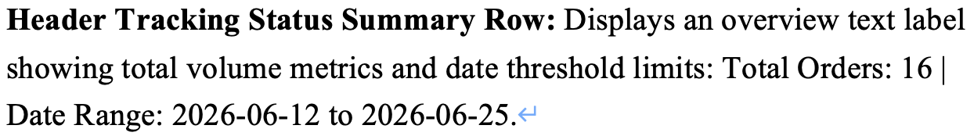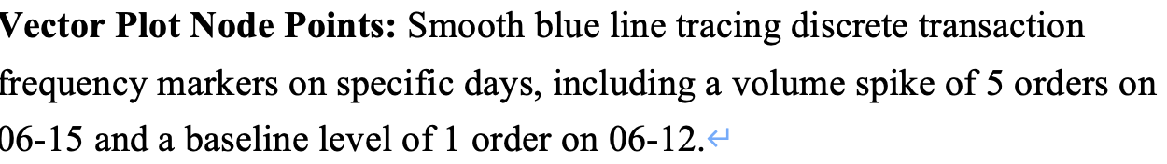

16. Test cases
Test ID | Objective | Brief Description | Test Data | Expected | Result
TC-LOGIN-01 | Verify Normal Login Functionality | When an employee enters the correct EmployeeID and Password, the system verifies and redirects them to the corresponding function homepage based on their department. | EmployeeID = `10001` (Keung To, SA Department), Password = `12345` | Login successful, the screen redirects to the Sales department homepage (`Sales.cs`). | PASS
TC-LOGIN-02 | Verify Incorrect Password Blocking Mechanism | If a correct EmployeeID is entered but an incorrect Password is entered, the system should refuse login and display an error message. | EmployeeID = `10001`, Password = `99999` | The system displays an "Invalid ID or Password" message box, denying login. | PASS
TC-LOGIN-03 | Verifying the Forgot Password Reset Process | The employee enters their EmployeeID and new password via the "Forgot Password" link, successfully resets their password, and can log in again. | EmployeeID = `10002`, New Password = `new123` | The system successfully updated the password; the employee can log in to the CS department using `new123`. | PASS

Test ID | Objective | Brief Description | Test Data | Expected | Result
TC-ORDER-01 | Verifying the Normal Order Creation Process | Sales personnel add products to their cart from the product browsing area, fill in customer information, and submit the order. The system automatically generates an OrderID and deducts inventory. | Product `PD00000001` (Modern Fabric Sofa), Quantity 2, Customer `Test User`, Phone `61234567` | The system generates an OrderID (e.g., `ORxxxxx`), the order status is `Pending`, and the product inventory is correctly deducted. | PASS
TC-ORDER-02 | Verify Insufficient Inventory Protection When Creating an Order | When the ordered quantity exceeds the current product inventory, the system should reject the order and display an error message. | Product `PD00000010` (Leather Recliner Chair), only 5 items in stock, quantity entered 10 | The system displays `Insufficient stock for Leather Recliner Chair`, the order cannot be created. | PASS
TC-ORDER-03 | Verify Order Editing Functionality | When sales personnel modify the product quantity or delivery date of an existing order, the system records the modification process and notifies the logistics department. | Order `OR8cd5d` (Pending status): Change Qty from 1 to 2 | Order details updated: `LastUpdatedTime` refreshed, and modified records written to the system. | PASS
TC-ORDER-04 | Verify Order Details Viewing Function | Clicking the "View" button in the order list will open the `OrderDetails` window, displaying complete order information and product details. | Order `ORa4711` (containing 2 products) | The window displays customer information, delivery address, all product items, unit price, subtotal, and total amount. | PASS
TC-ORDER-05 | Verify Order Cancellation and Inventory Replenishment | Canceling an order that has not yet been shipped will change the status to `Cancel` and automatically add back the deducted inventory quantity. | Order `OR39d0d` (Status: Pending, includes Solid Wood Dining Table x1) | Order status changed to `Cancel`, product `PD00000002` inventory replenished +1. | PASS
TC-ORDER-06 | Verify order search function | Enter keywords (OrderID or customer name) on the order search page, the system filters and displays a list of orders that meet the criteria. | Keyword `Chan` or `ORa4711` | `dataGridView2` only displays orders whose customer name contains `Chan` or whose OrderID is `ORa4711`. | PASS

Test ID | Objective | Brief Description | Test Data | Expected | Result
TC-PROD-01 | Verify raw material requisition creation | Production personnel select raw materials and enter the required quantity and estimated time, the system generates a RequestID and notifies the inventory department. | Material `MT00000001` (Solid Wood) Quantity 5, Estimated Time `2026-07-01` | The system generates `RQxxxxxxxx`, status `Pending`, and writes data to `rawmaterialrequest` and `rawmaterialrequestitem`. | PASS
TC-PROD-02 | Verify and query raw material requisition form | Enter RequestID or employee name, and the system displays the details of the requisition form (including all material details). | RequestID = `RQ81282469` | The system displays the employee, all material lists, quantities, and processing status of this order. | PASS

Test ID | Objective | Brief Description | Test Data | Expected | Result
TC-INV-01 | Verify Raw Material Receipt Operation | Inventory personnel select raw materials and enter the receipt quantity. The system updates the `StockQty` of the material. | Material `MT00000004` (Plastic), receipt quantity `200` | The inventory of this material increases from `300` to `500`. | PASS

Test ID | Objective | Brief Description | Test Data | Expected | Result
TC-LOG-01 | Verify and generate shipping order | Logistics personnel create shipping orders for paid orders, and the system generates a unique DeliveryID and notifies the delivery personnel. | Order `OR8f4d3` (Status: Paid, shipping order not yet created) | The system generates `DVxxxxxxxx`, status: `Pending`, order and shipping order successfully linked. | PASS
TC-LOG-02 | Verify Receipt Generation | Logistics personnel select an existing DeliveryID, fill in remarks, and save the receipt. The system generates a ReplyID. | DeliveryID = `DV45371653` (corresponding to order ORa4711) | The system generates `RSxxxxxxxx`, and the receipt record is stored in the `replyslip` table. | PASS
TC-LOG-03 | Verify Upload Receipt (Simulated) | After delivery, upload the customer's signature file (image). The system saves the file and updates the order status to "Delivered". | DeliveryID = `DV45371653`, upload `signature.jpg` | The file is copied to the system folder, and the order `ORa4711` status changes to `Delivered`. | PASS
Test ID | Objective | Brief Description | Test Data | Expected | Result
TC-PUR-01 | Verify Purchase Order Creation | Purchasing personnel select multiple raw materials from the shopping cart mode, fill in the delivery date, and save the purchase order. | Materials `MT00000001` x 2, `MT00000006` x 1 | The system generates `POxxxxxxxx`, status `Pending`, and writes the data to `procurement` and `procurement_items`. | PASS
TC-PUR-02 | Verify Searching and Viewing Purchase Orders | Enter ProcurementID or EmployeeID, and the system displays the purchase order master file and details. | ProcurementID = `PO33646565` | The system displays the employee, delivery date, all materials, and quantities for this purchase order.
TC-PUR-03 | Verify Editing Purchase Order (System Limitation) | The system currently only provides a "View" function; there is no direct editing interface. If modifications are needed, it is recommended to cancel the old order and create a new one. | ​​ProcurementID = `PO33646565` | Clicking "View" allows you to view details, but there is no "Edit" button. This is a system design limitation.

Test ID | Objective | Brief Description | Test Data | Expected | Result
TC-AFS-01 | Verify Creating an After-Sales Service Request | Customer service personnel select the order, request type (return/exchange/refund), fill in the reason, and upload photos (optional), then submit the request. | Order `OR4ad68`, Type `Replacement`, Reason `Product defective` | The system generates a RequestID, status `Pending`, and forwards it to the corresponding department via `ForwardTo`. | PASS
TC-AFS-02 | Verify and approve after-sales requests | Department staff enter the to-do list, click "View" to view details, and click "Confirm" or "Reject" to complete the approval. | RequestID = `4` (ForwardTo = LO, Status = Pending) | After clicking Confirm, the status changes to `Confirmed`; after clicking Reject, the status changes to `Rejected`. | PASS

Test ID | Objective | Brief Description | Test Data | Expected | Result
TC-MASTER-01 | Verify employee master data maintenance (system limitation) | The system does not provide a UI for adding/modifying/deleting employees. Employee information can only be managed directly through the database. | Add employee: EmployeeID=`10101`, Name=`New Staff` | This function is not available in the system. The `employee` table must be manipulated directly through SQL. | PASS
TC-MASTER-02 | Verify product master data maintenance (system limitation) | The system only provides the "Increase Product Inventory" function; it is impossible to add products or modify names/unit prices. | Add Product: ProductID=`PD99999999` | This function is not available in the system. You must directly manipulate the `product` table using SQL. | PASS
TC-MASTER-03 | Verify Raw Material Master Data Maintenance (System Limitation) | The system only provides the "Increase Raw Material Inventory" function; it cannot add new materials or modify names/categories. | Add Material: MaterialID=`MT99999999` | This function is not available in the system. You must directly manipulate the `rawmaterials` table using SQL. | PASS

Test ID | Objective | Brief Description | Test Data | Expected | Result
TC-FIN-01 | Verify Invoice Creation | The finance staff enters the order number and selects the payment method. The system generates an InvoiceID and changes the order status to Paid. | Order `OR0d283` (Status: Pending, invoice not yet issued) | The system generates `IVxxxxxxxx`, the order status changes to Paid, and the invoice record is stored in the `invoice` table. | PASS

User Guide

1.1 Standard Authentication Protocol
- Launch the application desktop client workspace instance to initialize the Login workspace portal view (image_ab3e45.png).
- Input your official corporate unique system login identification string inside the EmployeeID box field area.
- Supply your alphanumeric authentication credentials in the designated Password field box text line.
- Click the blue LogIn action square to authorize credential validation checking sequences.
- Upon verification, the terminal screen routes you automatically to your designated department interface layout structure console interface dashboard based on your user profile permissions (e.g., Sales Dashboard view).

1.2 Self-Service Password Recovery Reset Process
- Access the login screen canvas window frame options layout, then click on the Forgot password? link option selection string shortcut.
- The terminal displays the custom update tracking template frame module labeled Forgot Pawword.
- Fill in your assigned corporate validation identifier inside the EmployeeID box input zone.
- Populate the target updating password tracking sequence elements directly inside the New Password text field option control block.
- Select and execute structural updates by pressing the Submit operational context action button.
- Return to the basic starting access point view pane by clicking on the Back To log in action control button element to use your newly configured security access sequence patterns.

2.1 Inventory Lookup Search Catalog Routine
- Select the primary sidebar tracking navigation menu panel label tab item marked Search Product.
- Input key criteria terms (such as specific item descriptive identification headers or database numeric values) within the empty top layout navigation tracking selection check parameters text row workspace line.
- Execute validation calculations by pressing down on the blue Search layout command toggle button.
- Review available matching catalog arrays displayed directly inside the output information row dashboard panel sections tracker:
  - ProductID / ProductName: Identifies catalog inventory names.
  - UnitPrice: Baseline accounting catalog cost matrix records.
  - Stock: Remaining real-time product quantities available within corporate storage depots.

2.5 Historical Log Inquiries Data Reviews
- Click on the left-aligned navigational menu track indicator block marked Order History.
- Read system tracking status metrics records updates quickly by tracking colored text elements inside rows:
  - Pending (Orange Text Labeling): Active transaction request undergoing initial logistics preparation.
  - Paid (Green Text Labeling): Settlement procedures finalized successfully.
  - Cancel (Red Text Labeling): Request voided; allocations released.
  - Delivery (Blue Text Labeling): Items dispatched with field carrier teams en route to destination.

￼2.2 Product Configuration selection & Cart Management Operations
- Choose the sidebar interaction menu option section labeled Create Order to launch step 1 view layouts.
- Locate your target furniture item cards within the main catalog window display section area.
- Review item details and inventory indicators (e.g., S:52 indicates 52 items are currently available in stock balances).
- Use the item card quantity spinner counter component (Qty:) to enter your desired purchase amount values.
- Click the blue + Add action button element to place the selected item block configurations into your active temporary shopping cart registry workspace storage layout arrays on the right.
- Verify your running items index list items breakdown records data rows displayed in the right-side CART workspace framework container summary block panel.
- Click the Checkout functional interface navigation execution context layout button once selection requirements match customer requests.
CRITICAL ALERT NOTICE: Do not request quantities that exceed current warehouse inventory levels. Attempting to order amounts greater than available stock will cause validation errors, and the transaction request will be blocked.

2.3 Customer Metadata Entry Verification & Submission Operations
- Complete all customer input field metrics parameters within the confirmation checklist structure frame workspace window:
  - Enter the customer's name details inside the Customer Name input workspace container text row field.
  - Input contact metrics numbers directly into the Customer Phone Number text box data slot tracking space.
  - Provide tracking data logs metrics if available inside the Customer Email field container.
  - Use the dropdown calendar selector parameters tool interface options block control row elements to configure the correct target calendar delivery target point markers (Delivery Date).
  - Specify exactly where logistic handlers must drop off materials items inside the Delivery Address input text box tracking field row zone.
- Confirm that total billing aggregate financial cost statistics accurately compute with physical ledger limits via the red Total Price summary system text status row panel area display block.
- Finalize execution procedures by clicking the blue Submit interaction tracking execution action command selection box control layout element item tracking module component.

2.4 Active Transaction Modifications & Log Auditing Processes
[Search View Actions Console Step]
-> Select "Search Order" navigation sidebar item
-> Locate target row ID
-> Perform View details check or Cancel state parameters command
- Select the primary operational dashboard tab element entry labelled Search Order via the left main panel container.
- Locate specific active client tracking logs data indexes fields by looking up unique values (e.g., searching order codes matching formatting attributes such as OR0d283).
- To Review Inner Data Rows Configurations: Click the View button element component located directly on the left border framework lines within target index tracking rows to pop open detailed overview component subwindows detailing breakdown logs metrics structures.
- To Revoke Processing Sequences: Click on the dedicated Cancel data cell command button tool shortcut option item layout structure component block within the grid. This sets transactional indicators instantly to closed states and returns previously reserved quantities to corporate inventory counts.

1.1 Navigating and Auditing Request History Logs
- Open your desktop workstation client, input your security credentials, and ensure you are working within the main window console dashboard titled After-service Management.
- Verify that your system username credentials display accurately in the upper right header sector text field (e.g., verifying that the profile context displays your name: Joey Yung).
- Navigate to the left primary sidebar options menu console frame, and click onto the second vertical navigation link item tab labeled Request History.
- The main workspace layout panel dynamically populates to render the Request History Logs tracking data table grid.
- Scan down the ledger rows matrix to evaluate active client support transactions, noting the system's automated conditional status highlight maps:
  - Pending Tasks: Review rows marked with an orange/yellow status indicator text string (e.g., checking open request line item RequestID 8 tracking order record OR0d283 specifying a Return requirement type context).
  - Confirmed Tasks: Review rows marked with a green status indicator text string (e.g., verifying completed request line item RequestID 6 tracking order record OR8cd5d highlighting an archived issue state).
- To log out or switch user account desk contexts, move your cursor down to the lowest boundary corner point of the left navigation strip panel, and select the square white arrow exit icon action command switch button.

3.1 Initiating Resolution Customer Service Requests Tickets
- Access the operational terminal options framework, then click the menu bar option selection icon labeled Create Request.
- Click the dropdown arrow element inside the Order ID field control box row selection to connect this new issue ticket to an existing sales receipt index line.
- Select appropriate resolution criteria models via the Request Type dropdown picker choices selection row panel box (e.g., selecting option types like Return or Replacement).
- Type an explanation detailing exactly why changes are being requested inside the Reason multiline text input block field.
- If the request needs multi-department routing, select the target department from the Forward To dropdown options (or keep it assigned locally within the customer service queue).
- Upload supporting media evidence files (such as digital photos of defective products) by clicking the blue Upload command block box control button element structure.
- Finalize ticket setup by pressing the blue Submit tracking action button down below.

3.2 Evaluation Audits Review and Management Sign-off Operations
- Click the navigational track menu index element option shortcut block component labeled Handing Request.
- Review the incoming issue ticket items listed in the CS Pending Requests column list view index table matrix on the left side of the screen interface console.
- Click the View selector key action button tag line element row component next to an item to pull up its full request profile.
- Read all submitted parameters details fields properties carefully via the floating pop-up summary interface layout box display window frame module labeled Request Details on the right side:
  - Read descriptions captured from incoming client tickets inside the Reason text summary viewing panel box data slot tracking space area.
  - Verify whether required validation images exist by tracking validation feedback logs output strings rows notices (e.g., identifying notifications reading Photo file not found).
- To Grant Issue Validation Approvals: Click the green Confirm execution button structure component to switch ticket properties to finalized operational states.
- To Decline Request Files Processing: Click the red Reject execution command toggle option block component to close tickets out without executing processing changes.

2.1 Searching the Finished Product Inventory Catalog
- Launch your operational workspace console window, and verify that the interface frame title line reads Inventory Management.
- Check that the system tracking name header on the upper right displays your operator profile assignment: Hins Cheung.
- Select the top option row link item in the primary left navigation panel tab bar labeled Search Product.
- Click inside the long blank text search bar row located above the data view grid matrix panel framework, and key in your targeted product name search parameters.
- Click on the square blue action query icon button directly to the right of the input bar to execute the filtering process.
- Review your product parameters inside the updated ledger display matrix columns: check the product row index code field (ProductID), catalog text identification string (ProductName), formatted unit cost metrics (UnitPrice), and warehouse balances (Stock).
- Confirm product details directly against live warehouse balance summaries (e.g., verifying that catalog row PD00000001 for Modern Fabric Sofa shows an available inventory count of 52 units).

2.2 Performing a Material Resources Stock Balance Audit
- Move down to the second options link item tab position inside the primary left interface navigation strip panel, and click on Raw Materials.
- The main view workspace grid panel updates to display un-manufactured raw resource stock parameters.
- Audit material records across columns tracking MaterialID, MaterialName, Category, and Stock.
- Verify resource levels across different categories to locate supply shortages (e.g., verifying that item row MT00000001 for Solid Wood shows a low stock count of 20, while item row MT00000002 for Plywood shows an ample stock count of 200).

2.3 Logging Inward Resource Intake Balances
- Click onto the third vertical navigation action selection link item tab option inside the left system menu strip block labeled Inward Raw Material.
- The interface brings up the dedicated inventory intake data form entry panel titled Inward Raw Material.
- Navigate to the option selection field drop-down picker labeled Select Material:, click the right drop selector arrow indicator widget, and highlight your incoming material profile choice from the list.
- Move down to the text input box field labeled Qty:, click inside the blank input row box space, and type in the exact integer count of incoming physical units received at the unloading dock.
- Complete the intake logging step by clicking onto the blue action execution command switch button labeled Save, which features a white floppy disk icon layout design asset.

2.4 Initiating and Submitting Corporate Procurement Material Orders
- Click onto the fourth vertical menu selection row option item tab within the left primary navigation side bar panel titled Procurement.
- Review historical purchase orders on the screen, tracking your entries via action buttons and columns like ProcurementID, Status, and CreatedBy.
- Click the bright blue operation configuration action switch button labeled + Create located in the upper right workspace sector area to start a new material request.
- The system switches panels to show step 1 of the procurement catalog grid setup:
  - Browse the material options displayed in the catalog view (e.g., checking item cards for Solid Wood or Plywood).
  - Review green stock indicators on each card to confirm available amounts (e.g., verifying that Solid Wood displays a live warehouse balance of Stock: 20).
  - Go to the numeric input spinner box option widget labeled Qty: on your target item card, and use the arrow step controls to configure your desired quantity order size.
  - Click the light-blue interaction step control button labeled + Add to stage your choice and queue the item in your shopping cart.
  - Confirm that your items are listed correctly in the summary log column pane titled Procurement Cart.
  - Note: To flush out your current selections, click the lower white command option button labeled Clear.
  - When your cart setup is complete, click the bright green checkout navigation action button labeled Confirm.
- The system advances to step 2 of the final procurement validation layout confirmation form window:
  - Verify that your identity details auto-populate correctly in the read-only tracking text fields labeled Employee Name (Hins Cheung) and Employee ID (10003).
  - Move your cursor inside the text box field row labeled Phone Number:, and key in your mobile telephone number string details (e.g., entering contact string parameters: 51980201).
  - Click the small calendar icon widget box on the dropdown input field row labeled Delivery Date: to open the picker, and choose your target warehouse delivery date (e.g., selecting date parameters: 2026/ 7/ 2).
  - Double-check your staged items inside the central stacked summary panels to verify material details match your requirements (e.g., checking that the order list shows Plywood Qty: 1 and Solid Wood Qty: 1 under the bold red aggregate header Total Items: 2).
  - Note: If you need to make corrections or modify item quantities, click the dark blue back-step button labeled Back to to return to the catalog grid workbench.
  - Save and finalize the order request by clicking the bright blue database transactional commit switch button labeled Save.
  - To compile and view a print-ready document version, click the dark blue action command export report button labeled PDF.

5.1 Settlement Verification & Invoice Generation Workflow
When customers tender payment to settle open booking ledger profiles, follow these ledger modification routines:
- Open the primary financial reporting console window frame and open the Create Invoice module screen (image_aeecbb.png).
- Select or pass your target document parameter references into the system (e.g., referencing tracking entry metrics like order OR0d283).
- Review associated product configuration breakdown structures and verify that system totals sync perfectly with active invoicing standards via the Total Price monitoring segment line display (e.g., verifying a balance calculation of $4,980.00).
- Select the matching option representing the customer's actual choice of settlement instrument via the Payment Method RadioButton option array list selection slots (e.g., checking PayMe or Visa).
- Execute structural invoice lock-down processes by clicking the Generate Invoice command action item down below.
- The terminal emits an unique transaction verification code tracking document starting with IV prefixes (e.g., generating IV24505277 inside image_aeecb7.png), switches underlying operational tracking flags smoothly from Pending straight over to Paid states, and passes dispatch metrics onto logistical fulfillment tracks.

1.1 Managing and Printing Shipping Document Logs
- Navigate to the left navigation framework panel bar, then click the View Notes menu button tab selection option to launch the main workspace dashboard table.
- Review the active system delivery metrics tracking matrix lists layout columns (Delivery ID, Order ID, Customer Name, Delivery Date).
- To view or switch data tracking profiles, click the Check Reply context button anchored top-right to pull open the formal Reply Slip Explorer data list window layout.
- Click the View PDF cell shortcut control action button located on the leftmost boundary lines within an index row to automatically compile, render, and display formal printable delivery sheet layouts for field workers.

1.2 Creating Shipping Assignments for Paid Sales Orders
- Open the primary interface navigation bar layout, then choose the menu function option label marked Create Delivery.
- Expand the OrderID dropdown ComboBox picker control box selection string row to highlight a target pending paid sales order tracking index (e.g., choosing order reference number code row ORb6ae5).
- Verify that the client profile data details populating the adjacent read-only form input slots (Customer Name, Customer Phone) match your physical billing manifests.
- Use the calendar tools dropdown configuration arrow parameters row indicator to pick your target logistical deployment window tracking target parameter via the Delivery Date calendar picker.
- Review physical shipment lines displayed in the central items summary table tracking grid (confirming quantities like Modern Fabric Sofa count 1, value HK$4,980.00).
- Finalize execution procedures by clicking the Save action interaction button at the bottom center of the pop-up panel. The system commits records instantly into active logistical operations queues, flags order properties with an index prefix tracking string matching DVxxxxxxxx, and sets initial dispatch status properties to Pending.

1.3 Registering Signed Delivery Confirmation Slips
- Access the main software menu structure panel track layout column options and choose Create Reply to open the slip entry form.
- Locate the specific dispatch file index target parameters row selection matching your completed route requirements inside the Delivery ID dropdown selection option panel box (e.g., selecting index item parameters row DV68633206 - ORb6ae5).
- The application auto-populates all client metadata summary data logs blocks fields layout indicators rows across read-only informational display text lines layout blocks.
- Type relevant field observations, custom handling requests comments, or site conditions notes inside the open blank layout row box labeled Remarks.
- Finalize transaction database validation entries by clicking the blue Save execution control command icon button layout element. The application registers the transaction sheet details into historical storage tables and creates a verification code sequence matching layout pattern RSxxxxxxxx.

1.4 Field Carrier Dispatch Updates & Signature Asset Storage
- Navigate to the lower sector region menu link items panel row entries, and choose Upload Delivery to initiate route closure routines (image_5.png).
- On the left master checklist grid, locate the targeted transaction index line tracking your delivery run, and click its blue Upload action text grid button cell.
- Review properties mapped instantly over into the right-side configuration utility workspace dashboard labeled Upload Delivery Status:
  - Verify that the client identifiers are correct (e.g., Order ID: ORb6ae5, Customer: Ng).
  - Select your physical on-site time tracking validation marker properties via the Delivery Time dropdown calendar interface component tool.
  - Adjust operational processing phase status parameters flags using the Status choice box dropdown menu list to reflect ongoing status values (e.g., selecting option tag item tracking state label Delivery).
- Click the green Upload action execution button down below to open a file selection dialog. Browse your device storage to attach the customer's digital signature receipt photo document file (e.g., uploading target document data file path signature.jpg).
- Upon confirmation validation checking, the platform clones media assets securely into server asset roots, changes the underlying master sale system status tracking properties flags instantly over to Delivered, and removes the completed transaction out of open delivery tracking queues.

2.1 Auditing Material Requests Log Repositories
- Open the departmental operational dashboard window layout frame module titled Production Management (image_6.png).
- Click onto the first sidebar menu path item entry track line labeled Search Raw Material Request.
- View the current statuses of raw material requests via the main logging overview data table matrix columns (RequestID, EmployeeName, TakesTime, Status).
- System Navigation Operational Alert Rule: To review detailed underlying data rows configurations, select a target row index and click its associated cell action button marked View.
SYSTEM LIMITATION WARNING: The system provides read-only view access via this portal interface frame console. There is no edit button exposed to directly modify values. If an active pending request record needs changes, you must cancel the old request completely and compile a new request document from scratch.

2.2 Material Request Compilation & Cart Processing Routines
- Click the second sidebar menu pathway interface option entry marked Search Raw Material Request to load step 1 catalog layout canvas frames (image_7.png).
- Browse through distributed category inventory catalog sheets containing data summaries layout cards tracking stock metrics configurations.
- Check dynamic material quantities properties indicators text flags parameters rows down inside item profile cards to confirm current warehouse balances (e.g., identifying that item Solid Wood has Stock: 20 remaining, while item Plywood registers a balance of Stock: 200).
- Input your desired material request counts using individual item numericUpDown spinner boxes lines fields markers (Qty:).
- Click the blue + Add command box layout block button item components to cache item quantities down straight into the temporary CART workspace on the right pane.
- Verify your total running selection indicators count matches requirements via the red status tracking text counter indicator line reading Total: X items.
- Click the white layout block execution button component marked Request to advance straight over into checkout submission validation processing forms.

2.3 Executing and Saving Material Procurement Requests
- Complete form parameter entries within the material request summary form canvas window (image_8.png):
  - Confirm that your account identifier parameters display correctly in the read-only boxes (Employee ID: 10006, Employee Name: Anson Kong).
  - Type your active phone contact digits directly into the editable input workspace box field labeled Phone Number.
  - Use the calendar tool selector parameters dropdown menu box options rows to establish correct system reference timestamps markers values (Takes time:).
- Review the final confirmation list items displayed in the form rows to ensure your requested quantities match production requirements.
- Finalize operational procurement steps by clicking the blue Save action button at the base of the frame canvas. The system registers the transaction rows, generates a unique database indexing reference identifier matching formatting pattern POxxxxxxxx or RQxxxxxxxx, and flags the initial workflow lifecycle stage as Pending.

2.4 Registering Completed Factory Production Output Balances
- Navigate to the left interface menu panel track shortcuts listing, and select Inward Product Qty to open the production entry portal (image_9.png).
- Click the dropdown selection indicator layout line marked Select Product: to declare focus onto the targeted warehouse asset storage row item profile entry being returned from assembly loops.
- Input the exact numbers of newly completed finished goods items counted on-site into the editable Qty: form block text box field.
- Complete the transaction entry update routines by clicking down onto the blue Save interaction action command switch button tool shortcut component block. The system processes recalculations immediately, adds the new quantities to active warehouse stock records, and refreshes database metrics.

3.1 Analyzing Product Sales Performance Metric Data Share Splits
- Access your administrative client console terminal workspace, and verify that the application window frame title bar reads Management.
- Check that the session workspace identity label at the top right displays your executive role context title: Ian Chan.
- Click the first top menu choice tab option row on the left primary navigation sidebar panel labeled Product Sales.
- The screen opens the main executive dashboard analytics panel to display the high-contrast Product Sales Distribution circular pie chart.
- Read the plain-text subtitle indicator label to review aggregate unit sales metrics across current database logs (e.g., verifying that the system registers Total Products Sold: 32 units).
- Hover over or review the color-coded chart slices to analyze percentage performance breakouts among furniture categories (e.g., noting that the largest category slice commands a dominant 25.0% share of operations).
- Click the light-blue command link interface control switch button labeled Refresh in the top right quadrant corner to pull live sales metrics and update chart visualizations.

3.2 Monitoring Volume Velocities via Daily Order Rate Trends
- Navigate to the second vertical options layout selection menu row tab within the left primary sidebar panel strip, and click on Daily Order.
- The main analytics panel switches configurations to display the high-contrast Daily Order Rate trend line vector graph.
- Review the summary statistics line header text to verify your active evaluation date filters and total order counts (e.g., checking that the display logs report: Total Orders: 16 | Date Range: 2026-06-12 to 2026-06-25).
- Track the blue graph plot vector path along the timeline to evaluate operational volume shifts:
  - Baseline Activity: Note initial order volume points along the left side of the chart axis timeline (e.g., tracing a volume count of 1 order on 06-12).
  - Peak Volume: Identify significant production demand spikes by tracing the peak node points on the graph (e.g., locating a sharp peak of 5 orders on 06-15 before the line patterns stabilize into a steady run of 1 order per day through subsequent dates).
- Click the light-blue Refresh button at the top right of the graph workspace container to reload transaction histories and capture newly updated orders.

17. Project Schedule
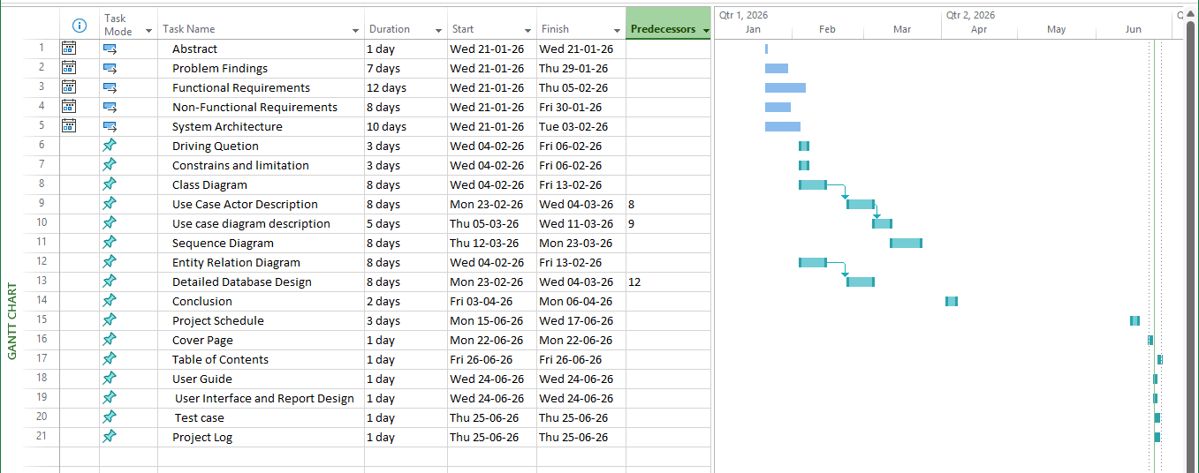

18. Conclusion

Premium Living Furniture Co. Ltd. stands at a critical juncture in its organizational development. As the company transitions from a traditional Business‑to‑Consumer (B2C) model to a hybrid Business‑to‑Business (B2B) and B2C approach, the need for a centralized computerized management system has become both urgent and strategic. The analysis conducted throughout this report has highlighted significant operational challenges, including fragmented departmental systems, reliance on manual communication, paper‑based documentation, and the absence of real‑time visibility into core processes. These inefficiencies have led to procurement delays, production disruptions, inconsistent customer service, and increased administrative burdens.
The proposed solution—a centralized, role‑based, and trackable management system—directly addresses these issues by integrating inventory control, logistics coordination, sales operations, and customer service into a unified platform. Technically, the system is feasible due to the availability of modern ERP solutions, scalable cloud infrastructure, and established database technologies. Economically, the investment is justified by the long‑term cost savings, efficiency gains, and enhanced customer satisfaction that will strengthen the company’s market position. Organizationally, the system aligns with the company’s strategic transformation, fostering collaboration, accountability, and transparency across departments while supporting both corporate clients and individual consumers.
The benefits of this system extend beyond operational improvements. Enhanced inventory control will reduce downtime and ensure production reliability. Structured customer service workflows will improve responsiveness, accountability, and brand reputation. A new communication channel between sales and logistics will minimize errors, accelerate order modifications, and improve customer confidence. Together, these improvements provide a scalable foundation for future growth, enabling Premium Living Furniture to remain competitive in a rapidly evolving global marketplace.

Ultimately, this project demonstrates the transformative power of information technology in modern enterprises. By embracing digital integration by the new system, Premium Living Furniture Co. Ltd. can move beyond its current limitations and establish itself not only as a manufacturer but as a trusted brand owner with a reputation for efficiency, innovation, and customer‑centric service. The centralized computerized management system is not merely a technical upgrade—it is a strategic enabler that will safeguard the company’s long‑term sustainability, reinforce its brand value, and position it for success in both B2B and B2C markets.

19. Project Log
Task Name | Duration | Start | Groupmate
Final Report
Abstract | 1 day | Wed 21-01-26 | Sung Kit
Problem Findings | 7 days | Wed 21-01-26 | Chan Ho Yin
Functional Requirements | 12 days | Wed 21-01-26 | Chan Ho Yin
Non-Functional Requirements | 8 days | Wed 21-01-26 | Miao Tung
System Architecture | 10 days | Wed 21-01-26 | Sung Kit
Driving Quetion | 3 days | Wed 04-02-26 | Sung Kit
Constrains and limitation | 3 days | Wed 04-02-26 | Miao Tung
Class Diagram | 8 days | Wed 04-02-26 | Miao Tung
Use Case Actor Description | 8 days | Mon 23-02-26 | Miao Tung
Use case diagram description | 5 days | Thu 05-03-26 | Miao Tung
Sequence Diagram | 8 days | Thu 12-03-26 | Miao Tung
Entity Relation Diagram | 8 days | Wed 04-02-26 | Chan Ho Yin
Conclusion | 2 days | Fri 03-04-26 | Sung Kit
Project Schedule | 3 days | Mon 15-06-26 | Sung Kit
Cover Page | 1 day | Mon 22-06-26 | Miao Tung
Table of Contents | 1 day | Fri 26-06-26 | Miao Tung
User Guide | 1 day | Wed 24-06-26 | Sung Kit
User Interface and Report Design | 1 day | Wed 24-06-26 | Sung Kit
Test data | 2 days | Mon 15-06-26 | Chan Ho Yin
Test case | 1 day | Thu 25-06-26 | Sung Kit
Project Log | 1 day | Thu 25-06-26 | Sung Kit
System (Software Prototype)
Menu Program / Login | 4 days | Sun 24-05-26 | Chan Ho Yin
Create and Edit Order | 5 days | Sun 24-05-26 | Chan Ho Yin
View Order | 5 days | Sun 24-05-26 | Chan Ho Yin
Cancel Order | 5 days | Sun 24-05-26 | Chan Ho Yin
Search Order | 7 days | Sun 24-05-26 | Chan Ho Yin
Production Processing Management | 5 days | Sun 24-05-26 | Sung Kit
Create Raw Material Request | 5 days | Sun 24-05-26 | Sung Kit
Search Raw Material Request | 5 days | Sun 24-05-26 | Sung Kit
Generate Delivery Notes & Reply Slip | 10 days | Sun 24-05-26 | Sung Kit
Handling Goods received | 5 days | Sun 24-05-26 | Miao Tung
Record of inward goods | 5 days | Sun 24-05-26 | Miao Tung
Create and Edit Procurement | 3 days | Sun 24-05-26 | Miao Tung
Search and List Procurement | 3 days | Sun 24-05-26 | Sung Kit
After-service Management | 5 days | Sun 24-05-26 | Sung Kit
Master Data Maintenance | 15 days | Sun 24-05-26 | Sung Kit
System Security & Control | 5 days | Sun 24-05-26 | Sung Kit
Database Implementation | 3 days | Sun 24-05-26 | Chan Ho Yin
Statistical Reports | 5 days | Sun 24-05-26 | Chan Ho Yin

20. Reference
- Tophoj, M. (2026, February 19). What is B2C Marketing?: Definition, Challenges & Tips | SAP Engagement Cloud. SAP Engagement Cloud. https://emarsys.com/learn/blog/what-is-b2c-marketing/
- Hashemi-Pour, C., & Contributor, T. (2024, March 15). B2B (business to business). Search CIO. https://www.techtarget.com/searchcio/definition/B2B
- Ramesh, P. (2025, September 1). What is inventory control? Its objectives, methods, and how to do it. Frappe Blog. https://frappe.io/blog/inventory-management/inventory-control
- Grant, M. (2025, May 3). What is customer service, and what makes it excellent? Investopedia. https://www.investopedia.com/terms/c/customer-service.asp
- Carrow, K. (2025, May 12). Sales representative. Who is it? And what do they do? RAYNET CRM. https://raynetcrm.com/know-how/sales-representative/
- _ESIC Business & Marketing School. (n.d.). The logistics department: What are its main functions? ESIC. https://www.esic.edu/rethink/logistica/logistics-department-main-functions-c
- Kolosky, C. (2025, August 2). A comprehensive guide to understanding and optimizing the approval process. Knack: No-Code Application Development Platform. https://www.knack.com/blog/understanding-approval-processes/
- What is a CMMS? | Features, Benefits & Selection Tips. (n.d.). https://www.fabrico.io/blog/what-is-a-cmms/
- Oracle. (2023, September 21). What is ERP? https://www.oracle.com/erp/what-is-erp/
- Authgear. (2026, February 12). What is Role-Based Access Control (RBAC)? Benefits, Comparisons, and Best Practices. https://www.authgear.com/post/what-is-role-based-access-control-rbac-benefits-comparisons-and-best-practices
- Yayo, D. (2026, March 30). Residential and commercial planning specialists. Expert Planning Consultants. https://expert-planning-consultants.com/residential-and-commercial-planning-specialists/
- What is an Entity Relationship Diagram (ERD)? (n.d.). Lucidchart. https://www.lucidchart.com/pages/er-diagrams
- What is Use Case Diagram? (n.d.). https://www.visual-paradigm.com/guide/uml-unified-modeling-language/what-is-use-case-diagram/
- What is Dynamics 365 | Microsoft Dynamics 365. (n.d.). https://www.microsoft.com/en-us/dynamics-365/what-is-dynamics-365
- Microsoft. (2024, August 27). Understanding information silos. Microsoft 365. https://www.microsoft.com/en-us/microsoft-365-life-hacks/organization/understanding-information-silos
- Susnjara, S., & Smalley, I. (2026, January 9). Disaster recovery. Think. https://www.ibm.com/think/topics/disaster-recovery
- Cisco Next Generation Firewall (NGFW) overview. (2026, April 3). [Video]. Cisco. https://www.cisco.com/site/us/en/learn/topics/security/what-is-a-next-generation-firewall.html
- What is network Security? | Microsoft Security. (n.d.). https://www.microsoft.com/en-us/security/business/security-101/what-is-network-security
- Synology Inc. (n.d.). What is NAS | Benefits of on-premises storage for home users | Synology Inc. https://www.synology.com/en-global/dsm/solution/what-is-nas/for-home
- Staff, C. (2025, December 8). What is Supply Chain Management? Roles, Salaries, and Career Insights. Coursera. https://www.coursera.org/articles/supply-chain-management
- What is Sequence Diagram? (n.d.). https://www.visual-paradigm.com/guide/uml-unified-modeling-language/what-is-sequence-diagram/
- Bigelow, S. J. (2020, September 30). Functional vs. nonfunctional requirements in software engineering. Search Software Quality. https://www.techtarget.com/searchsoftwarequality/answer/Functional-and-nonfunctional-requirements
- What is high availability? (n.d.). https://www.redhat.com/en/topics/linux/what-is-high-availability
- Guru99. (2024, December 18). What is User Acceptance Testing (UAT)? Examples. https://www.guru99.com/user-acceptance-testing.html
- Duo for AnyConnect VPN Overview Video. (2025, August 7). [Video]. Cisco. https://www.cisco.com/site/us/en/learn/topics/security/what-is-a-virtual-private-network-vpn.html
- What is Deep Packet Inspection (DPI)? | Fortinet. (n.d.). Fortinet. https://www.fortinet.com/resources/cyberglossary/dpi-deep-packet-inspection
- Cloud scalability: What it is and how it works. (n.d.). Google Cloud. https://cloud.google.com/discover/what-is-cloud-scalability
- Adamyk, B., Benson, V., Adamyk, O., & Liashenko, O. (2025). Risk Management in DEFI: Analyses of the innovative tools and platforms for tracking DEFI transactions. Journal of Risk and Financial Management, 18(1), 38. https://doi.org/10.3390/jrfm18010038
- Oracle. (2021, June 18). What is a Relational Database (RDBMS)? https://www.oracle.com/apac/database/what-is-a-relational-database/
- Romanchuk, J. (2025, October 16). How to do market research and better understand your target customers [+ AI prompts & template]. HubSpot Blog. https://blog.hubspot.com/marketing/market-research-buyers-journey-guide

